S.No. | CHAPTERS | PAGENo.
1 | Chemical Reactions and Equations | 4-12
2 | Acids, Bases and Salts | 13-21
3 | Metals and Non-metals | 22-29
4 | Carbon and its Compounds | 30-36
5 | Life Processes | 38-46
6 | Control and Coordination | 48-53
7 | How do Organisms Reproduce? | 54-60
8 | Heredity | 62-66
9 | Light – Reflection and Refraction | 63-79
10 | The Human Eye and the Colourful World | 80-89
11 | Electricity | 90-100
12 | Magnetic Effects of Electric Current | 101-113
13 | Our Environment | 114-121
INDEX

Chapter-1 Chemical Reactions and Equations
1 | A student added dilute HCl to a test tube containing zinc granules and made following observations: -  (a) the zinc surface became dull and black  (b) a gas evolved which burnt with a pop sound  (c) the solution remained colourless  (d)the solution becomes green in colour | 1
2 | A substance ‘X’ is used in white-washing by a painter and is obtained by heating limestone in the absence of air. Identify ‘X’.  (a) CaOCl₂ (b) Ca (OH)₂ (c) CaO (d) CaCO₃ | 1
3 | Sita buys a silver jewellery and used to wear that. After a long time of use she observed that ,When silver jewellery is exposed to air it gets a black coating of  (a) AgNO₃(b) Ag₂S(c) Ag₂O(d) Ag₂CO₃ | 1
4 | Assertion (A) : In electrolysis of water, the volume of hydrogen liberated is twice the volume of oxygen formed.  Reason (R) : Water (H₂0) has hydrogen and oxygen in the ratio of 1:2 by volume. | 1
5 | Rahul took a white colour powder in a china dish and put in the sun. After some time he observes that the powder turns grey. What may be the white colour powder taken?  (a) AgCl (b) Ca (OH)₂ (c) CaO (d) CaCO₃ | 1
6 | Ronit found that a green coating created in rainy season around the copper tumbler present in his house. He asked to his science teacher about the green coating. What may be the green coating?  (a) CuCl₂ (b) Ca (OH)₂ (c) Cu(OH)₂ (d) CuCO₃ | 1
7 | Arushi’s Copper ring fall in fire due to carelessness. She found that her shiny brown Copper ring turns into black. What may be the black colour coating formed?  (a) CuCl₂ (b) CuO (c) Cu(OH)₂ (d) CuCO₃ | 1
8 | During burning of magnesium, Teacher asked the students to wear sun glasses to protect their eyes from white dazzling light as it:-  (a) damage the retina (b) leads to loss of our vision  (c) both (a) & (b) (d) none of these | 1
9 | Fermentation of grapes is considered as a chemical reaction. Three students gave their opinion. Which may be opinion of their teacher:-  (a) chemical change  (b) sugar in grapes converts into alcohol  (c) Irreversible change  (d) all the above | 1
10 | Raju took two salt solutions and mix together. Which of the following observations is / are not correct about the given equation:-  Pb(NO₃)₂ (aq) + 2 KI (aq) → PbI₂(s) + 2KNO₃ (aq)  (a) PbI₂ is yellow precipitate insoluble in water  (b) It is precipitation reaction  (c) It is single displacement reaction  (d) It is very slow reaction | 1
11 | The following chemical equation does not represent a chemical reaction that can take place.  3Fe (s) + 4H₂O---🡪 Fe₃O₄(s)  State what needs to be changed in the above equation for it to represent the correct reaction between Fe and H₂O. | 1
12 | Tina was comparing combination reactions with decomposition reactions.  Which class of substances may be the product of a decomposition reaction but not a product of a combination reaction. | 1
13 | A strip of copper was placed in a beaker containing zinc sulphate solution.  On observing the strip next day , it was noticed that  - The copper strip remained as it was  - The copper strip became thinner  - The copper strip became thicker  d) The colour of the strip changed | 1
14 | Solutions of copper sulphate , iron sulphate and zinc sulphate are prepared and marked I, II and III respectively.  Few pieces of aluminium are added to each solution. After sometime , a change will be observed in  a)I and II b) II and III  c) III and I d) All the three | 1
15 | PbS reacts with ozone and forms PbSO₄.  As per the balanced equation , molecules of ozone required for every one molecule of PbS is/ are-  4 b) 3 c) 2 d) 1 | 1
16 | A piece of Magnesium ribbon is added to flask containing dil. HCl . Hydrogen gas is formed which is collected is the measuring cylinder. The amount of hydrogen formed with time is plotted in a graph. The line on the graph indicates the rate of chemical reaction occurring in the flask.  At what time is the reaction rate the fastest in the flask?  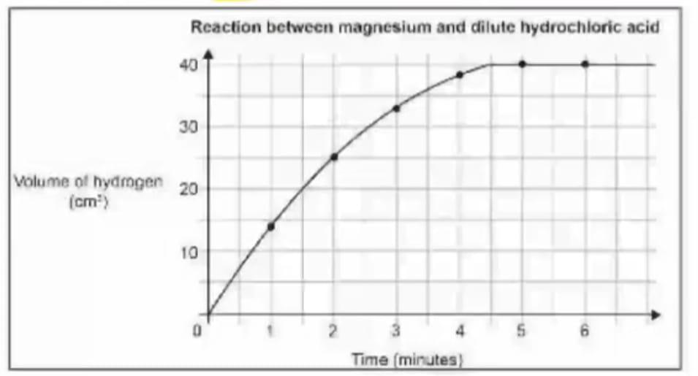  - at 1 minute b) at 3 minutes  - at 4 minutes d) at 6 minutes | 1
17 | Solid calcium oxide reacts vigorously with water to form calcium hydroxide accompanied by the liberation of heat. This process is called slaking of lime . Calcium hydroxide dissolves in water to form its solution called lime water. Which among the following is /are true about slaking of lime and the solution formed?  i)it is an endothermic reaction  ii)it is an exothermic reaction  iii)the pH of the resulting solution will be more than seven  iv)the PH of the resulting solution will be less than seven  a) i and ii b) iii and iv c)i and iv d) ii and iii | 1
18 | Identify the chemical reaction that correctly represents production of Magnesium Nitride by burning Magnesium metal in a pure nitrogen atmosphere from the following –  - Mg₃N₂(s) -🡪Mg (g) + N₂(g)  - Mg + N₂--🡪 Mg₃N₂  - 3MgN₂(g)---🡪 Mg₃N₂(g)  Mg₃N₂ ---🡪 3Mg + N₂ | 1
19 | Mohan took pure water for electrolytic decomposition of water but did not he see any bubbles near the electrodes . Give reason . Why? | 1
20 | Given below is the balanced equation for the thermal decomposition of Lead nitrate .  2Pb(NO₃)₂ ---^{Heat}---🡪 2 PbO + 4NO₂ + O₂  Which of the following information does the cofficients of PbO and NO₂ in the equation (2 and 4 respectively ) tell us ?  (a)The ratio of the number of moles produced of the two substances.  (b)The ratio of the number of atoms in the two substances.  (c) The ratio of the mass produced of the two substances.  (d) The ratio of the densities of the two substances. | 1
21 | Aman mixes an aqueous solution of Sodium Sulphate (Na₂SO₄) and an aqueous solution of Copper Chloride (CuCl₂).  Will this lead to a double displacement reaction? Justify your answer. | 2
22 | A student dropped few dropped few pieces of marble in dil .HCl in a test tube . The gas evolved was passed through lime water. What change would you observe in lime water?  Write chemical reaction for both the changes. | 2
23 | Eight identical iron blocks were placed on the ground in two arrangements X and Y as shown below . The block arrangements were kept moist by sprinkling water every few hours.  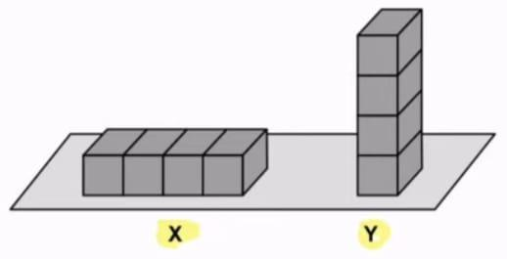  Which of these arrangements is likely to gather more rust after ten days ? Justify your answer. | 2
24 | Balance the following chemical equations.  a) Fe₂O₃ + Al → Fe + Al₂O₃  _{b)} Pb(NO₃)₂ → PbO+ NO₂ +O₂ | 2
25 | Padmaja conducting the following experiment. She could not understood the following. Let us help her to understood.  a)Name the brown fume and write its molecular formula.  b)Name the brown residue left in the test tube.  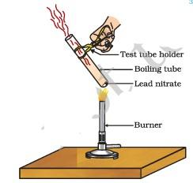 | 2
26 | While conducting the following experiment:-  a)How will you verify the hydrogen gas?  b) Write the balanced chemical equation for this reaction.  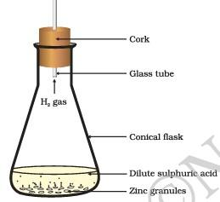 | 2
27 | A teacher conducting the electrolysis of water. Find out the solution of the following doubt arise by the students:-  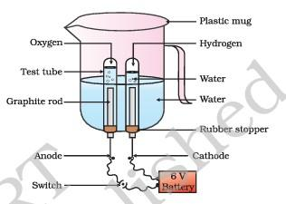  i)why does the amount of hydrogen is double than the amount of oxygen?  ii)What is the role of dil.sulphuric acid in this experiment?  iii)Name the type of reaction. | 3
28 | Find out the type of chemical reactions.  a) CaCO3 (s) Heat CaO(s) + CO2 (g)  b) Zn(s) + CuSO4 (aq)→ ZnSO4 (aq) + Cu(s)  c)Pb(NO₃)₂(aq) + KI (aq) → PbI₂(s) + KNO₃ (l) | 3
29 | Translate the following statements into chemical equations and then balance them:-  (a)Hydrogen gas combines with nitrogen to form ammonia.  (b)Hydrogen sulphide gas burns in air to give water and sulpur dioxide.  (c) Potassium metal reacts with water to give potassium hydroxide and hydrogen gas | 3
30 | Geeta has been collecting silver coins and copper coins. One day she observed a black coating on silver coins and a green coating on copper coins. Which chemical phenomenon is responsible for these coatings? Write the chemical names of black and green coatings. | 3
31 | Poonam finds a paper with a white substance in the chemistry lab. She keeps the paper near the window of the lab and comes back to pick it up after 5 hours. She noticed that the white substance had turned grey.  - What should be the substance on the paper?  - The substance changed from white to grey. Write the chemical equation for this change.  - State one application of this reaction in our everyday life. | 3
32 | Which of these could increase the rate of reaction ? Circle Yes /No for each row.  Will this increase the rate of reaction? Yes/ No  - Adding more acid to the flask Yes/ No  - Heating the contents Yes/ No  - Adding a catalyst Yes/No | 3
33 | Anshuman conducting the following experiment. Find out the following related to this reaction.  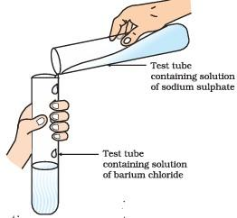  a)Write the chemical formula of this two reactants taken in aqueous form?  b)What is the colour change happen after the reaction?  c)Name the type of chemical reaction.  d)Name the precipitate produce in this reaction. | 4
34 | Prateek conducting the following experiment. Find out the solution for the following doubt related to this reaction.  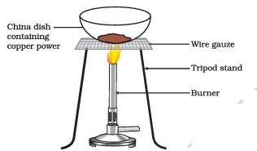  a)Why does the colour change happen to the copper?  b)Name the type of chemical reaction.  c)Write the balanced chemical equation for this.  d)How can prateek get back the shiny brown copper again? | 4
35 | On heating blue coloured powder of Copper(III) Nitrate in a boiling tube, Copper Oxide, Oxygen gas and a brown gas X is formed.  (a)Write a balanced chemical equation of the reaction.  (b)Identify the brown gas X evolved.  (c)Identify the type of reaction.  (d)What could be the pH range of aqueous solution of the gas X? | 4
36 | Study the given figure and answer the following questions-  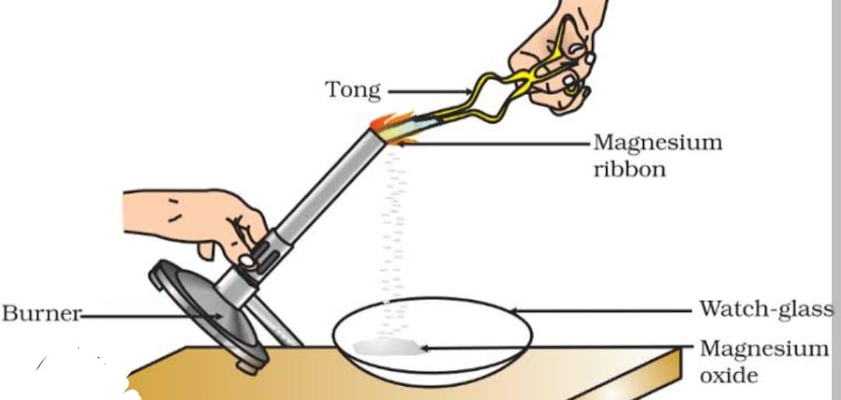  - Before burning a Magnesium ribbon it is rubbed with sandpaper. Why?  - State the type of chemical reaction.  - Write the balanced chemical equation for this chemical change.  - What will happen if water is added to the product of this reaction? | 4
37 | Question No. i) to v) consist of two statements – Assertion (A) and Reason (R). Answer these questions selecting the appropriate option given below:  (a) Both A and R are true and R is the correct explanation of the Assertion.  (b) Both A and R are true but R is not the correct explanation of the Assertion.  (c) A is true but R is false.  (d) A is false but R is true.  (e)Both the statements are wrong.  i)Assertion (A) : When HCl is added to zinc granules, a chemical reaction occurs.  Reason (R) : Evolution of a gas and change in colour indicate that the chemical reaction is taking place.  ii) Assertion (A) : Calcium carbonate when heated gives calcium oxide and water.  Reason (R) : On heating calcium carbonate, decomposition reaction takes place.  iii) Assertion (A) : Brown fumes are produced when lead nitrate is heated.  Reason (R) : Nitrogen dioxide gas is produced as a by product due to the decomposition of lead nitrate.  iv) Assertion (A): Pungent smelling gas is produced when sulphur burns in air.  Reason (R) : Sulphur trioxide is formed on reaction of sulphur with oxygen.  v)Assertion (A) : In a reaction of copper with oxygen, copper serves as a reducing agent.  Reason (R) : The substance which gains oxygen in a chemical reaction acts as a reducing agent | 5
38 | A student performed the experiment of heating ferrous sulphate crystals in a boiling tube. He smelt fumes of a pungent gas and saw colour of ferrous sulphate disappears.  (i)Name the gases produced during heating.  (ii)Write the balanced chemical equation.  (iii)State the colour of Ferrous Sulphate crystals both before heating and after heating.  (iv)Why does the colour of crystal disappear?  (v)Identify the nature of this chemical reaction. | 5
Answer – Chapter 1
Q | Answers
1 | (B)a gas evolved which burnt with a pop sound
2 | (C) CaO
3 | (B) Ag₂S
4 | (A) Both A and R are true and R is the correct explanation of the Assertion.
5 | (A) AgCl
6 | (D) CuCO₃
7 | (B) CuO
8 | (C) both (a) & (b)
9 | (D) all the above
10 | (B) It is precipitation reaction
11 | Water should be in the form of steam not liquid.
12 | An element.
13 | a) The copper strip remained as it was.
14 | d) All the three
15 | a) 4
16 | a) 1 minute
17 | d) ii and iii
18 | b)Mg + N₂--🡪 Mg₃N₂
19 | Pure water is a bad conductor of electricity as it does not have sufficient amount of ions i.e, charge carriers.
20 | (a)The ratio of the number of moles produced of the two substances.
21 | a) Fe₂O₃ + 2Al → 2 Fe + Al₂O₃  _{b)} 2Pb (NO₃)₂ → 2PbO + 4NO₂ +O₂
22 | a)Brown fume is nitrogen dioxide and write its molecular formulais NO₂.  b)Lead oxide (PbO)
23 | a) The gas will burn itself by making a pop sound.  b) Zn + H₂SO₄ ZnSO₄ + H₂
24 | No. Because, anyone of the products must be insoluble in water so that a precipitate can be formed.
25 | Carbon dioxide gas is evolved.  CaCO₃ + 2HCl ---🡪 CaCl₂ + H₂O + CO₂
26 | Y.  Rusting is a surface phenomenon.
27 | i) In water Hydrogen and Oxygen are present in the ratio 2:1 according to their volume. So during electrolysis of water the amount of hydrogen is produced is double than the amount of oxygen.  ii)Water is poor conductor of electricity. To make it good conductor few drops of dil. Sulphuric acid is added to it.  iii)It is decomposition reaction.
28 | a) It is decomposition reaction.  b) It is displacement reaction.  c) It is double displacement reaction.
29 | a)H₂ + N₂ 2NH₃  b)2H₂S + 3O₂ 2H₂O + 2SO₂  c)2K + 2H₂O 2KOH + H₂
30 | Corrosion.  Black coating due to formation of Ag₂S.  Green coating is due to formation of CuCO₃. Cu(OH)₂ .
31 | (a) Silver Chloride AgCl  (b) 2AgCl-^{sunlight}--🡪2Ag (s) + Cl₂  (c) Black and white photography
32 | (a) NO (b) Yes (c) Yes
33 | a)BaCl₂ and Na₂SO₄  b) The solution changes to white colour.  c) ) It is double displacement reaction.  d) The precipitate produce in this reaction is barium sulphate.
34 | a)A black colour coating created around the copper.  b) It is redox reaction.  c)2Cu + O₂ 2CuO  d) Prateek can get back the shiny brown copper again by passing hot hydrogen gas over this black compound.
35 | (a)2Cu(NO₃)₂ (s) ---heat------🡪 2CuO(s) + 4NO₂ (g) + O₂(g)  (b) X= NO₂  (c) Decomposition reaction  (d) 0-7
36 | (a) Because, to remove the coating of basic Magnesium oxide .  (b) Combination reaction  (c) 2Mg + O₂ ----🡪 2MgO  (d)Magnesium Hydroxide is formed.
37 | i)(a) Both A and R are true and R is the correct explanation of the Assertion.  ii)(d) A is false but R is true.  iii)a) Both A and R are true and R is the correct explanation of the Assertion.  iv)(c) A is true but R is false.  v) (a) Both A and R are true and R is the correct explanation of the Assertion.
38 | (a) SO₂ and SO₃  (b) 2FeSO₄ ---Heat--🡪 Fe₂O₃ + SO₂ + SO₃  (c) Before heating – Pale green , After heating – White  (d) On heating water in the crystal evaporates.  (e) Thermal decomposition reaction

Chapter-2 Acids, Bases, and Salts
1 | Sodium hydroxide is an ionic compound cannot conduct electricity but when it added to water it conducts electricity why?  a. ions are in free state in solid  b. ions are free in aqueous solution  c. ionic compound never conducts electricity  d. ionic compound always conducts electricity | 1
2 | Bleaching powder is prepared by mixing two substance X and Y  Which of the following is the correct pair of X and Y  a. X- calcium oxide and Y-chlorine  b. X- calcium hydroxide, Y-Oxygen  c-X -Calcium hydroxide Y- Chlorine  d- X-Calcium oxide Y- Oxygen | 1
3 | When soap is added to turmeric the color of turmeric changes to red this indicates that  a. turmeric when added to acid changes to red  b. turmeric when added to base changes to red  c. turmeric reacts with both acids and bases  d. turmeric neither reacts with acid nor with bases | 1
4 | A solution of pH 5 is filled in one beaker and another of pH 9 in another beaker. A few drops of methyl orange added to both how the color changes  a) it will become red in both  b) it will become yellow in both  c) it will become red in beaker 1 and yellow in beaker 2  d) it will become yellow in beaker 1 and red in beaker 2 | 1
5 | When acid reacts with metal carbonate then a gas is released which makes the lime water milky what is the gas released  a. Hydrogen  b. oxygen  c. nitrogen  d. Carbon dioxide | 1
6 | If we will test the pH of blood then it will come in which of the color ranges of the pH scale  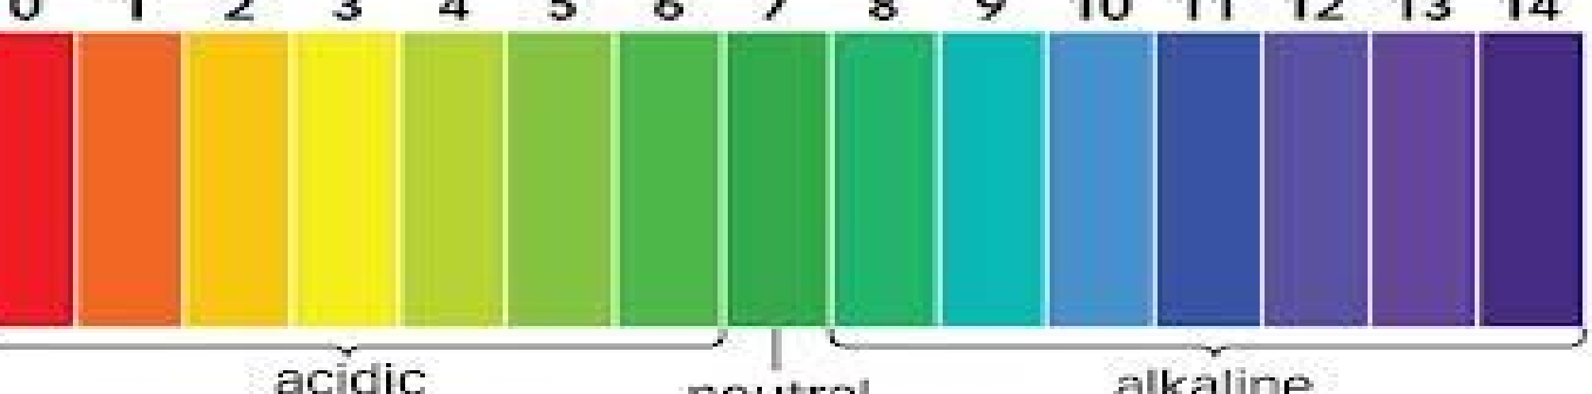  a. Red b. Yellow C. green d.Orange | 1
7 | When dilute hydrochloric acid is added to a solid X, a gas Y is formed along with the formation of  the salt of the solid. What could be X and Y?  a) X: zinc; Y: oxygen  b) X: zinc; Y: hydrogen  c) X: copper; Y: oxygen  d) X: carbon; Y: hydrogen | 1
8 | When hydrochloric acid having pH less than 7 reacts with sodium hydroxide having pH more than 7 then sodium chloride will be formed with the removal of water.  What will be the pH of the salt  a. more than 7 b. less than 7  c. equal to 7 d .can not be determined | 1
9 | 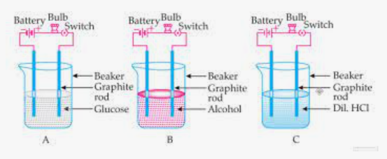  Suhana takes three beakers, A, B and C and adds aqueous solutions of glucose, alcohol and dil HCl, respectively in each beaker, as shown in the setup above. In which beaker the bulb will not glow  a)A and C b)B and C c)A and B d) All the three beakers. | 1
10 | Anita put a drop each of dil. Acetic acid and dil. HCl acid on pH paper and compared the colors of both respectively. The correct Observation of color by Anita will be  a) Light yellow and Red b) Red and Orange  c) pink and orange d) Red and Pink | 1
11 | 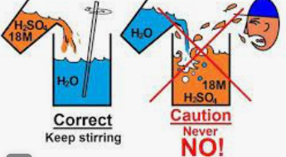  The figure here shows an important process. Which of the following process does it exhibit?  a) Hydration b) Neutralization  c) Dehydration d) Dilution. | 1
12 | Few drops of NH₄Cl Sol. Was put on Universal indicator paper and it’s color changed to pink. Study the following table and choose the correct option.  NH₄Cl is a Salt of: | 1
  options | Nature | Acid and Base Strength | pH range
  a) | Acidic | Weak acid and Strong base | < 7
  b) | Basic | Weak acid strong base | >7
  c) | Acidic | Strong acid and weak base | < 7
  d) | Basic | Strong acid and strong base | 7
13 | Which of the following are present in a dilute aqueous solution of hydrochloric acid?  a) H₃O⁺ + Cl⁻ b) H₃O⁺ + OH⁻  c) HCl + OH⁻ d) Cl⁻ + OH⁻ | 1
14 | 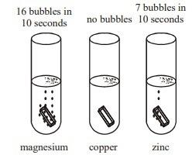  Study the figure given alongside and choose the correct statement from the following.  a) Cu is more reactive than Mg and Zn  b) Zn is more reactive than Cu and Mg  c) Mg is more reactive than Zn and Cu  d) All the three metals have the same reactivity. | 1
15 | During electrolysis of brine, a gas ‘P’ is liberated at anode and another gas ‘Q’ is liberated at cathode. ‘P’ is used for disinfecting water while ‘Q’  is used in aviation fuels. The correct identification of ‘P’ and ‘Q’ irrespectively is:  a) Cl₂ and H₂ b) H₂ and O₂  c) H₂ and Cl₂ d) O₂ and H₂ | 1
16 | A compound X of sodium is used in Soda acid fire extinguisher. This compound can also be used,  - in removing permanent hardness of water.  - as an antacid  - as a cleaning agent  - In the manufacturing of soap. | 1
17 | Assertion: Ammonium Hydroxide is a weak base.  Reason: Phenolphthalein becomes pink when added to ammonium hydroxide. | 1
18 | Assertion: All metal carbonates react with acids to give salt, water and carbon dioxide.  Reason: All metal oxides react with water to give salt and acid. | 1
19 | Equal volumes of hydrochloric acid and sodium hydroxide solutions of same concentration are mixed and the pH of the resulting solution be checked with a pH paper. What would be the colour obtained?  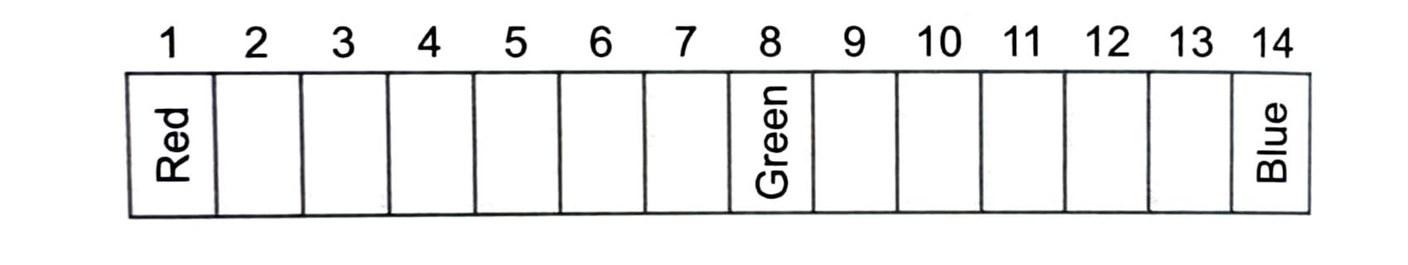  a. Red. b. Yellow  c. Yellowish green. d. Blue | 1
20 | Assertion: Ammonium hydroxide is weak base.  Reason: Phenolphthalein becomes pink in NH4OH  (a) Both the Assertion and the Reason are correct and the Reason is the correct explanation of the Assertion.  (b) Both the Assertion and the Reason are correct but the Reason is not the correct explanation of the Assertion.  (c) Assertion is true but the reason is false  (d) Assertion is false but the reason is true | 1
21 | 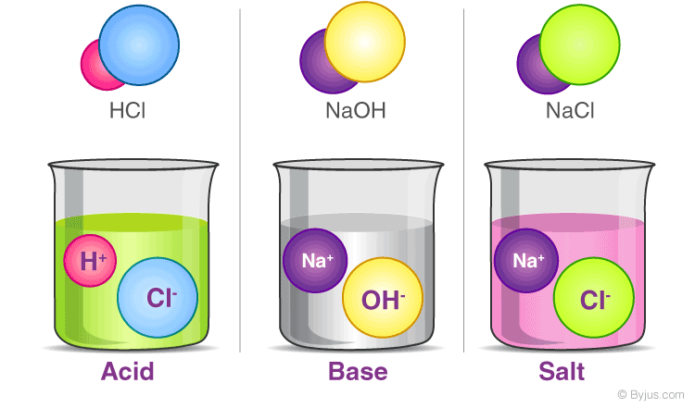  Which of the following statements can be concluded from this picture.  (I) Acid, Base and Salt are ionic compounds  (ii) Due to this they can conduct electricity.  (iii) Acid and Base Reacts to form salt.  (a) Only (i) and (ii)  (b) Only (i)  (c) Only (ii) and (iii)  (d) All (i), (ii) and (iii) | 1
22 | 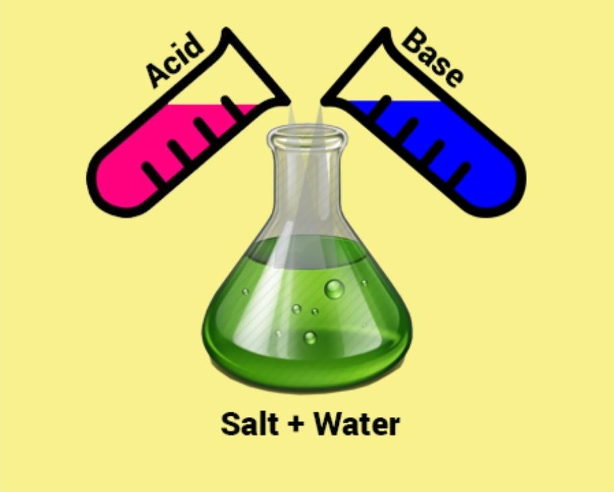  Identify the type of reaction occurs here  (i) Neutralization reaction  (ii) Exothermic reaction  (iii) Redox reaction  (iv) Double displacement reaction  (a) Only (i), (ii) and (iii)  (b) Only (i) and (iv)  (c) Only (i), (ii) and (iv)  (d) Only (i) | 1
23 | 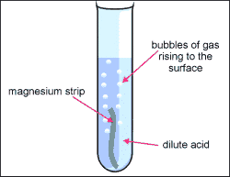  To identify the evolved gas Anil brought one burning match stick near the face of test tube. What he might have observed and concluded.  (a) Matchstick extinguished due to formation of carbon dioxide.  (b) Matchstick burnt with pop sound due to production of hydrogen gas.  (c) Matchstick extinguished due to formation of chlorine.  (d) Matchstick burnt with pop sound due to the formation of carbon dioxide. | 1
24 | What is the pH value of a salt formed by a weak acid and a strong base?  (a) Greater than 7. (b) equal to 7  (c) Less than 7. (d) between 0 to 14 | 1
25 | A solution has pH 4. It is diluted by adding it with water. How will it affect the pH of the solution?  (a) The pH will increase  (b) The pH will decrease  (c) There will be no change in the pH.  (d) It can't be said | 1
26 | A few drops of phenolphthalein indicator were added to an unknown solution A. It Acquired pink colour. Now another unknown solution B was added to it drop by Drop and the solution becomes colorless. Predict the nature of A & B.  (a) A- Acid, B- base  (b) A- Base, B- acid  (c) A- Acid, B- Salt  (d) A- Base, B- Salt | 1
27 | 1.From the taste of different food items foods can be classified as acid and base . students are asked to prepare a list of acidic food item . a student prepared the following list . which of the following is not correct for acidic food item list  A. Amla b. orange c. apple d. banana  2. Tomato contains which of the following acids?  a. citric acid b. Lactic acid c. Oxalic acid d. acetic acid | 2
28 | Explain with respect to pH change for the following  a) formation of acid rain  b) cause of tooth decay. | 2
29 | 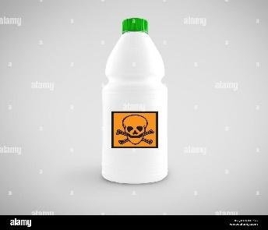  (i)Observe the caution mark shown in the container and account for the significance of it.  (ii)Why can acids be not stored in metal containers? | 2
30 | 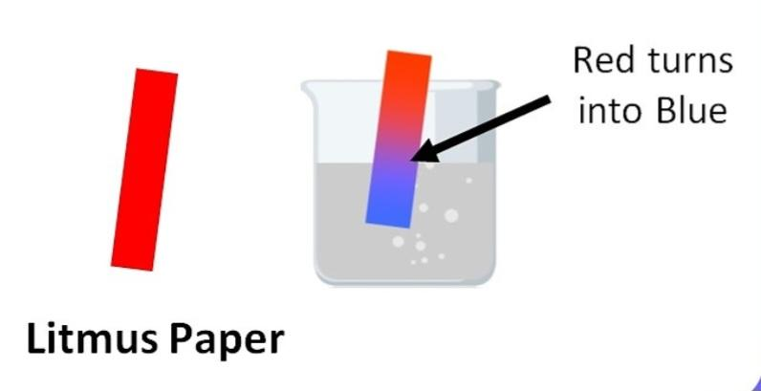  (i) Which of the following liquid may the beaker contain?  a. Vinegar. b. Soft drink  c. Salt water. d. Baking soda solution  (ii) What can be the pH range of the solution?  a. 0 to 7. b. 7.  c. 7 to 14. d. Can't be said | 2
31 | A first aid manual suggests that vinegar should be used to treat wasp sting and baking soda for bee stings.  (i) What does this information tell you about the chemical nature of the wasp stings  (ii) If there were no baking soda in the house, what other household substance could you use to treat bee stings? | 2
32 | 1 g of solid sodium chloride is taken in a clean, dry test tube and 2mL of conc. Sulphuric acid is added is added to it. If the gas evolved is first tested with dry litmus paper and then with wet litmus paper  - In which case will the litmus paper change its colour?  - Give reason for your answer above?  - What conclusion can be drawn about the nature of the gas evolved? | 3
33 | What pH do you expect for the following salt solutions and why?  KCl, CuSO₄, Na₂CO_{3.} | 3
34 | 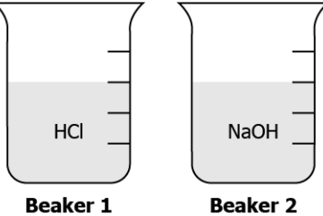  A student placed 10 mL each of HCl and NaOH in two separate beakers as shown. In beaker 1, 4 mL of NaOH is added whereas in beaker 2, 4 mL of HCl is added.  a) Explain giving reason, how will the pH in both the beaker, change?  b) Write the chemical equation of the reaction between the two compounds. | 3
35 | Observe the graph drawn between concentration of H₃O⁺ vs pH. Observe the graph carefully and answer the questions that follow:  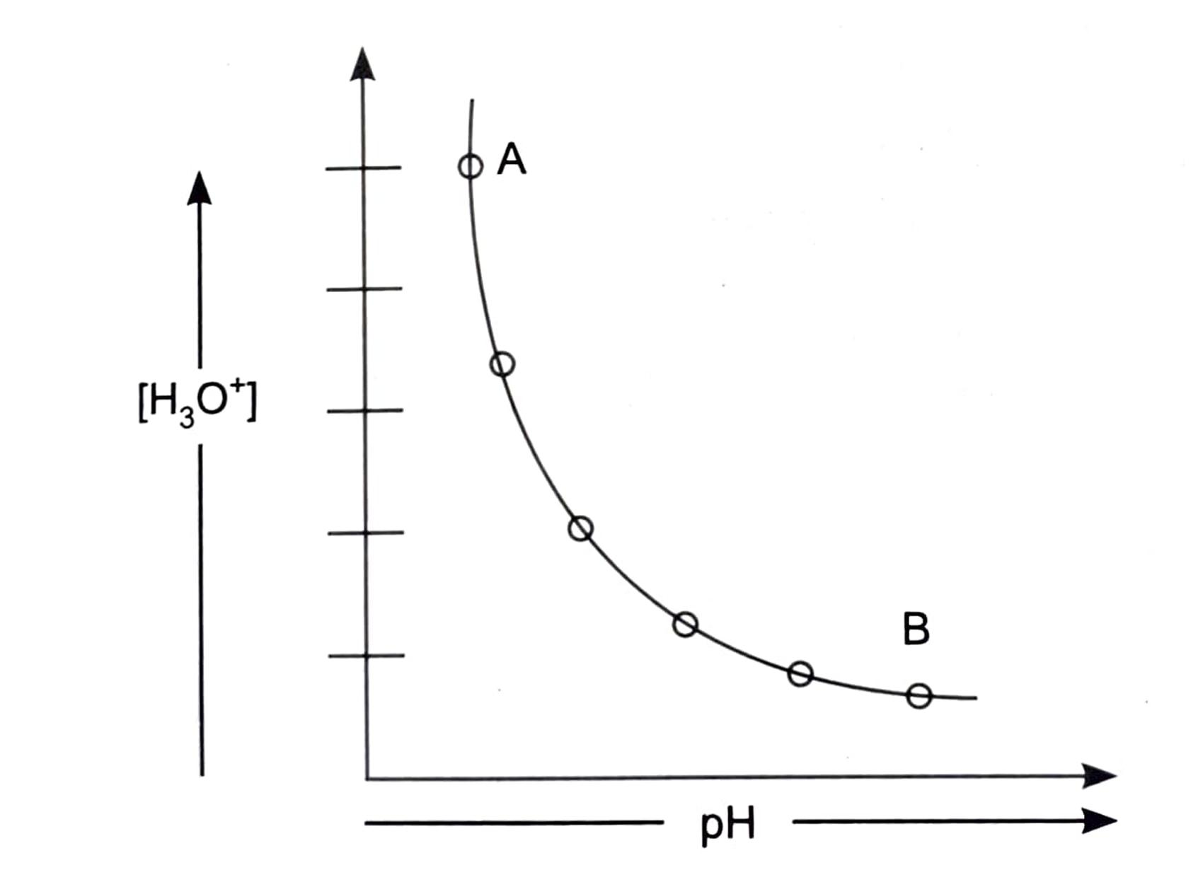  (a) The graph shows  (i) Concentration of H₃O⁺ increases, pH  of solution decreases.  (ii) Concentration of H₃O⁺ decreases, pH  of solution increases.  (iii) Concentration of H₃O⁺ and pH both  decreases.  (iv) Concentration of H₃O⁺ and pH both  increases.  (b) 'A' is  (i) Strongly acidic. (ii) Strongly basic  (iii) Weakly acidic. (iv) Weakly basic  (c) 'B' is  (i) Strongly acidic. (ii) Strongly basic  (iii) Weakly acidic. (iv) Weakly basic | 3
36 | The pH values of everyday chemicals typically range from pH 0 to pH 14. Values between 0 and 7 indicate an acidic solution. Values between 7 and 14 indicate a basic solution. A pH of exactly 7 indicates that a solution is neutral, neither acidic or basic. Pure water is usually pH 7.  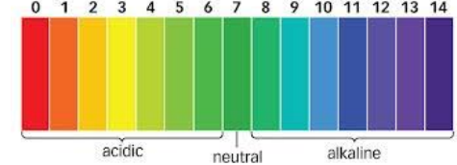  Turmeric is another natural indicator of pH.  [i] What happens to turmeric stains on clothes when washed with soap? Why? (1)  [ii]Milk of Magnesia which is used to treat acidity is basic in nature and hence is able to neutralise the excessive acid in the stomach. Which appropriate pH value will it show?  - 2 b) 6 c) 14 d) 10  [iii] Does a solution with pH 10 have equal, less or more H⁺ions than of a solution with a pH 6? (1)  [iv]What will be the [H⁺] for both solutions, include units in your answer:  - For pH 10, [H+] = _________________  For pH 6, [H+] = _________________ (1) | 4
37 | Radhika wanted to bake a cake for her mother's birthday. She added baking soda in the batter. But when she tasted the cake after the baking it tasted bitter.  (a) Explain why the cake tasted bitter with the reaction.  (b) Write one step by which Radhika could have made her cake better.  (c) Her mother suggested her to add baking powder instead. Why the baking powder doesn't make the taste of the cake bitter.  (d) Baking soda is a/an  i. acid. ii. Base. iii. Acidic salt. iv. Basic salt | 4
38 | 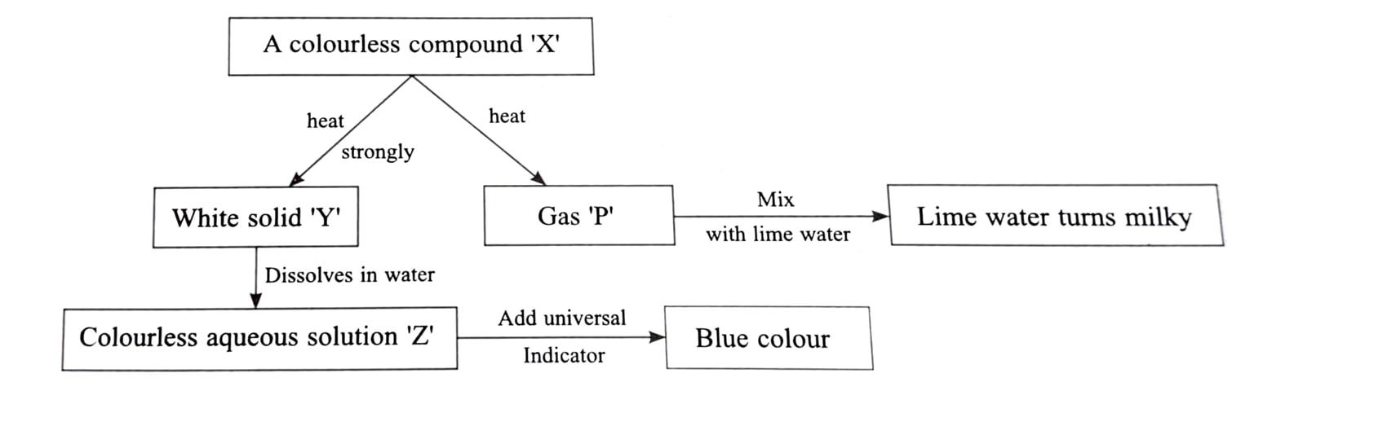  (a) Identify the compounds X and Y ?  (b) Write the reaction for X breaking into Y and P.  (c) Name an acid which can liberate P from X?  (d) Write reaction of lime water with P and identify the type of reaction. | 5

Answers Chapter-2 Acids, bases and salts
Q | Answers
1 | B
2 | C
3 | B
4 | C
5 | D
6 | C
7 | B
8 | C
9 | C)
10 | A)
11 | D)
12 | C)
13 | A)
14 | C)
15 | A)
16 | B)
17 | B)
18 | C)
19 | c. Yellowish green (NaCl is a neutral salt)
20 | Option B (Both the Assertion and the Reason are correct but the Reason is not the correct explanation of the Assertion.)
21 | (a) Only (i) and (ii)
22 | (c) Only (i), (ii) and (iv)
23 | (b) Matchstick burnt with pop sound due to production of hydrogen gas.
24 | (a) Greater than 7
25 | (a) The pH will increase
26 | (b) A- Base, B- acid
27 | i. D ii. C
28 | a) Acid rain occurs when the pH of rain water falls below 5.6  b) Tooth decay begins when the pH in the mouth falls below 5.5
29 | i)As acids are corrosive, the label cautions to use the acids carefully or else it might be dangerous.  ii) Because Acids react with metals, and so the metal container will not be able to hold it.
30 | (i) d. Baking soda solution, (ii) c. 7 to 14.
31 | (a) Basic because vinegar(acid) is being used to neutralise it  (b) Ammonium hydroxide (NH4OH) can be used.
32 | a) With wet litmus paper  b) When the Dry HCl gas dissolves in the moist litmus paper, it will ionize to form H⁺ ions.  c) It is acidic in nature.
33 | KCl—pH is 7, Neutral salt. CuSO₄ --- pH less than 7, Acidic salt. Na₂CO₃ – pH more than 7,Basic salt
34 | a) Beaker 1- pH will increase, due to decrease of H⁺ ion conc. per unit volume.  b) Beaker 2- pH will decrease, due to increase in H⁺ ion conc. per unit volume.  HCl + NaOH --------🡪 NaCl + H₂O
35 | (a) (ii) Concentration of H3O+ decreases, pH  of solution increases.  (b) (i) Strongly acidic.  (c) (ii) Strongly basic
36 | i] Turmeric Stains turn red. Soap contains base, and bases change the color of turmeric to red.  ii] option d) 10  iii] H+ ions will be less,  iv] For pH 10 ,[ H⁺]=10⁻¹⁰mol/L , For pH 6, [ H⁺]=10⁻⁶mol/L
37 | (a) 2 NaHCO₃ ---------> Na₂CO₃ + H₂O + CO₂  Formation of sodium carbonate makes the taste bitter.  (b) By adding some acid like cream tartar or vinegar into it as it will neutralise the basisity of baking soda.  (c) Because baking powder already has an acid named tartaric acid.  (d) iv. Basic salt
38 | (a) X- Calcium carbonate (CaCO₃). Y- Calcium oxide (CaO)  (b) CaCO₃. ----------->CaO + CO₂  (c) Hydrochloric acid (HCl)  (d)Ca(OH)₂ + CO₂ -------------> CaCO₃ + H₂O, Redox/Exothermic/Neutralization/precipitation reaction

Chapter-3 Metals and Non-metals
1 | Steel is an alloy of iron and carbon with improved strength and fracture resistance compared to other forms of iron. Many other elements may be present or added. Stainless steels, which are resistant to corrosion and oxidation, typically need an additional 11% chromium. Because of its high tensile strength and low cost, steel is used in buildings, infrastructure, tools, ships, trains, cars, bicycles, machines, electrical appliances, furniture, and weapons. Generally, alloys are a homogeneous mixture of a metal with a metal or nonmetal. Which among the following alloys contain non-metal?  - Amalgam  - Bronze  - Steel  - Brass | 1
2 | Given bellow are images of gold ore and iron ore. Explain why gold ore is looking very similar to pure gold but iron ores do not.  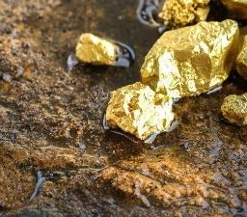  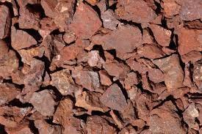 | 1
3 | The electronic configuration of sodium ion is  (A) 2,8,8  (B) 2,8,2.  (C) 2,6  (D) 2,8. | 1
4 | An element is a pure substance made up of same kind of atoms. At present, nearly 118 elements are known but all of them do not occur free in nature, some of them have been synthesized by artificial methods. Based on their properties, they are mainly classified as metals and non-metals. Metals are those elements which lose electrons and form positive ions i.e., they are electropositive in nature. They are generally hard, good conductors of heat and electricity, malleable, ductile and have striking lustre. They have a significant role to play in our daily life. Metals which are of vital importance to the national defense, energy and industry sector are called strategic metals.  Which of the following is a strategic metal?  (A) Titanium  (B) Zirconium  (C) Manganese  (D) All of these | 1
5 | An element is a pure substance made up of same kind of atoms. At present, nearly 118 elements are known but all of them do not occur free in nature, some of them have been synthesized by artificial methods. Based on their properties, they are mainly classified as metals and non-metals. Metals are those elements which lose electrons and form positive ions i.e., they are electropositive in nature. They are generally hard, good conductors of heat and electricity, malleable, ductile and have striking lustre. They have a significant role to play in our daily life. Metals which are of vital importance to the national defence, energy and industry sector are called strategic metals.  Identify the correct statement(s).  - (I) The wires that carry current in our homes have a coating of PVC or a rubber like material.  (II) School bells are made of metals.  (III) Metals do not conduct electricity.  (IV) Metals which produce a sound on striking a hard surface are said to be non-sonorous.  (A) (I) and (III)  (B) (I) and (II)  (C) (III) and (IV)  (D) Only (II) | 1
6 | Which one of the following figures describes electrolytic refining:  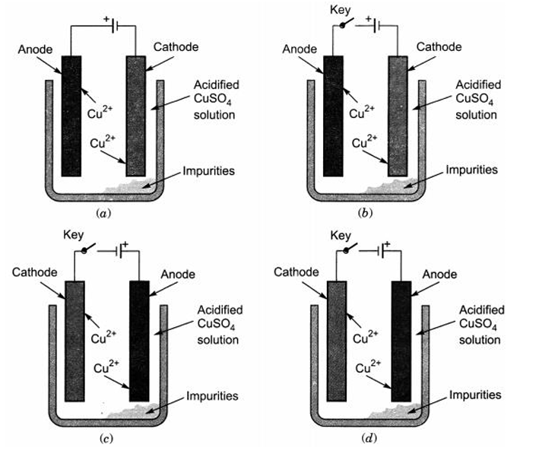 | 1
7 | Element X reacts with element Y to form a compound Z. During the formation of compound Z, atoms of X lose one electron each whereas atoms of Y gain one electron each. Which of the following properties is not shown by compound Z?  A. High melting point  B. Low melting point  C. Occurrence as solid  D. Conduction of electricity in molten state | 1
8 | A cable manufacturing unit tested few elements on the basis of their physical properties  Among the above elements, the company would discard the elements for making cables  - W, X,Y B) X,Y,Z C)W,X,Z D)W,Y,Z | 1
  Properties | W | X | Y | Z
  Malleable | Yes | No | No | No
  Ductile | Yes | NO | No | Yes
  Electrical conductivity | Yes | Yes | Yes | No
  Melting Point | High | Low | Low | High
9 | The diagram shows the reaction between metal and dilute acid  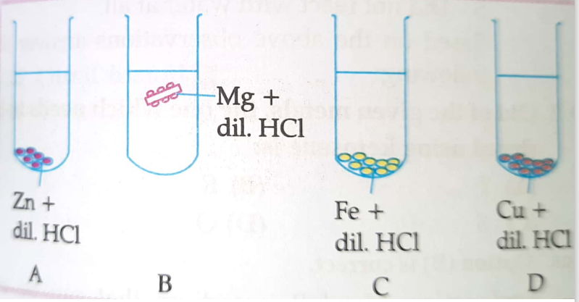  What is the reason for different behaviour of Mg in test tube B  a)Mg is lighter element than dil. HCl  b) Mg reacts with dil. HCl to produce N₂ gas, which helps in floating  c)Mg reacts with dil. HCl to produce H₂ gas , which helps in floating  d) Mg reacts with dil. HCl to produce CO₂ gas , which helps in floating | 1
10 | A student adds some metallic ash in water taken in a test tube. The ash gets completely dissolved in water and the solution changes colour. What should the student do to test the chemical properties of the product formed?  a)Test the acidity using blue litmus paper  b) Evaporate the solution to get crystals.  c)Measure the temperature change using a thermometer.  d) Test the basicity by using red litmus paper. | 1
11 | The list of metals in the metal reactivity series is given below. In this series along with metal hydrogen is also placed which is a non metal. The correct reason for placing hydrogen in the series is  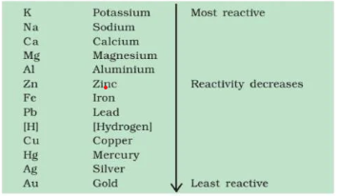  a)It is a lighter gas  b)It shows the behaviour of electropositive elements to form H⁺ ion  c)It is a non reactive element  d)It is very reactive element | 1
12 | The correct statement about the reaction  ZnO + C → Zn+CO is  a)ZnO is being oxidized  b) COis being oxidized  c) ZnO is being reduced  d)Zn is being oxidised | 1
13 | 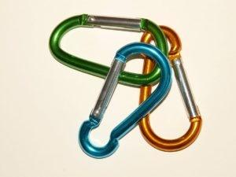  Anodising is an electrolytic process for producing thick oxide coatings, usually on aluminium and its alloys. The oxide layer is typically 5 to 30µm in thickness and is used to give improved surface resistance to wear and corrosion, or as a decorative layer. If H₂SO₄ solutionis used as electrolyte then answer the following.  I. The aluminium is placed at which electrode during electrolysis.  A. Cathode  B. Anode  C. It can be placed at both electrodes  D. Not as electrode  II. Why gold and silvers are not coloured or anodized?  - Expensive to colour or anodize  - These are very brittle so can brake during the process  - The keep the beauty of the metal surface  - Are least reactive metals | 2
14 | Suggest the possible reason behind formation of sodium hydroxide and only aluminium oxide when both sodium and aluminium react with water. | 2
15 | Waheeda dissolved some common salts in the given experimental set up and found that the bulb is glowing while she performed same experiment by taking the solid common salts, she marked that the bulb is not glowing.  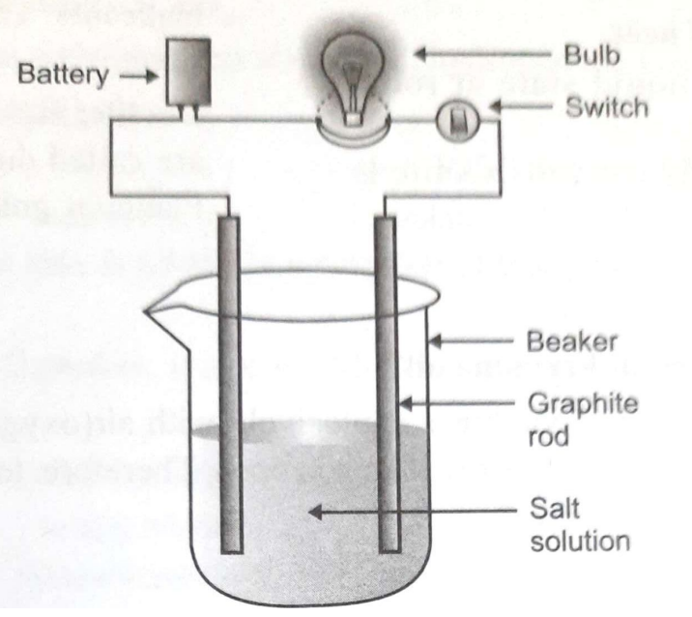  Analyse both the experiments and mention the reason for difference in results. | 2
16 | Riya a student of class 10 was given sample of Mg, Zn, Fe, and Cu and dilute  HCl and Dilute HNO₃. She put each sample of metals in the test tube containing dilute HCl and Dilute HNO₃ separately. Basing on her observation she had drawn the following observation.  1-Bubbles are formed when Mg is put in the test tube containing dilute HNO₃  2-Bubble are seen when Zn is put in the test tube containing dilute HCl.  3- Bubbles are released from the test tube when Cu metal is put in the test tube containing dilute HCl.  4- Bubbles are formed when Fe is put in the test tube containing dilute HNO₃  Analyse the inferences drawn by Riya and identify the incorrect statements. | 2
17 | An element A burns with golden flame in the air. It reacts with another element B, atomic number 17, to give a product C. An aqueous solution of product C on electrolysis gives a compound D and liberates hydrogen. Identify A, B, C and D. Also, write down the equations for the reactions involved. | 3
18 | When a metal X is treated with cold water, it gives a basic salt Y with the molecular formula XOH (Molecular mass = 40) and liberates a gas Z which easily catches fire. Identify X, Y and Z and also write the reaction involved. | 3
19 | Ionic compound is a chemical compound in which ions are held together by ionic bonds. An ionic bond is the type of chemical bond in which two oppositely charged ions are held through electrostatic forces. We know that, metal atoms have loosely bound valence electrons in their valence shell and non-metal atoms need electrons in their valence shell to attain noble gas configuration. The metal atom loses the valence electrons while non-metal atom accepts these electrons. By losing electrons, metal atoms change to cations and by accepting electrons, non-metals form anions. Ionic compounds are generally solid and exist in the form of crystal. They have high melting and boiling points.  Why we cannot melt salt by heating over gas flame but make syrup easily by melting sugar. Write the chemical name and draw the electron dot structure of common salt.
20 | The reaction of metallic oxides of zinc, magnesium and copper with the following metals are given below  Complete the above table by writing YES in the cases the displacement reactions taking place | 3
  Metal | Zinc | Magnesium | Copper
  Zinc oxide
  Magnesium oxide
  Copper oxide
21 | A teacher asks students to identify a metal, M.She gives them the following clues to help them.  I)Its oxide reacts with both HCl and NaOH.  II)It does not react with hot or cold water but reacts with steam.  III)It can be extracted by electrolysis of its ore.  Basing on the clues  - Identify the metal M.  - List the chemical equations of the reaction of the oxide of the metal M with HCl and NaOH.  - Mention the type of oxide into which the oxide of metal M can be categorized. | 3
22 | A non-metal A, the largest constituent of air, when heated with H2 in a 1:3 ratio in the presence of a catalyst (Fe), gives a gas B. On heating with O2, it gives an oxide C. If this oxide is passed into the water in the presence of air, it gives an acid D which acts as a strong oxidising agent.  (a) Identify A, B, C, and D  (b) To which group of periodic tables does this non-metal belong? | 4
23 | A metal ‘M’ is stored under kerosene . It vigorously catches fire, if small piece of this metal is kept open in air. Dissolution of this metal in water releases great amount of energy and the metal catches fire. The solution so formed turns red litmus to blue.  a)Name the metal.  b)Why is metal ‘M’ stored under kerosene?  c)Write the formula of the compound formed when this metal is exposed to air. Show the formation of this compound by transfer of electron.  d) If the hydroxide of this metal reacts with hydrochloric acid what would be the products formed? Give a name to this type of reaction | 5

Answers Chapter-3 Metals and Non-metals
Q | Answers
1 | (C)) STEEL
2 | Gold is the least reactive among all the metals due to which it is found in almost pure form but due to reactive nature of iron ores are found in the form of iron oxides, sand and clay referred to as gangue.
3 | (D) 2,8
4 | (D) All of these
5 | (B) (I) and (II)
6 | figure a
7 | B. Low melting point
8 | B
9 | C
10 | D
11 | B
12 | C
13 | . I. B. Anode, II. D. Are least reactive metals
14 | Sodium is more reactive than aluminium and when put in water forms sodium oxide which further dissolves in water to give sodium hydroxide solution whereas aluminium reacts with oxygen to form aluminium oxide which further do not dissolve in water
15 | Ionic compound does not conduct electricity in solid state but they do so in fused state as in fused state free ions are available
16 | Statements 3 and 4 are incorrect
17 | Sodium is more reactive than aluminium and when put in water forms sodium oxide which further dissolves in water to give sodium hydroxide solution whereas aluminium reacts with oxygen to form aluminium oxide which further do not dissolve in water
18 | Element A is sodium metal (Na) as it burns with a golden flame.  Element B with atomic number 17 is chlorine (Cl).  Sodium and chlorine combine to form sodium chloride, NaCl(compound C).  We can write the reaction as  2 Na + Cl₂ → 2 NaCl.  An aqueous solution of NaCl on electrolysis gives the compound D, sodium hydroxide(NaOH). We can write the reaction as  2 NaCl (aq) + 2 H₂O (l) → 2 NaOH (aq) + Cl₂ (g) + H₂ (g)
19 | X is Na because the molecular mass of NaOH is 40.  Na (23) + O (16) → NaOH (40)  Hence,  - X is Sodium.  - Y is Sodium hydroxide.  - Z is hydrogen, which catches fire when it reacts with water.  2 Na + 2 H₂O → 2 NaOH + H₂.  Here oxygen is losing hydrogens, so it is oxidised. The Na has gained oxygen, so it is reduced. Therefore, it is a redox reaction and an H₂ displacement reaction. Redox reactions are reactions in which one species is reduced and another is oxidised. Consequently, the oxidation state of the species involved must change.
20
  Metal | Zinc | Magnesium | Copper
  Zinc oxide | No | Yes | No
  Magnesium oxide | No | No | No
  Copper oxide | Yes | Yes | NO
21 | - Metal M is Aluminium  - Al₂O₃+6HCl→2AlCl₃ +3H₂O  Al₂O₃+2NaOH→2NaAlO₂ +H₂O  - Amphoteric oxide
22 | (a) A is nitrogen; because nitrogen is the largest constituent of air. B is ammonia, C is nitrogen dioxide, and D is nitric acid (a potent oxidising agent).  When nitrogen is heated with hydrogen in the presence of a catalyst, the following reaction occurs.  N₂ + 3 H₂ → 2 NH₃.  When nitrogen is heated with oxygen, we get nitrogen dioxide.  N₂ + 2 O₂ → 2 NO₂  When nitrogen dioxide is treated with water, we get nitric acid.  NO₂ + H₂O → HNO₃  (b) This non-metal belongs to Group 15.
23 | - Na  - Sodium metal is highly reactive element and it can catch fire on exposure to moisture.  - Na₂O  - 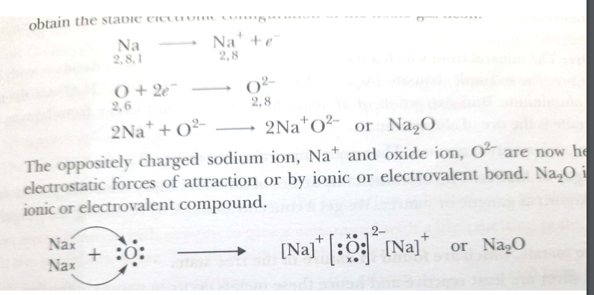  The product formed would be NaCl , the type of reaction is Neutralization Reaction

Chapter-4 Carbon Compounds
1 | Substance 'X' is a moderate conductor of electricity. The structure of substance 'X' is as shown below:  Which statements about substance 'X' are correct:  (I) It is covalent compound.  (II) It has a giant molecular structure.  (III) It has the same structure as graphite.  (IV) It has the same structure as diamond.  (a) (I) and (III). (b) (II) and (III). (c) (II) and (IV).  (d) (I), (II) and (IV) | 1
2 | Several factories were pouring their wastes in rivers A and B. Water samples were collected from these two rivers. It was observed that sample collected from river A was acidic while that of river B was basic. The factories located near A and B are  (a) Soaps and detergents factories near A and alcohol distillery near B.  (b) Soaps and detergents factories near B and alcohol distillery near A.  (c) Lead storage battery manufacturing factories near A and soaps and detergents factories near B.  (d) Lead storage battery manufacturing factories near B and soaps and detergents factories near A. | 1
3 | Write the name and structure of a saturated compound in which the carbon atoms are arranged in a ring. Give the number of single bonds present in this compound. | 1
4 | Assertion: Vegetable oils are unsaturated, react with hydrogen in presence of nickel to form vegetable ghee.  Reason: This reaction is saponification.  a) Both (A) and (R) are true and (R) is the correct explanation of the assertion (A).  (b) Both (A) and (R) are true, but (R) is not the correct explanation of the assertion (A).  (c) (A) is true, but (R) is false.  (d) (A) is false, but (R) is true. | 1
6 | Assertion (A) : Ethanoic acid is also known as glacial acetic acid.  Reason (R) : The melting point of pure ethanoic acid is 290 K and hence it often freezes during winters in cold climates.  (a) Both (A) and (R) are true and (R) is the correct explanation of the assertion (A).  (b) Both (A) and (R) are true, but (R) is not the correct explanation of the assertion (A).  (c) (A) is true, but (R) is false.  (d) (A) is false, but (R) is true. | 1
7 | A student studies that acetic acid is a saturated compound. The structure of the compound is  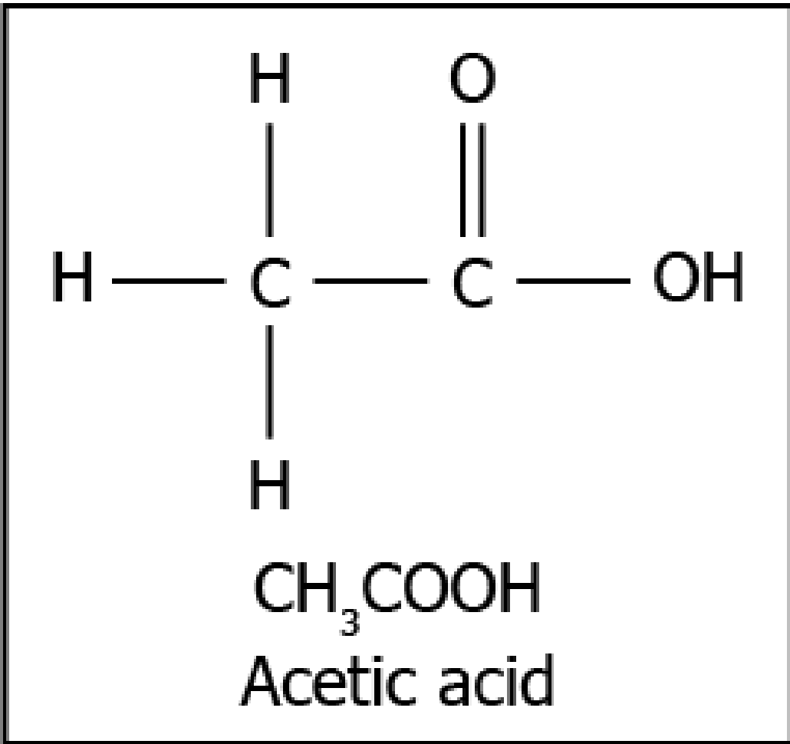  shown.  Why is acetic acid classified as a saturated compound?  a) because there is a the single bond between the carbon atoms  b) because there is a double bond between the carbon and oxygen atoms  c) because there is a single bond between the carbon and hydrogen atoms  d) because there is a single bond between the carbon and hydroxide diatom | 1
8 | The image represents a carbon compound  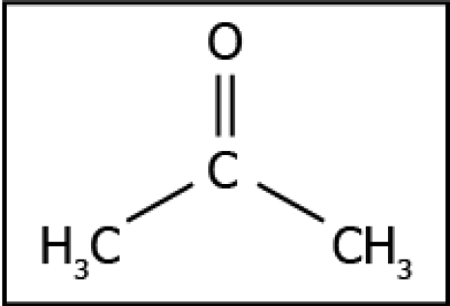  Which functional group is present in the compound?  (a) alcohol  (b) aldehyde  (c) carboxylic acid  (d) ketone | 1
9 | Which of these series can be classified as homologous series?  (a) CHCl3, C2H5OH, C3H7OH  (b) CH3OH, C2H5OH, C3H7OH  (c) CHCl3, C4H9OH, CH3COOH  (d) CH3COOH, C4H9OH, C2H5OH | 1
10 | The image represents the structure of a carbon compound known as ethane.  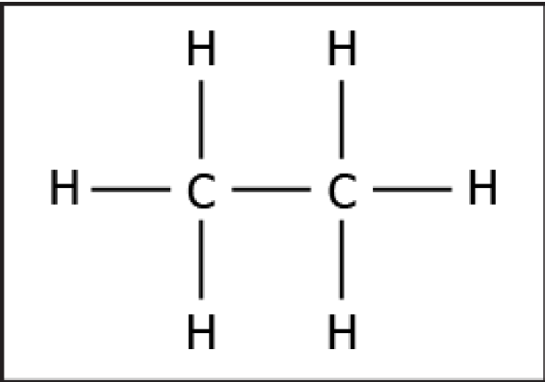  Which option explains the naming of ethane?  (a) the presence of functional group connected with a single bond  (b) as it contains two carbon atoms and a single bond connects the carbon atoms  (c) carbon compound with a total number of eight atoms are named as ethane  (d) as it contains six hydrogen atoms and a single bond connects the carbon and  hydrogen atom. | 1
11 | A student studies that a soap molecule has two ends, one of which is an ionic end and the  other is the carbonic chain. Which option explains the interaction of a soap molecule with oil?  (a) ionic end of the soap interacts with the oil  (b) the closest end of the soap interacts with the oil  (c) carbonic chain end of the soap interacts with the oil  (d) ends of the soap randomly interact with the oil | 1
12 | 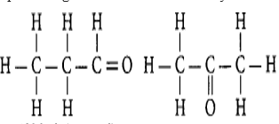  Identify the one compound out of two which has the functional group ketone. | 1
13 | Assertion (A) : Carbon monoxide is extremely poisonous in nature.  Reason (R) : Carbon monoxide is formed by complete combustion of carbon.  a) Both (A) and (R) are true and (R) is the correct explanation of the assertion (A).  (b) Both (A) and (R) are true, but (R) is not the correct explanation of the assertion (A).  (c) (A) is true, but (R) is false.  (d) (A) is false, but (R) is true. | 1
14 | Assertion(A) : Carbon is the only element that can form large number of compounds.  Reason (R) : Carbon is tetravalent and shows the property of catenation.  (a) Both (A) and (R) are true and (R) is the correct explanation of the assertion (A).  (b) Both (A) and (R) are true, but (R) is not the correct explanation of the assertion (A).  (c) (A) is true, but (R) is false.  (d) (A) is false, but (R) is true. | 1
15 | Assertion(A) : If the first member of a homologous series is methanal, its third member will be propanal.  Reason (R) : All the members of a homologous series show similar chemical properties. (a) Both (A) and (R) are true and (R) is the correct explanation of the assertion (A).  (b) Both (A) and (R) are true, but (R) is not the correct explanation of the assertion (A).  (c) (A) is true, but (R) is false.  (d) (A) is false, but (R) is true. | 1
16 | Carbon does not form iconic compounds. Why? | 2
17 | Why no leather formation take place when soap is added to hard water? | 2
18 | Draw the structure of cyclopentane ,also write the number ofcovalentbonds in it. | 2
19 | Give reason for the following :  a)Acetylene burns with a sooty flame  b)Kerosene does not decolourise bromine water while cooking oils do. | 2
20 | (I) Draw the electron-dot structure for ethyne. (II) A mixture of ethyne and oxygen is burnt for welding. In your opinion, why cannot we use a mixture of ethyne and air for this purpose? | 3
21 | On dropping a small piece of sodium in a test tube containing carbon compound ‘X’ with molecular formula C₂H₆O, a brisk effervescence is observed and a gas ‘Y’ is produced. On bringing a burning splinter at the mouth of the test tube the gas evolved bums with a pop sound.  (I) Identify ‘X’ and ‘Y’.  (II) Also write the chemical equation for the reaction.  (III) Write the name and structure of the product formed, when you heat ‘X’ with excess cone, sulphuric acid. | 3
22 | 3 ml of ethanol is taken in a test tube and warmed gently in a water bath. A 5% solution of alkaline potassium permanganate is added first drop by drop to this solution, then in excess.  (i) How is 5% solution of KMnO₄ prepared?  (ii) State the role of alkaline potassium permanganate in this reaction. What happens on adding it in excess?  (iii) Write chemical equation of this reaction. | 3
23 | Why is high temperature not favourable for alcoholic fermentation? | 3
24 | Draw the electron dot structure of carbon dioxide.  How can we confirm that the gas produced in any reaction is carbon dioxide.  Also write the reaction involved . | 3
25 | A compound X is formed by the reaction of carboxylic acid C₂H₄O₂ and alcohol in the presence of a few drops of H₂SO₄. The alcohol on oxidation with alkaline KMnO₄ followed by acidification gives the same carboxylic acid as used in this reaction.  Give the names of (a) carboxylic acid, (b) alcohol.  Also, write the reaction. | 3
26 | How would you bring about the following conversions? Name the process and write reaction involved.  a.ethanol to ethene  b.propanol to propanoic acid | 4
27 | Look at the given figure and answer the following questions:  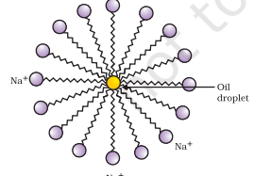  (a)Identify the given diagram  (b) Explain the mechanism of cleansing action of soap. | 4
28 | 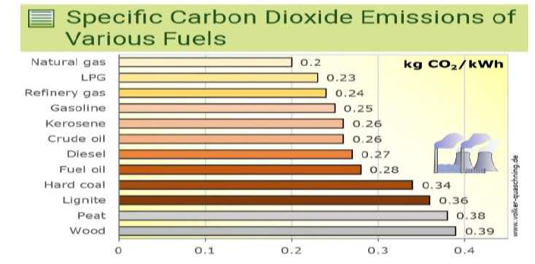  a)Which is fuel is the most eco friendly fuel ?  b)The reaction that occurs during burning of fuel is called _______.  c)As per the graph which is the most harmful fuel?  d)If there is insufficient supply of oxygen, which gas will be released during combustion of fuel? | 4
29 | The molecule of alkene family are representated by a general formulaCnH2n. Now answer the following.  a.What do n and 2n signify?  b.What is the name of the alkene when n=4?  c.What is the molecular formula of alkene when n=6?  d.What is the molecular formula of the alkene if there are six H atoms in it?  e.Write the molecular formula of lower and higher homologues of an alkene which contain 4 carbon atoms. | 5

Answers Chapter-4 Carbon Compounds
Q | Answers
1 | (c) Each atom is covalently bonded to four other atoms, which in turn, are bonded to four more atoms. Thus X is a giant molecule and has a structure similar to that of diamond. Substance X is not a compound as it consists of one type of atoms. Thus, X is an element. Graphite has layers of Carbon atoms.
2 | (c) Lead storage battery manufacturing factories near A and soaps and detergents factories near B.
3 | Name: Cyclopentane  Number of single bonds : 15
4 | (c)
5 | (a)  Pure ethanoic acid or acetic acid freezes below room temperature into white crystals that resemble glaciers.
6 | A
7 | B
8 | D
9 | B
10 | B
11 | C
12 | The second compound has ketone functional group.
13 | (C)
14 | (D)
15 | (B)
16 | Carbon cannot lose 4 electrons because high energy is needed to remove four electrons. It cannot gain 4 electrons because 6 protons cannot hold 10 electrons. So carbon cannot form ionic compounds.
17 | Hard water contains Ca2+ and Mg2+ ions while soaps contain sodium salts of fatty acids.  Thus, when soap is added to hard water, the Ca2+ and Mg2+ ions present in hard water react with soap and sodium salts are converted to their respective calcium and magnesium salts which are precipitated as scum.
18 | 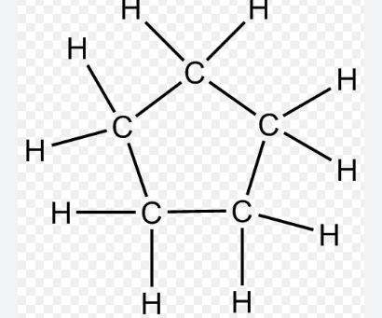  It has 15 covalent bonds.
19 | a)The formula of acetylene is HC ≡ CH. It is an unsaturated hydrocarbon where carbon content is more than the hydrogen content. Hence, carbon is not completely burnt and the unburnt carbon deposits as a soot.  b)Cooking oils (unsaturated compounds) decolourise bromine water due to formation of addition products whereas kerosene (saturated compound) does not decolourise bromine water.
20 | (I) STRUCTURE OF ETHYNE  (II) In pure oxygen, ethyne undergoes complete combustion and high temperature suitable for welding is attained. Whereas air contains less percentage/amount of oxygen which results in incomplete combustion of ethyne and the temperature required for the welding is not attained.  Hence, we cannot use a mixture of ethyne and air for this purpose.
21 | (I) X = Ethanol = CH₃CH₂OH  Y = Hydrogen gas = H₂ ↑  (II) When ethanol reacts with sodium it forms sodium ethoxide and hydrogen gas.  (III) When ethanol is heated with excess of conc. sulphuric acid, it gets dehydrated to
22 | (I) 5% solution of KMnO₄ is prepared by adding 5 g of KMnO₄ in 95 g of water.  (ii) Here alkaline KMnO₄ acts as an oxidising agent. It oxidises ethanol to ethanoic acid by donating nascent oxygen. If excess of KMnO₄ is added the purple colour will persist indicating no more alcohol is left and there is no reaction.
23 | High temperature is not favourable for alcoholic fermentation because at high temperature the enzymes like invertase and zymase present in fermentation process becomes inactive and stops functioning as a result fermentation process will not occur.
24 | 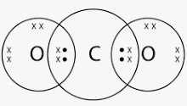 pass the gas through lime water .If lime water turns milky , then it confirms that the gas is C02.  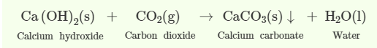
25 | The carboxylic acid is ethanoic acid, alcohol is ethanol.  CH₃COOH + CH₃CH₂COOH → CH₃COOC₂H₅ + H₂O
26 | a. By the dehydration of ethanol in presence of conc.H2SO4  b. By the oxidation of propanol using an oxidizing agent such as alkaline KMno4.
27 | a)Micelles  b)When a dirty cloth is put in water containing dissolved soap, then the hydrocarbon end of the soap molecules in micelle attach to the oil or grease particles present on the surface of dirty cloth. In this way the soap micelle entraps the oily or greasy particles by using its hydrocarbon ends. The ionic ends of the soap molecules in the micelles, however, remain attached to water. When the dirty cloth is agitated in soap solution, the oily and greasy particles present on its surface and entrapped by soap micelles get dispersed in water due to which the soap water becomes dirty but the cloth gets cleaned. The cloth is cleaned thoroughly by rinsing in clean water a number of times.
28 | a)natural gas b)combustion c)wood because it produces less energy but more C02 d)CO
29 | a.n=number of carbon atoms  2n=number of hydrogen atoms  b.butene  c.C6H12  d.C3H6  e.lower homologue-C3H16  higher homologue-C5H10

Chapter-5 Life Processes
1 | From Which structure, the free Oxygen gas produced during photosynthesis is released?  A.Epidermis  B.stomata  C.cortex  D.guard cells | 1
2 | Internal respiration may be defined as  A.Breathing in and releasing of oxygen in the tissue  B.The oxidation of food substances to release energy  C.The building up (synthesis) of complex substances  D.Getting Rid of carbon dioxide that would accumulate in the tissue. | 1
3 | It has been found that people living in very high mountains have many more red corpuscles in their blood than people living in plains. Which one of the following best accounts for this phenomenon  A.The cold climate stimulates the production of red corpuscles to keep the body warm  B.People of high mountains breathe more quickly  C.The lower air pressure requires more red corpuscles to supply the body cells with oxygen  D.The lower air pressure in high mountains speeds up the blood circulation so that more red corpuscles are needed. | 1
4 | The correct sequence of anaerobic reactions in yeast is  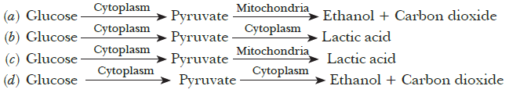 | 1
5 | Which of the equations shows the correct conversion of CO2 and H2O into carbohydrates in plants?  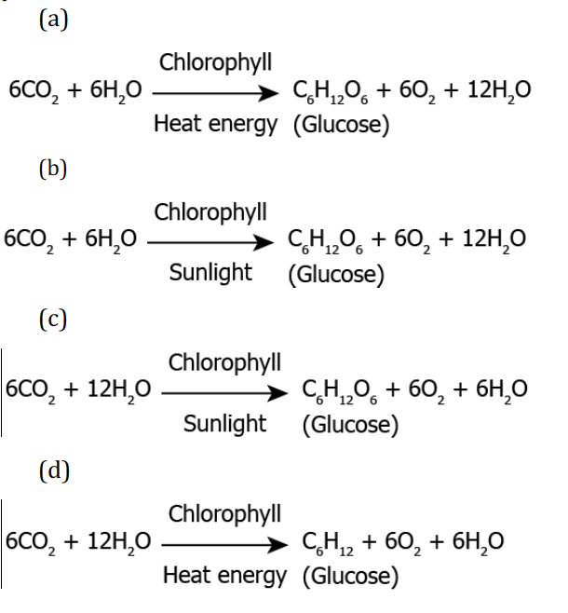 | 1
6 | The following image shows the bread moulds on bread:  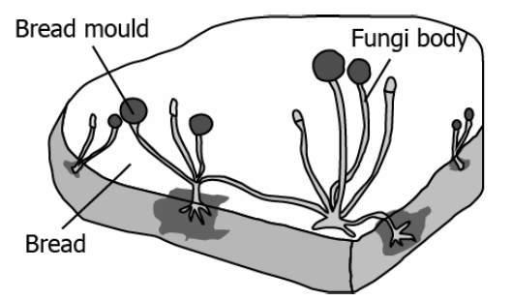  How do these fungi obtain nutrition?  A.By eating the bread on which it is growing  B By using nutrients from the bread to prepare their own food  C.By breaking down the nutrients of bread and then absorbing them  D. By allowing other organisms to grow on the bread and then consuming them | 1
7 | The given image shows how Amoeba obtains nutrition.  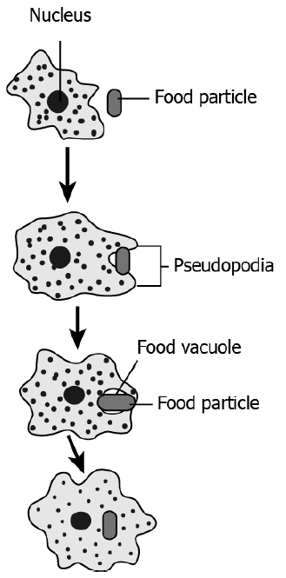  How is this process advantageous for amoeba?  (a) Capturing food takes less time  (b) Complex food can be digested easily  (c) More amount of food can be consumed  (d) Fast distribution of nutrition within the body | 1
8 | Plants exchange gases through stomata. Which of the following statement is not true regarding exchange of gases through stomata?  - Large intercellular spaces ensure gaseous exchange.  - Carbon dioxide and oxygen are exchanged by osmosis.  - The direction of exchange of gases depends upon the environmental condition.  - The direction of exchange of gases depends on the requirement of the plant. | 1
9 | A student sets up an experiment to study the role of enzymes in digestion of food.  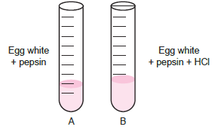  In which test tube, the digestion of protein will occur?  (a) Test tubes A as pepsin will breakdown protein into simple molecules.  (b) Test tube B as HCl will breakdown protein into simple molecules.  (c) Test tube A as pepsin will breakdown into simple molecules.  (d) Test tube B as HCl will activate pepsin for breakdown of protein into simple molecules. | 1
10 | A student sets up an experiment to study human respiration using lime water, test tube and a straw. Lime water is colourless in the absence of CO2 and is milky in its presence. The student fills a freshly prepared limewater in a test tube and blows air through straw into the limewater. It was observed that the solution turns cloudy as shown. What can be evaluated from this observation?  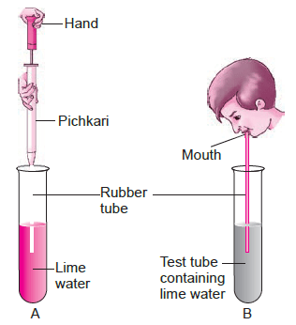  (a) Oxygen is exhaled during respiration.  (b) Water vapours are produced during respiration.  (c) Carbon dioxide is exhaled during respiration.  (d) Glucose is produced during respiration. | 1
11 | A student performs an experiment using a Balsam plant with intact stem, leaves, roots and flowers. The plant was kept in a test tube containing eosin solution (a pink colour dye). The test tube mouth was covered using cotton plug as shown.  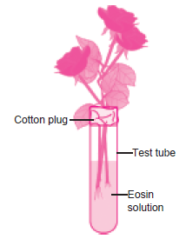  The student kept the plant undisturbed in the lab. After 2-3 hours, a transverse section of stem was obtained using sharp scissors and studied under microscope. The studies reveal the presence of pink colour in the vessels of xylem. What does this observation explain?  (a) Most portion of the plant stem is occupied by xylem.  (b) Water moves through xylem in the plant.  (c) Eosin solution gets stored in the xylem.  (d) Xylem reacts with eosin and gives colour. | 1
12 | A student covered a leaf from a de-starched plant with a black paper strip and kept it in the garden outside his house in fresh air. In the evening, he tested the covered portion of the leaf for the presence of starch. By doing so the student was trying to show that:  (a) CO2 is given out during respiration  (b) CO2 is necessary for photosynthesis  (c) Chlorophyll is necessary for photosynthesis  (d) Light is necessary for photosynthesis | 1
13 | Choose the option with correct match.  - (1,i) (2,ii) (3,iii) (4,iv)  - (2,i) (1,ii) (3,iii) (4,iv)  - (1,ii) (2,iv) (3,i) (4,iii)  - (1,iii) (2,ii) (1,iii) (4,iv) | 1
  Glands | secretions
  1.Salivary glands | i. trypsin
  2.Gastric glands | ii. Salivary amylase
  3.pancreas | iii. Bile juice
  4.liver | iv. pepsin
14 | Study the graph below that represents the blood test reports of an athlete just before and after a race.  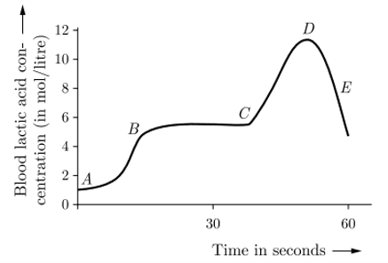  Choose the correct combination of plots provided in the following table. | 1
   | Section of race | The concentration of lactic acid | Type of respiration
  a) | A - B (sprint start) | Changing high to low | Changing from anaerobic to aerobic
  b) | B - C (maintaining speed) | High to low | Anaerobic
  c) | C - D (sprint finish) | High | Aerobic
  d) | D - E (just after sprint finishing) | Low | Aerobic
15 | Assertion (A) : In anaerobic respiration, one of the end product is alcohol.  Reason (R) : There is an incomplete breakdown of glucose.  (a) Both A and R are true and R is the correct explanation of A.  (b) Both A and R are true but R is not the correct explanation of A.  (c) A is true but R is false.  (d) A is false but R is true. | 1
16 | Assertion (A) : Bile is essential for digestion of lipids.  Reason (R) : Bile juice contains enzymes.  (a) Both A and R are true and R is the correct explanation of A.  (b) Both A and R are true but R is not the correct explanation of A.  (c) A is true but R is false.  (d) A is false but R is true. | 1
17 | Assertion (A): Pyruvate is a six-carbon molecule  Reason (R) : It is prepared in the cytoplasm as the first step to cellular respiration.  (a)Both A and R are true and R is the correct explanation of A.  (b)Both A and R are true but R is not the correct explanation of A.  (c) A is true but R is false.(d)A is false but R is true. | 1
18 | Assertion (A) : Veins have thinner walls compared to arteries.  Reason (R) : Veins carry deoxygenated blood.  (a) Both A and R are true and R is the correct explanation of A.  (b) Both A and R are true but R is not the correct explanation of A.  (c) A is true but R is false.  (d) A is false but R is true. | 1
19 | Assertion (A) : Plants have low energy needs compared to animals.  Reason (R) : Plants do not show locomotion and not all cells in their body are living.  (a) Both A and R are true and R is the correct explanation of A.  (b) Both A and R are true but R is not the correct explanation of A.  (c) A is true but R is false.  (d) A is false but R is true. | 1
20 | Assertion (A) : Blood circulation in fish heart is called double circulation.  Reason (R) : Oxygenated and deoxygenated blood are not kept separated in fishes heart.  (a) Both A and R are true and R is the correct explanation of A.  (b) Both A and R are true but R is not the correct explanation of A.  (c) A is true but R is false.  (d) A is false but R is true. | 1
21 | Assertion (A): Oxygenated blood flows in pulmonary artery.  Reason (R): Arteries have narrow lumen.  (a)Both A and R are true and R is the correct explanation of A.  (b) Both A and R are true but R is not the correct explanation of A.  (c)A is true but R is false.(d) A is false but R is true. | 1
22 | Assertion (A):The opening and closing of the pore is a function of the guard cells.  Reason(R): Stomatal pores are the site for exchange of gases by diffusion.  (a)Both A and R are true and R is the correct explanation of A.  (b) Both A and R are true but R is not the correct explanation of A.  (c) A is true but R is false.  (d) A is false but R is true. | 1
23 | Assertion (A): Hydrochloric acid helps in the digestion of food in the stomach.  Reason (R): Hydrochloric acid creates an acidic medium to activate protein digesting enzymes.  (a)Both A and R are true and R is the correct explanation of A.  (b) Both A and R are true but R is not the correct explanation of A.  (c) A is true but R is false.  (d) A is false but R is true. | 1
24 | Assertion (A): Autotrophs can produce food on its own.  Reason (R): Green plants can absorb 10% energy of sunlight that falls on the leaves.  (a)Both A and R are true and R is the correct explanation of A.  (b) Both A and R are true but R is not the correct explanation of A.  (c) A is true but R is false.  (d) A is false but R is true. | 1
25 | What would happen if there is injury in blood vessel and there is no natural system to minimize the loss of blood?  How is loss of blood due to injury minimized in our body? | 2
26 | In the process of Photosynthesis food A is prepared which gets converted into food B. What are A and B? Why is A converted to B? | 2
27 | (a) State the purpose of formation of urine.  (b) What will happen if there is no tubular reabsorption in the nephrons of kidney? | 3
28 | Heterotrophic nutrition is a mode of nutrition in which organisms obtain readymade organic food from outside sources. The organisms that depend upon outside sources for obtaining organic nutrients are called heterotrophs. Heterotrophic nutrition is of three types: saprophytic, parasitic and holozoic nutrition.  i. In which of the following groups of organisms food material is broken outside the body and absorbed?  (a) Mushroom, green plants, Amoeba  (b) Yeast, mushroom, bread mould  (c) Paramecium, Amoeba, Cuscuta  (d) Cuscuta, lice, tapeworm  ii. Which of the following is a parasite?  (a) Yeast (b) Taenia (c) Amoeba (d) Earthworm  iii. Which of the following is an example of saprotroph?  (a) Grass (b) Mushroom (c) Amoeba (d) Paramecium  iv. Heterotrophic nutrition involves  (a) production of simple sugar from inorganic compounds  (b) utilization of chemical energy to prepare food  (c) utilization of energy obtained by plants  (d) all of these. | 4
29 | Arteries are the vessels which carry blood away from the heart to various organs of the body. Since the blood emerges from the heart under high pressure, the arteries have thick, elastic walls. Veins collect the blood from different organs and bring it back to the heart. They do not need thick walls because the blood is no longer under pressure, instead they have valves that ensure that the blood flows only in one direction.  On reaching an organ or tissue, the artery divides into smaller and smaller vessels to bring the blood in contact with all the individual cells. The smallest vessels have walls which are one-cell thick and are called capillaries. Exchange of material between the blood and surrounding cells takes place across this thin wall. The capillaries then join together to form veins that convey the blood away from the organ or tissue.  1. What is the importance of thin walls of blood capillaries?  (a) Thin walls of blood capillaries provide them protection.  (b) Exchange of materials between the blood and surrounding cells take place across the thin walls of blood capillaries.  (c) Thin walls of blood capillaries help on smooth flow of blood.  (d) All of the above.  2. What is the function of valves in veins?  (a) Valves ensure the unidirectional flow of blood.  (b) Valves increase the oxygen carrying capacity of the blood.  (c) Valves protect the veins from outer shocks.  (d) Valves withstand the high pressure of blood in veins.  3. How are arteries designed to withstand high blood pressure? | 4
30 | All living cells need nutrients, O, and other essential substances. Also, the waste and harmful substances need to be removed continuously for healthy functioning of cells. So, a well developed transport system is mandatory for living organisms. Complex organisms have special fluids within their bodies to transport such materials. Blood is the most commonly used body fluid by most of the higher organisms. Lymph also helps in the transport of certain substances.  i)Which of the following does not exhibit phagocytic activity?  (a) Monocytes  (b) Neutrophils  (c) Basophil  (d) Macrophage  ii)Amount of blood corpusles in changed in dengue fever. One of the common symptoms observed in people infected with dengue fever is  (a) significant decrease in RBC count  (b) significant decrease in WBC count  (c) significant decrease in platelets count  (d) significant increase in platelets count  iii) Why are WBCs called soldiers of the body?  (a) They are capable of squeezing out of blood capillaries.  (b) They are manufactured in bone marrow.  (c) They fight against disease causing germs.  (d) They have granular cytoplasm with  iv) Name the blood cells, whose reduction in number can cause clotting disorder, leading to excessive loss of blood from the body.  (a) Erythrocytes  (b) Neutrophils  (c) Leucocytes  (d) Thrombocytes | 4

Answers Chapter- 5 Life Processes
Q | Answers
1 | B
2 | B
3 | C
4 | D
5 | C
6 | C
7 | D
8 | B
9 | D
10 | C
11 | B
12 | D
13 | C
14 | D
15 | A
16 | C
17 | D
18 | B
19 | A
20 | D
21 | D
22 | B
23 | A
24 | C
25 | Leakage of blood due to injury would lead to a loss of pressure which would reduce the efficiency of the pumping system.  To avoid this , blood has platelets cells which circulate around the body and plug these leaks by helping to clot the blood at these points of injury.
26 | Food A is glucose and food B is Starch.  A is converted to B as B is insoluble form of carbohydrate. It is more compact and hence, suitable for storage.
27 | (a)  - Urea is produced as a waste by decomposition of unused proteins in the liver. Our body must get rid of these waste materials because their accumulation in the body is poisonous and harmful for us.  - Kidneys are the organs which remove the poisonous substance urea, other waste salts and excess water from the blood and excrete them in the form of a yellowish liquid called urine.  (b) During filtration, the substances like glucose, amino acids, salts, water and urea etc. present in the blood pass into Bowman’s capsule and then enter the tubule of nephron. When the filtrate containing useful substances as well as the waste substances passes through the tubule, the useful substances like glucose, amino acids, most salts and most water etc. are reabsorbed into blood through blood capillaries surrounding the tubule.  Only the waste substances like urea, some unwanted salts and excess water remain behind in the tubule. Therefore, reabsorption in the nephrons of kidneys is important.
28 | i. b ii. b iii. b iv. c
29 | - d  - b  Arteries have thick and elastic wall to withstand high blood pressure.
30 | i)c  ii) c  iii) c  iv) d

Chapter-6 Control and Coordination
1 | Auxin is a plant hormone that promotes cell elongation and is produced by the apical meristem. It inhibits the growth of lateral buds which are present at nodes (where leaves attach to the stem). As long as sufficient auxin is produced by the apical meristem, the lateral buds remain dormant. A gardener wants the plants in the hedge that he is growing to become bushier with more branches. Which of the following should he do?  a.Add more manure  b.addmixure of manure and fertilizer  c.Allow more light to fall on the tree  d. Trim the hedge by cutting off the tips of the stems | 1
2 | 2.The end product of carbohydrate digestion is sugar. A person went to a patholab to test his blood. It is found that his average blood sugsr is 174 gm/dl but the normal blood sugar level of a healthy person is <140 gm/dl . What may be the cause?  a. Improper digestion of food  b.blood vessels are plugged  c. Mal function of pancreas leads to less secretion of insuline  d.Over eating of food containing carbohydrate | 1
3 | Identify the correct sequence of tansmission of nerve impulse in different nuron  - 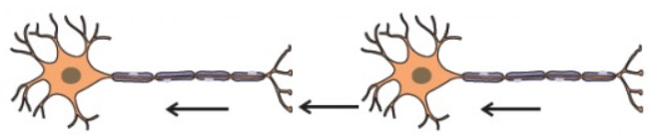  - 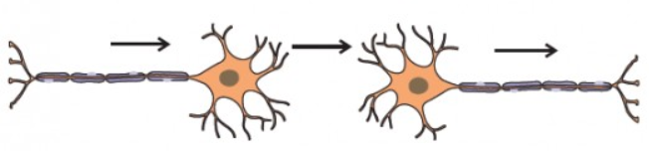  - 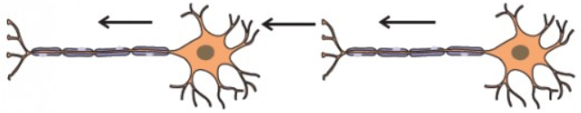  - 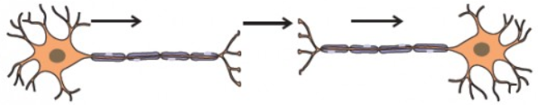 | 1
4 | Ramesh met an accident and had a head injury. On examining the MRI report doctor said that he had some problem in ‘speech area’. Identify the part of the brain where the problem lies in the following diagram  - A and B b. A only c. C d. C and D only  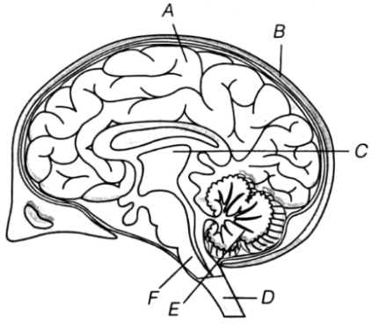 | 1
5 | Which of the following statements are true about the brain?  - The main thinking part of brain is hind brain.  - Centers of hearing, smell, memory, sight, etc are located in fore brain.  - Salivation, vomiting, blood pressure are controlled by the medulla in the hind brain.  - Cerebellum does not controls posture and balance of the body.  - (i) and (ii)  - (i), (ii) and (iii)  - (ii) and (iii)  - (ii) and (iv) | 1
6 | This movement of plant part in response to gravity is called geotropic movement and the phenomenon involved is called geotropism. Find in figure A, B and C, which appears more accurate .  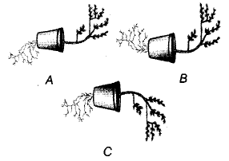 | 1
7 | Vicky was going to a crop field where his father was working. While he was going through the grassy field he saw a sleeping snake and suddenly jumped off (A). Then he walked slowly to escape without disturbing the snake (B). Two activities were performed by Vicky namely A and B. Can you compare the above two activities.  - There is no difference between A and B  - A is a reflex action and B is controlled action  - Both are reflex actions.  - Both activities are controlled by brain  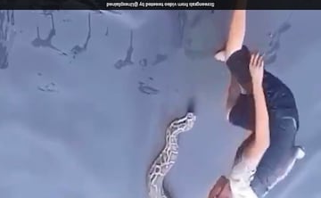 | 1
8 | Following questions consist of two statements – Assertion (A) and Reason (R). Answer these questions selecting the appropriate option given below:  (a) Both A and R are true and R is the correct explanation of A.  (b) Both A and R are true but R is not the correct explanation of A.  (c) A is true but R is false.  (d) A is false but R is true.  Assertion(A) : Animals can react to stimuli in different ways.  Reason (R) : All animals have a nervous system and an endocrine system involving hormones. | 1
9 | Which statement is not true about thyroxin  A. Iron is essential for the synthesis of thyroxine  B. It regulates carbohydrates. protein and fat metabolism in the body  C. The thyroid gland requires iodine to synthesize thyroxine  D. Thyroxine is also called thyroid hormone | 1
10 | Breathing is controlled by which part of the brain?  (a) Cerebrum  (b) Cerebellum  (c) Hypothalamus  (d) Medulla oblongata | 1
11 | Organisms depend on hormones as well as electric impulses for the transmission of signals from the brain to the rest of the body. What can be a likely advantage of hormones over electric impulses?  (a) It is secreted by all types of cells present in the body.  (b) It is secreted by stimulated cells and reaches all cells of the body.  (c) It is relayed to the target organ faster than electric impulses.  (d) It does not depend on an external stimulus to be generated in the cells | 1
12 | Which of the following is NOT a reflex action?  a)Blinking of eyes  b) Coughing  c) Sneezing  d) Shivering | 1
13 | The human nervous system is divided into two parts:  a) Central nervous system and autonomic nervous system  b) Central nervous system and peripheral nervous system  c) Peripheral nervous system and autonomic nervous system  d) None of the above | 1
14 | Endocrine glands are ductsless gland which secrets hormone. The chemical coordination of the human body is performed by different hormones. Name the hormone secreted from labelled endocrine glands  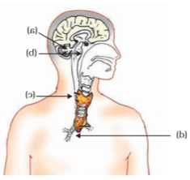 | 2
15 | You are studying in your study room. Suddenly you got the burning smell from your kitchen. Then you rushed in to the kitchen. Is it a kind of reflex action? Justify? | 2
16 | Here is the report of blood test of a person whose age is 55 years. Go through the data and identify the possible cause of it.   | 2
17 | Identify the type of movement shown the tendril. Explain its mechanism  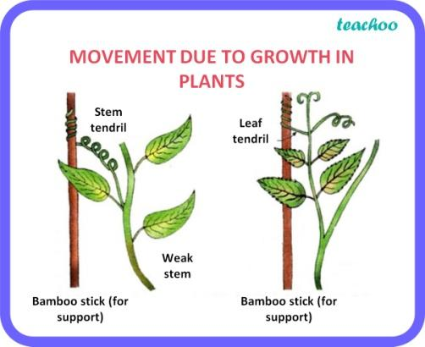 | 3
18 | Some farmer inject certain chemical to the cows before milking them. Which chemical anf why? Give other function of the chemical | 3
19 | (a) How is brain protected from injury and shock?  (b) Name two main parts of hind brain and state the functions of each. | 3
20 | Nastic movement is another form of curvature movement shown by some members of plants. It refers to the reversible movement in a plant caused due to the elastic changes in the size of special motor cells within the plant’s tissue. It is another type through which higher plants show curvature movement due to cell size and turgor pressure variations. The plant’s response to the external stimulus is generally non-directional. Alternations in the turgor pressure facilitate nastic movements like the opening and folding of leaves and petals in response to external stimuli.  i) How nastic movement differ from tropic movement  ii) What are two main causes of nastic movement?  iii) Give one example photo nastic movement.  iv) Why nastic movement is reversible? | 4
21 | If the body design in the squirrel relied only on electrical impulses via nerve cells, the range of tissues instructed to prepare for the coming activity would be limited. On the other hand, if a chemical signal were to be sent as well, it would reach all cells of the body and provide the wide-ranging changes needed. This is done in many animals, including human beings, using a hormone called adrenaline that is secreted from the adrenal glands.  I) which is the target organ for the adrenaline hormone?  II)Which hormone is released by thyroid gland?  III)What is the function of thyroxine hormone?  IV)Name the hormone released by ovary? | 4
22 | Identify the elements of reflex action. Explain the mechanism of reflex action.  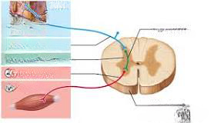 | 5

Answers Chapter-6 Control and Coordination
Q | Answers
1 | D
2 | C
3 | 3
4 | A) A
5 | 3
6 | A
7 | B).A is a reflex action and B is controlled action
8 | (A) Both A and R are true and R is the correct explanation of A.
9 | A. Iron is essential for the synthesis of thyroxine
10 | D) Medulla oblongata
11 | (B) It is secreted by stimulated cells and reaches all cells of the body.
12 | D)Shivering
13 | B) Central nervous system and peripheral nervous system
14 | 1.Nuro-Hormone 2.Growth Hormone. 3.Thyroxin 4.Parthormone
15 | It is not a reflex action. It is a controlled action by central nervous system
16 | Deficiency of insulin hormone causes increase in sugar level in the blood
17 | 1. Movement is thighmotropic movement  Mechanism:  In general, tendrils are able to curve by employing a process known as "differential growth". This process involves the stimulation of growth in particular regions of the tendril. In positive thigmotropism, for example, the side of the tendril which is opposite to the side of contact will grow at a faster rate than the contact side due to more accumulation Auxin. In some cases, the cells on the contact side will actually compress, which enhances the curving response. Therefore, the non-contact side begins to elongate faster than the rest of the tendril, while the contact side actually compresses. This causes the tendril to curve toward the site of contact.
18 | Oxytocin because it activates mammary gland to release more milk. It also induces contraction of muscle of uterus
19 | (a) Brain is covered by a three layered membrane called meninges. In between the layers of meninges and brain, cavity fluid named Cerebro Spinal Fluid (CSF) is filled. The hard skull covers the meninges. Thus Meninges, CSF and Skull protects our brain for a certain extent.  (b) Two main parts of hind-brain are — Medulla and Cerebellum. Their functions are:  Medulla : Involuntary actions such as blood pressure, salivation and vomiting.  Cerebellum: It is responsible for precision of voluntary actions and maintaining the posture and balance of the body.
20 | i) Nastic movement is a non- directional movement  ii) Cell size and turgor pressure variation  iii) Petals of lily flower  iv)Back to original form again
21 | - Heart is the target organ for the adrenaline hormone which increases the heartbeat rate.  - Thyroxine is released by thyroid gland.  - It regulates carbohydrate, protein and fat metabolism in the body and promote the best balance for growth.  - Estrogen and progesterone
22 | 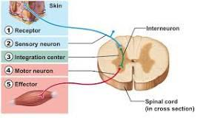  The mechanism of reflex action can be studied with the help of an example showing the withdrawal of a hand from a hot object. This is called a spinal reflex arc. The steps are-  - The specific receptors present in the skin receive the sensation of heat or pain.  - This sensation of heat or pain is first transferred to the dorsal root of the spinal nerve via sensory neurons and then to the spinal cord.  - The nerve impulse is further carried to the relay neuron in the spinal cord, also termed an interneuron, from where it reaches the motor neuron.  - The motor neuron emerges from the ventral root of the spinal cord and reaches the effector muscles, which initially felt the temperature rise.  - The muscles in that area respond to the stimulus, and the hand turns away from the hot utensil

Chapter-7 How do organisms reproduce?
1 | Which one is due to bacterial infection?  - AIDS  - Gonorrhoea  - Cancer in cervix  - Tumour in ovary | 1
2 | Based on the two statements, assertion and reason, choose the correct option:  (A) If both Assertion and Reason are true and Reason is the correct explanation of Assertion.  (B) If both Assertion and Reason are true but Reason is not the correct explanation of Assertion.  (C) If only Assertion is true but Reason is false.  (D) If Assertion is false but Reason is true.  Q. Assertion (A): Spores are unicellular bodies.  Reason (R): The parent body simply breaks up into smaller pieces on maturation. | 1
3 | Based on the two statements, assertion and reason, choose the correct option:  (A) If both Assertion and Reason are true and Reason is the correct explanation of Assertion.  (B) If both Assertion and Reason are true but Reason is not the correct explanation of Assertion.  (C) If only Assertion is true but Reason is false.  (D) If Assertion is false but Reason is true.  Q. Assertion (A): Colonies of yeast multiply in sugar solution.  Reason (R): Sugar is made up of sucrose which provides energy for sustaining all life activities. | 1
4 | Colonies of yeast fail to multiply in water, but multiply in sugar solution because they derive energy by fermenting sugars and carbohydrates to produce  a) methanol and CO2  b) ethanol and CO  c) methanol and O2  d) ethanol and CO2 | 1
5 | 3. The diagram shows a sperm. The tail enables the sperm to swim. Why does the sperm need to be able to swim?  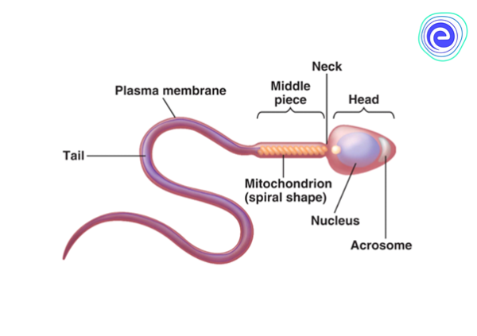  - so that it doesn't drown in the semen  - in order to get to the egg  - because it is a member of fish family  - to travel around in the testicle | 1
6 | Given below are the stages of binary fission in Amoeba. Which one out of the following would you select as the correct sequence of these stages.  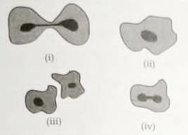  - i,ii,iii,iv  - iv,iii,i,ii  - ii,iv,i,iii  - iii,i,iv,ii | 1
7 | 6. Reema observes the process of regeneration in Planaria.  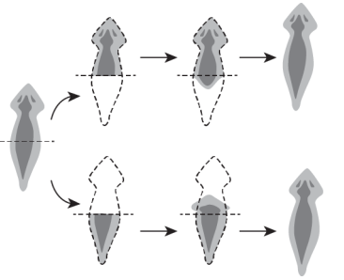  Reema claimed that the newly formed planarians have identical genetic make up. Which statement support the claim?  (a) It is a single celled organism.  (b) All planarians share the same genetic material.  (c) Division in Planaria involves a single parent.  (d) Planaria divides only under unfavourable condition | 1
8 | Out of many papaya plants growing in your garden, only a few bear fruits. What could be the reason?  - It bears unisexual flowers.  - It bears bisexual flowers.  - Both (a) and (b)  - Due to presence of special type of tissues | 1
9 | 8. What will likely happen if testes are located inside the abdominal cavity?  (a) delayed puberty  (b) sperm formation  (c) increase in body temperature  (d) change in genetic composition of sperms | 1
10 | After a female attains puberty, the body undergoes many changes for maturation. Which event will likely happen in the female body when there is no fertilization of egg?  (a) disintegration of uterine wall  (b) development of egg into zygote  (c) increase in the production of eggs in the ovaries  (d) of a mature egg into an immature egg | 1
11 | Which of the following is corret sequence of events of sexual reproduction in in a flower  a. pollination, fertilization, seedling, embryo  b. seedling, embryo, fertilization, pollination  c. pollination, fertilization, embryo, seedling  d. embryo, seedling, pollination, seedling | 1
12 | Permanent fertility control in male is achieved by:  a. Tubectomy b. Vasectomy c. Anatomy d.Pills | 1
13 | In relation to a particular series, what is the reason behind the number of chromosomes in parents and offspring being constant?  (a) Doubling of chromosomes after zygote formation  (b) Halving of chromosomes during gamete formation  (c) Doubling of chromosomes after gamete formation  (d) Halving of chromosomes after gamete formation | 1
14 | 1 Radha found some potatoes in the kitchen which had one or two sprouted buds. She  planted them in kitchen garden and started watering them daily.  (i) What is this method of propagation called?  (ii) Which part of plant is used by her in this case?  - Rhizomes  - Bulbs  - Runners  - Tubers | 2
15 | 13. What happens when  (a) Bryophyllum leaf falls on the wet soil.  (b) on maturation sporangia of Rhizopus bursts | 2
16 | Why is DNA copying is an essential part of the process reproduction? | 2
17 | Why is variation beneficial to the species but not necessarily for the individual?
18 | 14. State the role of placenta in the development of embryo.  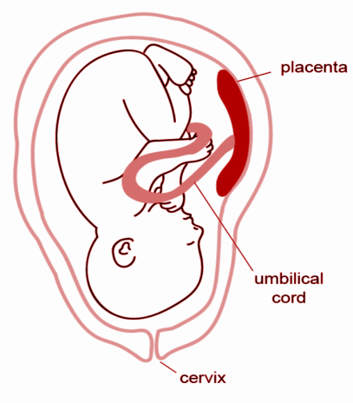 | 3
19 | 15. Raghav an employee in MNC was not keeping well for a long time. He underwent a complete medical check up and was diagnosed as HIV+. He was terminated on account of this condition.  (i) To which category of disease AIDS belong?  (ii) __________ is its causative organism.  (iii) The decision to terminate him from the company  - was right as its a communicable disease  - was wrong as its not transmitted from one individual to another  - was wrong as it doesn't spread through shaking and mixing with HIV infected individuals  - was wrong as it spreads through shaking and mixing with HIV infected individuals | 3
20 | The reproductive parts of angiosperms are located in the flower. You have already studied the different parts of a flower – sepals, petals, stamens and pistil. Stamens and pistil are the reproductive parts of a flower which contain the germ-cells. The flower may be unisexual (papaya, watermelon) when it contains either stamens or pistil or bisexual (Hibiscus, mustard) when it contains both stamens and pistil.  - What is the male reproductive part of a flower?  - What are the different parts of pistil?  - What is pollination?  - What are two types of pollination? | 4
21 | A survey conducted by an organization for the cause of illness and death among the women between the ages 15-44 (in years) worldwide, found the following figure in (%)  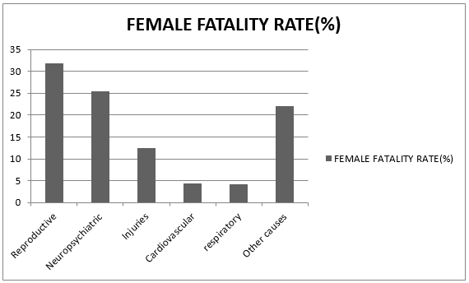  (i)Which condition is the major cause of women's ill health and death worldwide?  (ii)Which part of the female reproductive system remains blocked after tubectomy?  (a) Fallopian tube  (b) Oviduct  (c) Cervix  (d) Uterine cavity  (iii) What problem in reproductive health care require doctors help?  (a) STDs  (b) conception and abortion  (c) infertility and menstruation problem  (d) All  (iv) Which of the following is not a STDs caused by bacteria?  - Syphilis  - Gonorrhea  - AIDs  - Chlamydia | 4
22 | Germination starts with the rapid intake of water by the seed through its micropyle. The first visible indication of germination is the swelling of the seed with a resultant increase in weight. It is also accompanied by the softening of the seed coat. Absorption of water causes a number of physiological changes in the seed. Germinating seeds exhibit increased respiratory activity. The embryo produces enzymes which convert the food materials stored in the cotyledons into soluble form usable by the growing embryo. Once the food is made available, cell division activity starts in the growing embryo. The growth of the embryonic tissue ruptures the seed coat.  - Which among the following are true  (i) Radicle develops into root  (ii) Radicle develops into shoot  (iii) Plumule develops into root  (iv) Plumule develops into shoot  (a) (i) and (ii) (b) (i) and (iii)  (c) (i) and (iv) (d) (ii) and (iv)  2. What are the three conditions necessary for the germination of seeds?  3. Name the part of the seed that provides nutrition for the growing seedling | 4

Answers Chapter-7 How do organisms reproduce
Q | Answers
1 | B
2 | C
3 | A
4 | (d) ethanol and CO2
5 | (b) in order to get to the egg
6 | (c) ii , iv , i , iii
7 | (c) Division in Planaria involves a single parent.
8 | Both (a) and (b)
9 | delayed puberty
10 | disintegration of uterine wall
11 | c. pollination,fertilization,embryo,seedling
12 | b. Vasectomy
13 | (b) Halving of chromosomes during gamete formation
14 | (i) Vegetative Propogation (ii) Tubers
15 | (a) When the Bryophyllum leaf falls on the wet soil, the buds present in the notches along the leaf margin develop into new plants. This is known as vegetative propagation.  (b) The sporangia of Rhizopus contain cells or spores that can eventually develop into new Rhizopus individuals when it bursts on maturation. When a small piece of Hydra breaks off it grows into complete new Hydra.  During regeneration, the cells of cut body part of the organism divide rapidly to make a mass of cells. The cells here move to their proper places within the mass where they have to form different types of tissues. In this way complete organism is regenerated.
16 | DNA copying is an essential part of the process of reproduction because it carries the genetic information from the parents to their offspring. A copy of DNA is produced by some chemical reactions resulting in two copies of DNA.
17 | Variations are useful for the survival of species in changed environment situations. If a population of reproducing organisms were suited to a particular niche and if the niche is drastically altered the population could be wiped out.  However, some variations are present some species will survive. Thus, variation is useful to species but not the individual.
18 | Placenta is a physiological connection between an embryo and uterine wall of the mother through which nutrients and other useful substances enter into fetus from mother’s blood and waste products like urea and carbon dioxide are expelled into mother's blood from fetus.
19 | (i) Sexually transmitted disease (ii) Human immunodeficiency virus (iii) (c) was wrong as it does not spread through shaking and mixing with HIV infected individual .
20 | - Stamen is the male reproductive part of a flower. It consists of anther and filament.  - Stigma, style and ovary  - The transfer of pollen grain from the stamen to stigma of flower is called pollination.  Self pollination and cross pollination.
21 | (i) Reproductive health (ii) (a) Fallopian tube (iii) (d) All (iv) (c) AIDS
22 | 18.1. (i) and (iv)  2. Conditions necessary for the germination of seeds:  Water,Oxygen,Temperature  3. The cotyledons of the seed provide nutrition for the growing seedling or the embryo.

Chapter-8 Heredity
1 | If a pure tall plant (TT) with height 20cm cross with the pure dwarf plant (tt) with height 10cm, and then find out the height of hybrid tall plant. | 1
2 | A garden pea plant produced axial white flowers. Another of the same species produced terminal violet flowers. Identify the dominant trait. | 1
3 | A couple has five sons. What is the possibility of their having a son next time? | 1
4 | In peas, a plant with round seed cross with a plant with wrinkled seed. What percentage of plant will have round seed in F1 generation? | 1
5 | How many pairs of chromosomes control somatic characters in human being? | 1
6 | Two pink coloured flowers on crossing resulted in 1 red, 2 pink and 1 white flower progeny. The nature of the cross will be  (a) double fertilization (b) self-pollination  (c) cross fertilisation (d) no fertilisation | 1
7 | If a round, green seeded pea plant (RR yy) is crossed with wrinkled, yellow seeded pea plant, (rr YY) the seeds produced in F1 generation are  (a) round and yellow (b) round and green  (c) wrinkled and green (d) wrinkled and yellow | 1
8 | Height of a plant is regulated by:  a) DNA which is directly influenced by growth hormone.  b) Genes which regulate the proteins directly.  c) Growth hormones under the influence of the enzymes coded by a gene.  d) Growth hormones directly under the influence a gene. | 1
9 | If a tall pea plant is crossed with a pure dwarf pea plant then, what percentage of F1 and F2 generation respectively will be tall?  (a) 25%, 25%  (b) 50%, 50%  (c) 75%,100%  (d) 100%, 75% | 1
10 | 2) The inheritance of color trait in flower is as shown.  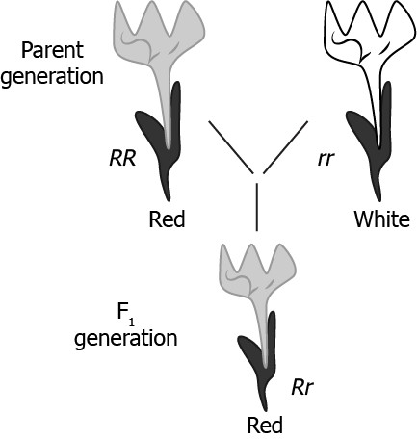  R and r denote two different genes for color. Which law of Mendel can be explained using the image?  - Only Law of segregation  - Only Law of independent assortment  - Law of segregation and Law of dominance  - Law of segregation and Law of independent assortment | 1
11 | How many gametes will form from following genotypes?  a) TTRr b)TtYy | 2
12 | What will be expected percentages of blood groups in the offspring when there is a cross between AB blood group mother and heterozygous B blood group father? | 2
13 | In childhood due to a severe accident Sumita got a huge scar on her right hand. After she heard the lecture of Heredity in her class 10th, she was worried about what if her baby inherits the scar. She asked her teacher about her concern. After an elaborate explanation from her teacher, now she convinced successfully. What according to you could be the possible explanation which the teacher gave to Sumita? | 2
14 | Mustard was growing in two fields- A and B. While Field A produced brown coloured seeds, field B produced yellow coloured seeds.  It was observed that in field A, the offsprings showed only the parental trait for consecutive generations, whereas in field B, majority of the offsprings showed a variation in the progeny.  What are the probable reasons for these? | 2
15 | A hybridization experiment of garden pea plant was conducted between pure breeding pea plant with round, yellow seeds and wrinkled and green seeds. Based on the above experiment answer the following.  i) Write the phenotype of F₁ progeny and state the reasons for your answer.  ii) What will be the type of phenotypes one would obtain in F₂ progeny when F₁ progeny was selfed? | 3
16 | In a survey it is found that blue eye colour is recessive among human in contrast to the brown eye colour. Answer the following questions if a brown eyed man has a blue eyed mother.  - What are the possible genotypes of his father?  - What is the genotype of the man and his mother?  - Which Mendelian principle is used in determining the genotypes? | 3
17 | Two pea plants - one with round yellow seeds (RRYY) and another with wrinkled green (rryy) seeds produce F1 progeny that have round, yellow (RrYy) seeds.  When F1 plants are self-pollinated, which new combination of characters is expected in F2 progeny? How many seeds with these new combinations of characters will be produced when a total 160 seeds are produced in F2 generation? Explain with reason. | 3
18 | In a pea plant, the trait of flowers bearing purple colour (PP) is dominant over white colour (pp). Explain the inheritance pattern of F1 and F2 generations with the help of a cross following the rules of inheritance of traits. State the visible characters of F1and F2 progenies. | 3
19 | Read the following extract and answer the questions that follow:  Sex determination is the method by which distinction between males and females is established in species. The sex of an individual is determined by specific chromosomes. These chromosomes are called sex chromosomes. X and Y chromosomes of an individual are known as autosomes.  i)A couple has six daughters. What is the possibility of their having a girl next time?  a)50% b)25% c)100% d)75%  ii)In human male all he chromosomes are paired perfectly except one. This unpaired chromosome is/are  a)X chromosome b)Y chromosome c) Large chromosome d)both (a) and (b)  iii) Select the incorrect statement.  - In male grasshoppers, 50% of sperms have no sex chromosomes.  - In animals like snails, individuals cannot change their sex.  - Human male produces two types of sperms 50% having X chromosomes and 50% having Y chromosomes.  - In turtle,sex determination is regulated by environmental factors.  iv)Number of pair(s) of sex chromosomes in the zygote of human is  - 1 b) 2 c) 3 d) 4 | 4
20 | Read the following extract and answer the questions that follow:  Pure breed pea plant with smooth seeds (dominated characteristic) was crossed with purebred pea plant with wrinkled seeds (recessive characteristic). The F1 generation was self-pollinated to give rise to the F2 generation.  i) If a genotype consists of different types of alleles, it is called  a) homozygous b) heterozygous c) monoallelic d) uniallelic  ii) The alternative form of gene is called  a)allele b)alternative genes c)dominant character d)recessive character  iii) Which of the following will be the genotypic ratio of given F2 generation?  a)1:2:1 b)3:1 c)1:3 d)1:1:1  iv) What is the expected observation of the F2 generation of plants?  a) 1/2 of them have smooth seeds and 1/2 of them have wrinkled seeds.  b) 1/4 of them have wrinkled seeds and 3/4 of them have smooth seeds.  c) 3/4 of them have wrinkled seeds and 1/4 of them have smooth seeds.  d) All of them have smooth seeds. | 4
21 | Pooja has green eyes while her parents and brother have black eyes. Pooja’s husband Ravi has black eyes while his mother has green eyes and father has black eyes.  (a) On the basis of the above given information, is the green eye colour a dominant or recessive trait? Justify your answer.  (b) What is the possible genetic makeup of Pooja’s brother’s eye colour?  (c) What is the probability that the offspring of Pooja and Ravi will have green eyes? Also, show the inheritance of eye colour in the offspring with the help of a suitable cross. | 4
22 | Sahil performed an experiment to study the inheritance pattern of genes. He crossed tall pea plants (TT) with short pea plants (tt) and obtained all tall plants in F1 generation.  a. What will be set of genes present in the F1 generation?  b. Give reason why only tall plants are observed in F1 progeny.  c. When F1 plants were self - pollinated, a total of 800 plants were produced. How many of these would be tall, medium height or short plants? Give the genotype of F 2 generation. | 4

Answers
Chapter-8 Heredity
Q | Answers
1 | Here tallness is the dominant character and dwarfness is the recessive character. In F₁ generation the dominant character is expressed. Thus, the height of the F₁ hybrid is 20cm.
2 | Axial ,violet flowers
3 | 50%
4 | 100%
5 | 22 pairs
6 | (b) self-pollination
7 | (a) round and yellow
8 | c) Growth hormones under the influence of the enzymes coded by a gene.
9 | (d) 100%, 75%
10 | (c )Law of segregation and Law of dominance
11 | No of gametes=2^{n} (where n=no of heterozygotes)  - TTRr= 2¹=2 (here no of heterozygote=1, i.e Rr)  - TtYy=2²=4 (here no of heterozygote=2,i.e Tt,Yy)
12 | Parents I^{A}I^{B} x I^{B}i  Gametes I^{A ,} I^{B}I^{B ,} i  25% AB Blood group, 25% A blood group, 50% B blood group.
   | I^{A} | I^{B}
  I^{B} | I^{A}I^{B} | I^{B}I^{B}
  I | I^{A}i | I^{B}i
13 | Traits are acquired due to interaction with the environment are called acquired traits which are not inheritable. So the scar on sumita’s right hand was an acquired trait and that won’t be transferred to her next generation.
14 | In field A, the reason for parental trait in consecutive generations of the offsprings is  self-pollination.  In field B, variation is seen to occur because of recombination of genes as cross - pollination is taking place.
15 | i) The phenotype of F1 progeny is pea plant with round and yellow seeds. The reason for my answer is Round shape and yellow colour of the seed is the dominant traits over wrinkled shaped green colour seeds. So in F1 generation dominant traits will express themselves by suppressing the recessive traits which are wrinkled shaped green colour seeds.  ii) The phenotypic ratio is 9:3:3:1. Round yellow-9, Round green-3, Wrinkled yellow-3, wrinkled green-1.
16 | a) The possible genotype of father is- BB,Bb  - Genotype of man-Bb  Genotype of mother-bb  - Principle of dominance
17 | Round green : 30  Wrinkled yellow : 30  New combinations are produced because of the independent inheritance of seed shape and seed colour trait.
18 | Let purple trait be represented by: PP White trait be : pp  Parental PP X pp  ↓  F1 Pp X Pp (Selfing)  F2  ↓  Gametes P p  P PP Pp  p Pp pp  Visible characters of F1 progeny all flowers are purple coloured and in F2 progenies 3 are purple coloured and 1 is white coloured flower
19 | i) (a) ii)(d) iii)( b) iv) (a)
20 | i) (b) ii) (a) iii) (a) iv) (b)
21 | - Yes, green eye colour is recessive as it will express only in homozygous condition  - BB, Bb (  - bb*Bb  Genetic cross -  50% of the offsprings can have green eye colour
   | B | b
  b | Bb | bb
  b | Bb | bb
22 | - Tt  - Traits like ‘T’ are called dominant traits, while those that behave like ‘t’ are called recessive traits./Alternatively accept the definition of dominant and recessive traits with examples of T and t respectively /Alternatively accept the law of Dominance  with examples of T and t.  - Out of 800 plants 600 plants will be tall and 200 plants will be small (1 mark), 1 TT: 2Tt: 1tt

 |  | CH 9 _ LIGHT, REFLECTION & RAREFACTION
Q. NO |  | QUESTION | MARKS
- 1 |  | A student does the experiment on tracing the path of a ray of light passing through a rectangular glass slab for different angles of incidence. He can get a correct measure of the angle of incidence and the angle of emergence by following the labeling indicated in figure:  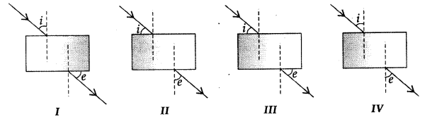 | 1 MARK
- 2 |  | If the power of a lens is – 2 D, what is its focal length?  (a) +50 cm  (b) -100 cm  (c) -50 cm  (d) +100 cm | 1 MARK
- 3 |  | In which of the following is a concave mirror used?  (a) A solar cooker  (b) A rear view mirror in vehicles  (c) A safety mirror in shopping malls  (d) In viewing full size image of distant tall buildings | 1 MARK
- 4 |  | 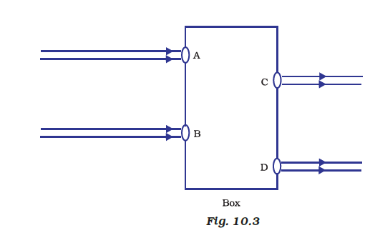  Beams of light are incident through holes A and B and emerge out of the box through holes C and D, respectively, as shown in the Figure 10.3. Which of the following could be inside the box?  (a) A rectangular glass slab  (b) A convex lens  (c) A concave lens  (d) A prism | 1 MARK
- 5 |  | If the magnification produced by a lens has a negative value, the image will be  (a) virtual and inverted  (b) virtual and erect  (c) real and erect  (d) real and inverted | 1 MARK
- 6 |  | 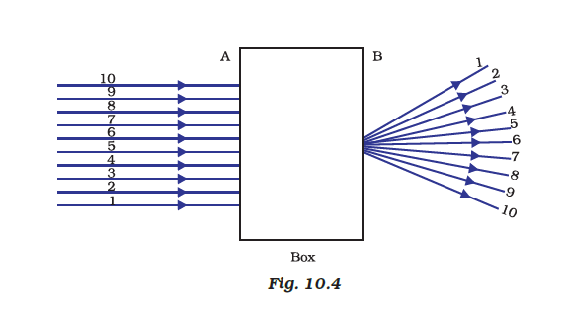  A beam of light is incident through the holes on side A and emerges out of the holes on the other face of the box as shown in the Figure.10.4 Which of the following could be inside the box?  (a) Concave lens  (b) Rectangular glass slab  (c) Prism  (d) Convex lens | 1 MARK
- 7 |  | When we insert a coin to a glass half filled with water then coin appears as raised slightly which is due to:  (a) Reflection  (b) Refraction  (c) Diffraction  (d) Dispersion | 1 MARK
- 8 |  | When the object is placed between C (center of curvature) and F (focus) in case of concave mirror then the image formed will be at:  a) At C  b) At infinity  c) Beyond C  d) At F | 1 MARK
- 9 |  | 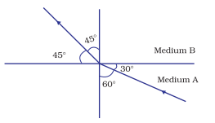  Figure shows a ray of light as it travels from  medium A to medium B. Refractive index of the  medium B relative to medium A is  (a) √3 / √2  (b) √2 /√ 3  (c) 1/ √2  (d) √2 | 1 MARK
- 10 |  | The bouncing back of the ray in the same medium is called as  (a) Reflection  (b) Refraction  (c) Diffraction  (d) Dispersion | 1 MARK
 |  | The number of images formed by two plane mirror inclined at and 60 degree angle of an object placed symmetrically between mirror is  a) 5 b) infinity c) 6 d) 7 | 1 MARK
 |  | Choose the wrong statement  a) a concave mirror can form a magnified real image  b) a concave mirror can form a magnified virtual image  c) a convex mirror can form a diminished virtual image  d) a convex mirror can form diminished real image | 1 MARK
 |  | Given a point source of light which of the following can produce a parallel beam of light?  a) concave lens  b) two plane mirrors inclined at 90 degree to each other  c) convex mirror  d) concave mirror | 1 MARK
 |  | For a real object a convex mirror always forms and image which is  a) virtual and erect b) real and magnified  c) real and inverted d) virtual and inverted | 1 MARK
 |  | An objective 20cm from a spherical mirror give rise to a virtual image 15 cm behind the mirror. The type of the mirror and its focal length is  a) concave, 8.5 cm  b) convex, 30 cm  c) concave, 60 cm  d) convex 60 cm | 1 MARK
 |  | A convex mirror has a focal length 15 cm. Real object placed at a distance 15 cm in front of it from the pole produces an image at  a) 7.5 cm  b) 30 cm  c) infinity  d)15 cm | 1 MARK
 |  | A person standing in front of a mirror finds his image thinner but with normal height. This implies that the mirror is  a) convex and cylindrical with axis vertical  b) convex and cylindrical with axis horizontal  c) convex and spherical  d) concave and horizontal | 1 MARK
 |  | A person standing in front of a mirror find his image larger than himself. This implies that the mirror is  a) concave  b) cylindrical with bulging side outwards  c) plane  d) convex | 1 MARK
 |  | All of the following statements are correct except  a) a virtual , erect, magnified image can be formed using a concave mirror  b) a real, inverted, same sized image can be formed using convex mirror  c) the magnification produced by a convex mirror is always less than 1  d) a virtual, erect, same size image can be obtained by using a plane mirror | 1 MARK
 |  | Which of the following can produce a virtual image?  a) plane mirror  b) concave mirror c) convex lens  d) all of these | 1 MARK
 |  | Rahul finds out that the sharp image of the window pane of her science laboratory is formed at a distance of 15 cm from the lens. She now tries to focus the building visible to her outside the window instead of the window pane without disturbing the lens.  - In which direction will she move the screen to obtain a sharp image of the building?  - What is the approximate focal length of this lens? | 2 MARKS
 |  | You are given three lenses.  i) a concave lens of focal length 25 cm.  ii) a convex lens of focal length ¼ m and  iii) a convex lens of focal length 100 cm.  Which combination out of these three lenses will form a lens of zero power? | 2 MARKS
- 11 |  | A lemon kept in water in a glass tumbler appears to be bigger than its actual size, when viewed from the sides. Explain why?. | 2 MARKS
- 12 |  | 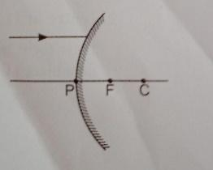  A ray of light is incident on a convex mirror as shown. Redraw the diagram and complete the path of this Ray after reflection from the mirror. Mark angle of incidence and angle of reflection on it. | 2 MARKS
- 13 |  | 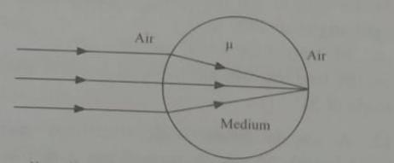  calculate the refractive index of the given situation. | 2 MARKS
 |  | 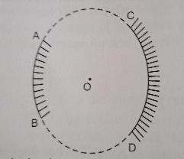  AB and CD , two spherical mirrors form parts of a hollow spherical ball with its centre at O as shown in the diagram. If arc AB = 1/2 arc CD, what is the ratio of their focal length? State which of the two mirror will always form virtual image of an object place in front of it and why. | 2 MARKS
 |  | One half of a convex lens of focal length 10 cm is covered with a black paper. Can such a lens produce an image of a complete object placed at a distance of 30 cm from the lens?  A 4 cm tall object is placed perpendicular to the principal axis of a concave lens of focal length 20 cm. The distance of the object from the lens is 15 cm. Find the nature, position and size of the image. | 3 MARKS  (1+2)
- 14 |  | Define power of a lens. What is its unit? One student uses a lens of focal length 50 cm and another of –50 cm. What is the nature of the lens and its power used by each of them? | 3 MARKS  (½+½+1+1)
- 15 |  | Under what condition in an arrangement of two plane mirrors, incident ray and reflected ray will always be parallel to each other, whatever may be angle of incidence. Show the same with the help of a diagram. | 3 MARKS  (1+2)
- 16 |  | 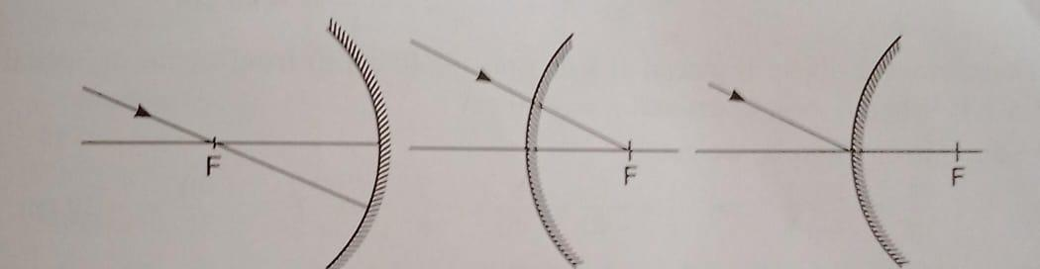  Draw the following diagram in which a Ray of light is incident on a concave and convex mirror on your answer sheet. Show the path of this Ray after reflection in each case. | 3 MARKS
 |  | All student wants to project the image of a candle flame on a screen 80 cm in front of a mirror by keeping the candle flame at a distance of 20 cm from its pole.  a) which type of mirror should the student use?  b) find the magnification of the image produced.  c) Find the distance between the object and its image ?  d) Draw a ray diagram to show the image formation in this case and mark the distance between the object and its image. | 3 MARKS
 |  | A student holding a mirror in his hand direct to the reflecting surface of the mirror towards the sun. He then direct it the reflected light on to a shit of paper held closed to the mirror.  a) what should he do to burn the paper?  b) Which type of mirror does he have?  c) will he be able to determine the approximate value of focal length of this mirror from this activity? give reason and draw ray diagram to justify your answer in this case. | 3 MARKS
 |  | Rishi went to a palmist to show his palm. The palmist used a special lens for this purpose.  (i) State the nature of the lens and reason for its use.  (ii) Where should the palmist place/hold the lens so as to have a real and magnified image of an object?  (iii) If the focal length of this lens is 10 cm, the lens is held at a distance of 5 cm from the palm, use lens formula to find the position and size of the image. | 4 MARKS  (1+1+2)
- 17 |  | An object 5 cm in length is held 25 cm away from a converging lens of focal length 10 cm. Draw the ray diagram and find the position, size and the nature of the image formed. | 4 MARKS
- 18 |  | a) If the image formed by a mirror for all positions of the object placed in front of it is always diminished erect and virtual state the type of the mirror and also draw a ray diagram to justify your answer. Write one use such mirror a put to and why.  b) define the radius of curvature of spherical mirror. Find the nature and focal length of spherical mirror whose radius of curvature is 24 cm. | 4 MARKS
 |  | if the image formed by a lens for all positions of the object placed in front of it is always virtual erect and diminished, state the type of the lens. Draw a ray diagram in support of your answer. If the numerical value of focal length of such a lens is 20 cm, find its power in new Cartesians sign convention. | 4 MARKS
- 19 |  | - A child reads words of a book with the help of a convex lens keeping it close to the book. He finds words enlarged and erect when he gradually withdraws the lens away from the book. At one position, the words again become distinctly visible but this time, these are enlarged and inverted. Explain the difference with the help of a ray diagram for both cases.  - An object is held at the principal focus of a concave lens of focal length f. Where the image will form. | 5 MARKS  (3+2)
 |  | Analysis the following observation table showing variation of image distance (v) with object distance (u) in case of convex lens and answer the questions that follow without doing any calculation:  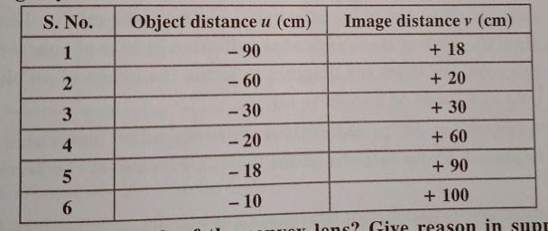  a) what is the focal length of the convex lens? give reason in support of your answer.  b) write the serial number of that observation which is not correct? How did you arrive at this conclusion?  c) take an appropriate scale to draw ray diagram for the observation at serial number 4 and find the approximate value of magnification. | 5 MARKS
Q.No | ANSWERS
- 1 | (d)
- 2 | (c) -50 cm
- 3 | (a) A solar cooker
- 4 | (a) A rectangular glass slab
- 5 | (b) virtual and erect
- 6 | (d) Convex lens
- 7 | (b) Refraction
- 8 | (c)Beyond C
- 9 | (a) √3 / √2
- 10 | (a) Reflection
 | a
 | d
 | d
 | a
 | d
 | a
 | a
 | a
 | b
 | d
- 11 | (a) He has to move the screen towards the lens, as for a convex lens, the image distance increases from the lens with the decreasing object distance and vice-versa. Final image is at the focus  (b) The focal length will be slightly less than 15 cm as the building can be treated as an object at infinite distance.
- 12 | 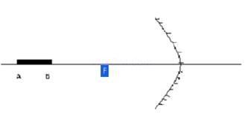  Combination of concave lens of focal length of 25 cm and a convex lens of focal length of ¼ m
- 13 | As the ray of light comes into air from the different points on the surface of a lemon kept in w water in a glass tumbler, it bends away from the normal, i.e. there is a change in the direction of propagation of light due to refraction. So the ray of light appears to come from a point different from that of the actual point.
 | 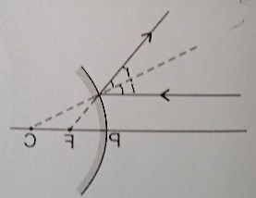
 | 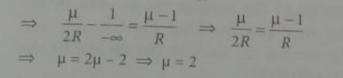
 | the focal length of a spherical mirror depends only on the radius of curvature of the hollow sphere of which the mirror is a part ( f = R/2). Both spherical mirrors are the part of the same hollow spherical ball. Hence, their radius of curvature is same. Therefore, ratio of their focal length will be 1:1. Mirror AB will always form a virtual image of an object placed in front of its because it is a convex mirror.
- 14 | 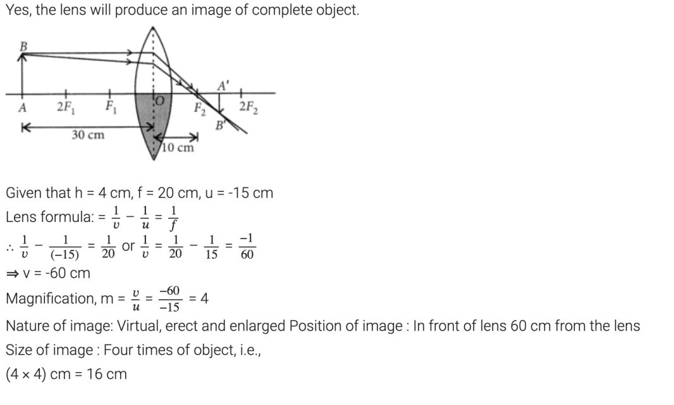
- 15 | The degree of convergence or divergence of light rays achieved by a lens is expressed in terms of its power. The power of a lens is defined as the reciprocal of its focal length. It is represented by the letter P. The power P of a lens of focal length f (in m) is given by  P=1/f  The SI unit of power of a lens is ‘dioptre’. It is denoted by the letter D.  The power of a convex lens is positive and that of a concave lens is negative. Thus, the lens with focal length 50 cm is convex and that with -50cm is convex. Their powers are +2 D and -2 D respectively.
- 16 | 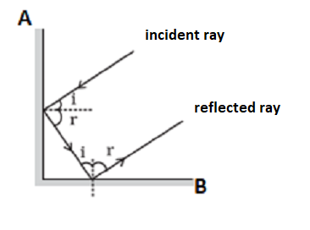  When two plane mirrors, like A and B, are placed perpendicular to each other, the incident ray and reflected ray will always be parallel to each other, whatever may be the angle of incidence.
 | 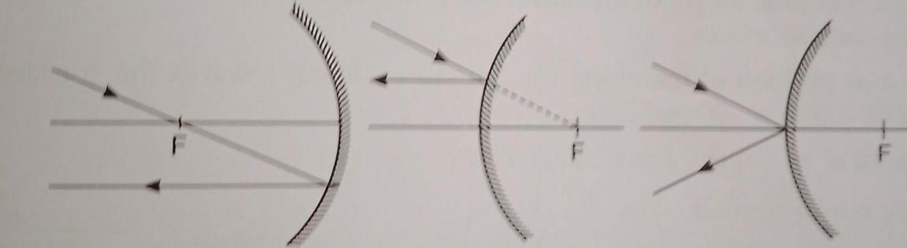
a) concave mirror
b) magnification,
m = -v/u
= - (-80/-20)
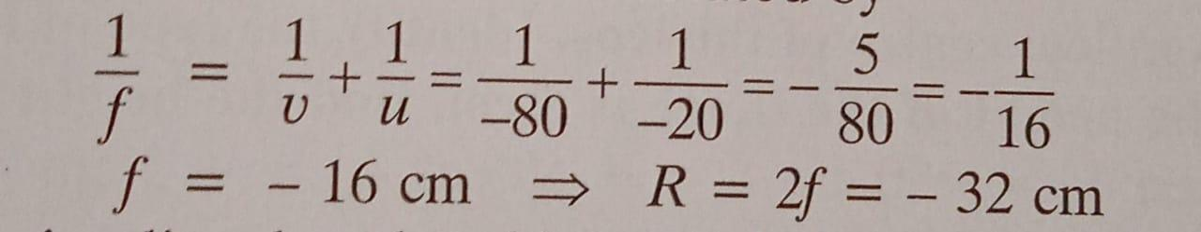
= -4
c) the focal length of the concave mirror is calculated by

Since u = - 20 cm, it implies that the object lies in between F and C.
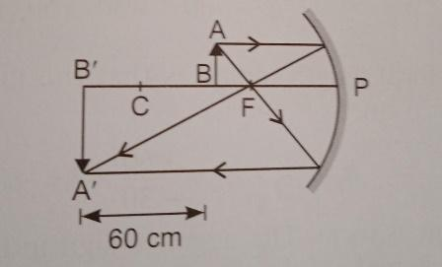
a) we should adjust the position of paper until bright shop image of the sun is obtained on the paper.
b) Concave mirror
c) yes, the distance between the mirror and paper gives an approximate value of focal length of the mirror.
- 17 | (i) The lens used here is a convex lens and it is used as a magnifying glass because at close range, i.eWhen the object is placed between the optic center and principal focus it forms an enlarged, virtual and erect image of the object.  (ii) When this lens is placed such that the object is between the center of curvature and the principal focus, the palmist obtains a real and magnified image.  (iii) Given focal length, f = 10 cm and u = -5 cm According to lens formula,  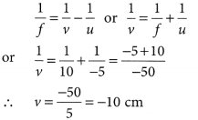  Thus, the image will be formed at 10 cm on the same side of the palm and the size of the image will be enlarged.
- 18 | 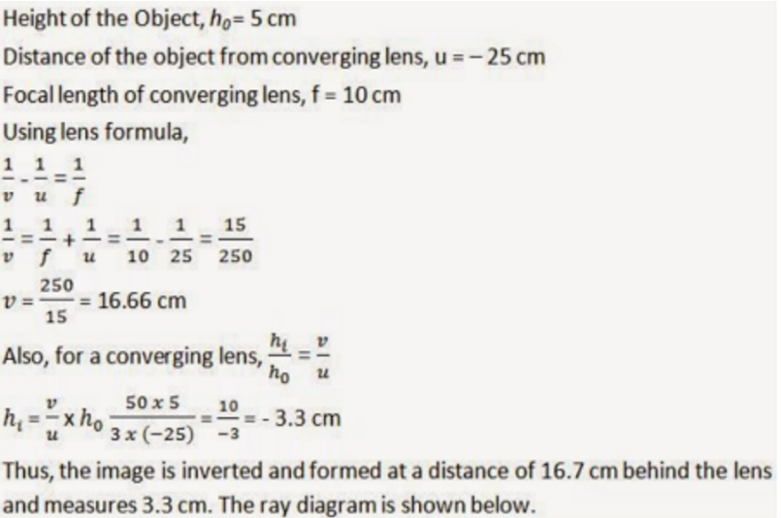  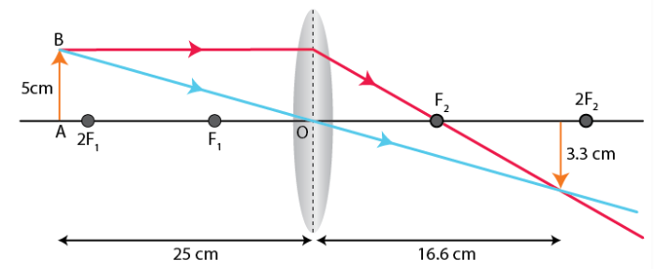
- convex mirror (diverging)
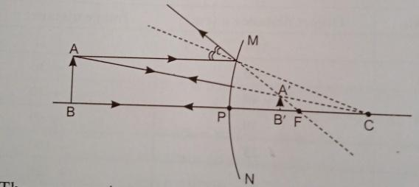

Use: the convex mirror can be used as a rear-view mirror.
Reason: it always produces says a virtual and erect image the size of image formed is smaller than the object. Therefore, it enables the driver to see a wide field view of the traffic behind the vehicle in a small mirror.
b) radius of curvature the separation between the pole and the centre of curvature are the radius of the hollow sphere of which the mirror is a part, is called radius of curvature that is PC = R.
since focal length of the mirror is 24 cm.
It indicates that nature of the given spherical mirror is convex that is diverging mirror.
As R = 2f = 24 cm
Therefore. f= 12 cm
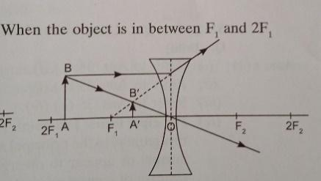
Does from the figure it is clear that whatever be the position of the object in front of a concave lens the image formed is always virtual erect and the diminished
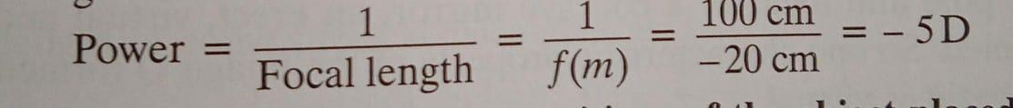
power of the given lens is calculated as
- 19 | 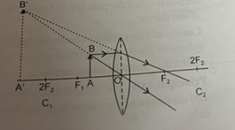  - When the child holds the book between the optical center O and F1, an enlarged, virtual and erect image is formed as shown :  Again when the child hols the book between F1 and 2F1, words again become distinctly visible as the image is formed beyond 2F2,and is real, inverted and enlarged as shown below:  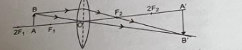  - Between the optical center (O) and its focus (F)
38 | a) the focal length of the convex lens is =15 cm.  Reason : objects at serial number 3 indicates that yu = -30 cm and v = 30 cm.  Thus ,object is at 2F.  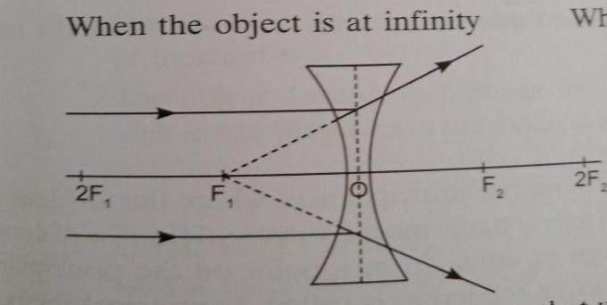  b) observation at serial number 6 is not correct. The value u =10 cm, indicates that the object is in between the optical centre and the focus that is less than the focal length of the lens and hence the image should be on the same side as the object. Hence the image distance should be negative and cannot be positive the shown in table.  c) ray diagram for the observation at serial number 4  given  u = - 20 cm  v = 60 cm  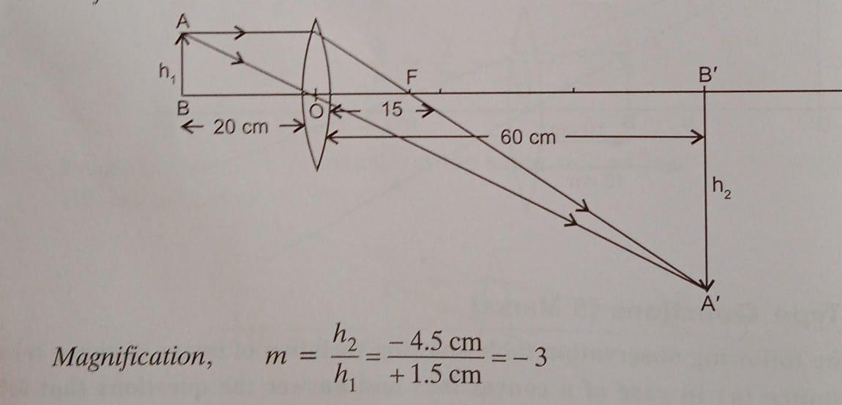  f= 15 cm

Chapter-10 Human eyes and the colourful world
1 | A person cannot see objects distinctly kept beyond 2 M. This defect can be corrected by using a lens of power.  a) +0.5 D b) -0.5 D c) +0.2 D d)-0.2D | 1
2 | At noon the sun appears white as  a) light is least scattered b) all the colours of the white light are scattered away c) blue colour is scattered the most d) red colour is scattered the most. | 1
3 | When light rays enter the eye, most of the refraction occurs at the  a) crystalline lens b) outer surface of the cornea c) iris d) pupil. | 1
4 | The phenomenon of light responsible for the working of the human eye is  a) Reflection b) refraction c) power of accommodation d) phototropism. | 1
5 | The focal length of the eye lens increases when eye muscles  a) are relaxed & lens becoming thinner b) contract & lens becomes thicker c) are relaxed & lens becomes thicker d) contract & lens becomes thinner. | 1
6 | Twinkling of stars is due to atmospheric  a) Dispersion of light by water droplets b) refraction of light by different layers of varying refractive indices c) scattering of light by dust particles d) internal reflection of light by clouds. | 1
7 | Which of the following phenomenon of light is involved in the formation of a rainbow?  a) reflection, refraction & dispersion b) refraction, dispersion & total internal reflection c) refraction, dispersion & internal reflection d) dispersion, scattering & total internal reflection. | 1
8 | In an experiment to trace the path of a ray of light through a triangular glass prism, a student would observe that the emergent ray  a) is parallel to the incident ray.  (b) Is along the same direction of incident ray.  (c) Gets deviated and bends towards the thinner part of the prism.  (d)gets deviated & bends towards the thicker part (base) of the prism. | 1
9 | The human eye can focus objects at different distances by adjusting the focal length of the eye lens. This is due to  (a) presbyopia (b) accommodation (c)nearsightedness (d) farsightedness | 1
10 | The clear sky appears blue because:  (a) Blue light gets absorbed in the atmosphere (b) ultraviolet radiations are absorbed in the atmosphere (c) violet & blue lights get scattered more than light of all other colourby the atmosphere (d) light of all other colours is scattered more than the violet and blue colour light by the atmosphere. | 1
11 | State one function of iris in human eye | 1
12 | State one function of the crystalline lens in human eye | 1
13 | At noon, the sun appears white as  a. Light is least scattered  b. All the color of the white light are scattered away  c. Blue colour is scattered most  d. Red colour is scattered most | 1
14 | Which of the following statements is correct regarding the propagation of light of different color of white in air  - red light moves fastest  b. blue light moves faster than Blue light  c. All the colours of the white light move with the same speed  d. yellow light move with the same speed | 1
15 | Assertion _ Higher the refractive index of the prism material, higher is the angle of deviation  Reason _for a prism material, the angle of deviation is directly proportional to the angle of prism  (a) Both Assertion (A) and Reason (R) are the true and Reason (R) is a correct explanation of Assertion (A).  (b) Both Assertion (A) and Reason (R) are the true but Reason (R) is not a correct explanation of Assertion (A).  (c) Assertion (A) is true and Reason (R) is false.  (d) Assertion (A) is false and Reason (R) is true. | 1
16 | Assertion _ Sun may be considered as a source of monochromatic light.  Reason _ The light of a single wave length is called monochromatic light. | 1
17 | Assertion _ The sun light has to cover a larger distance when it is overhead.  Reason _The sun appears white at noon. | 1
18 | When light travel from hot air to cold air, then it bends  a. towards the normal  b. away from the normal  c. towards normal and scatter  d. away from the normal and scatter | 1
19 | The sun appears oval shaped or flattened due to  a. scatterings of light  b. dispersion of light  c. atmospheric refraction  d. None of the above | 1
20 | To an astronaut in a spaceship, the colour of the earth appears  a. red b. blue c. white d. black | 1
21 | Which type of image is created on retina ?  a. real image  b. virtual image  c. both  d. none of these | 1
22 | A person suffering from cataract has  a. opaque eye lens  b. weakened ciliary muscle  c. excessive curvature of eye lens  d. elongated eyeball | 1
23 | The focal length of eye lens increases when eye muscles  a. contract& lens become thinner  b. are relaxed & lens become thicker  c. contract and lens become thicker  d. are relaxed and lens become thinner | 1
24 | The danger signals installed at the top of building are red in colour as it  a. is scattered least by smoke or fog  b. is scattered most by smoke or fog  c. is absorbed most by smoke or fog  d. moves fastest in air | 1
25 | The colour deviated least by prism in spectrum of white light  a. green b. red c. violet d. yellow | 1
26 | ASSERTION: The sky looks dark in space.  REASONING: No atmosphere containing air in space to scatter light. | 1
27 | ASSERTION: A normal eye can see objects clearly beyond certain minimum distance.  REASONING: The human eye can adjust focal length of eye lens. | 1
28 | ASSERTION: Myopic eye can see near by objects clearly.  REASONING: The eye ball is elongated. | 1
29 | ASSERTION: Scattering of light by colloidal particles gives rise to Tyndall effect .  REASONING: The colour of scattered light depends on the size of scattering particles. | 1
30 | ASSERTION: A rainbow is seen in rainy season when observer’s back towards sun.  REASONING: Internal reflection in water droplets cause dispersion and final rays are in backward direction. | 1
31 | Draw ray diagrams each showing (i) myopic eye (ii) hypermetropic eye. | 2
32 | Write the function of each of the following parts of human eye.  (i) cornea (ii) iris (iii) crystalline lens (iv) ciliary muscle | 2
33 | What is meant by power of a lens? What does its sign (+ve or – ve) indicate? State its SI unit. How is this unit related to focal length of a lens? | 2
34 | What is rainbow? Draw a labelled diagram to show the formation of a rainbow | 2
35 | Draw a ray diagram to explain the term angle of deviation | 2
36 | A person may suffer from both myopia and hypermetropia defects.  (a) What is this condition called?  (b) When does it happen?  (c) Name the type of lens often required by the persons suffering from this defect. Draw labelled diagram of such lenses | 2
37 | Rahul was discussing with his friends about his father using spectacles with a power of + 3.5 D. What type of eye defect his father is suffering from and what is the nature of lens used? | 2
38 | Why sky seems different to us and the astronauts? | 2
39 | Pooja while looking towards the sky observed ring around moon. Why this happens? | 2
40 | A person is suffering from both myopia & hypermetropia.  a) What kind of lenses can correct this defect?  b) How are these lenses prepared?  c) A person needs a lens of power +3 D for correcting his near vision & -3 D for correcting his distant vision. Calculate the focal lengths for the lenses required to correct these defects. | 3
41 | (a)What is visible spectrum?  (b)Why is red used as stopping light at traffic signals?  (c)Two triangular glass prisms are kept together connected through their rectangular side. A light beam is passed through one side of the combination. Will there be any dispersion? Justify your answer. | 3
42 | Differentiate between a glass slab & a glass prism. What happens when a narrow beam of (i) monochromatic light & (ii) white light passed through (a) glass slab (b) glass prism? | 3
43 | Define the term power of accommodation. Write the modification in the curvature of the eye lens which enables us to see the nearby objects clearly? | 3
44 | (a) List two causes of hypermetropia.  (b) Draw ray diagrams showing (i) a hypermetropic eye and (ii) its correction using suitable optical device | 3
45 | What is ‘dispersion of white light’? State its cause. Draw a ray diagram to show the dispersion of white light by a glass prism | 3
46 | Simran’s little sister asked her why red colour is seen at the top of the rainbow? How she can explain to her? | 3
47 | Mohan was frequently finding difficulty in seeing the blackboard from the last bench . What the teacher should suggest? | 3
48 | Raman noticed, his teacher while looking at the back benchers was removing his glasses frequently but not while looking into the book. Give reason. | 3
49 | Read the following passage and answer the following questions.  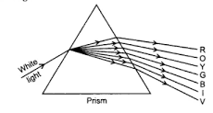  A narrow beam of light is passing through a glass prism as shown in the diagram. Study the diagram and answer the questions.  i) The phenomenon observed in the above set –up is  a) scattering of light  b) dispersion of light  c) reflection of light  d) refraction of light  ii) In nature, this phenomenon is observed in  a) Formation of rainbow  b) Twinkling of stars  c) Blue colour of sky  d)Advance sunrise  iii) Which of the following is correct about constituents of white light based on above observations?  a) White light consists of seven colors.  b) Violet colour suffers minimum deviation.  c) Red light suffers maximum deviation.  d) All the colours of the white light move with different speed in vacuum.  iv) The cause of dispersion of light is  a) All the colors of light travel with the speed more than the speed of light.  b) All colors have different angles of deviation.  c) All the colors do not travel with the same speed of light.  d) All colors have the same wave length. | 4
50 | Atmospheric refraction is the phenomenon of bending of light on passing through earth’s atmosphere. As we move above the surface of earth, density of air goes on decreasing. Local conditions like temperature etc. also affect the optical density of earth’s atmosphere. On account of atmospheric refraction, stars seen  Appear higher than they actual are; advanced sunrise; delayed sunset, oval appearance of the sun at sunrise and sunset; stars twinkle, planets do not.  i) Due to atmospheric refraction, apparent length of the day  a) increases  b) decreases  c) remains the same  d) all of these  ii) Apparent position of the star appears raised due to  a) atmospheric refraction  b) scattering of light  c) both a & b  d) none of these  iii) The sun appears oval shaped or flattened due to  a) dispersion  b) scattering  c) atmospheric refraction  d) none of these  iv) Twinkling of stars &non –twinkling of the planets is accounted for by  a) scattering of light  b) dispersion of light  c) atmospheric refraction  d) none of these  v) In the absence of atmosphere, the colour of sky appears  a) blue  b) black  c) red  d) yellow | 4
51 | Trace the sequence of events which occur when a bright light is focused on your eyes | 4
52 | Differentiate between a glass slab and a glass prism. What happens when a narrow beam of  (i) a monochromatic light and (ii) white light passes through (a) glass slab and (b) glass prism | 4
53 | Richa’s grandfather was finding difficulty in identifying objects around him. After consultation with an ophthalmologist, he started feeling comfortable.  a. What defect was he suffering from?  b. What doctor could have suggested?  c. Draw a diagram showing the type of lenses used by him. | 4
54 | a. Why always red light is used as traffic signal to stop?  b. Why we find difficulty in visualizing things inside rooms after coming from a broad daylight? | 4
55 | (a) What is meant by the term power of accommodation? Name the component of eye that is responsible for the power of accommodation.  (b) A student sitting at the back bench in a class has difficulty in reading. What could be his defect of vision? State two possible causes of this defect. Explain the method of correcting this defect with the help of ray diagram. | 5
56 | What is myopia? List two causes for the development of this defect? How can this defect be corrected using a lens? Draw ray diagrams to show the image formation in case (i) defective eye and (ii) corrected eye. | 5

Answers
Chapter-10 Human eyes and the colorful world
Q | Answers
1 | B
2 | A
3 | B
4 | B
5 | A
6 | B
7 | B
8 | D
9 | B
10 | C
11 | Irish a dark muscular diaphragm that controls the size of the pupil.
12 | The crystalline lens of human eye focuses the light that enters the eye and form the image on the retina.
13 | A
14 | C
15 | B
16 | D
17 | D
18 | A
19 | C
20 | D
21 | B
22 | A
23 | D
24 | A
25 | B
26 | Both A and R are true and R is the correct explanation of A
27 | Both A and R are true and R is the correct explanation of A
28 | Both A and R are true and R is the correct explanation of A
29 | Both A and R are true and R is not the correct explanation of A
30 | Both A and R are true and R is the correct explanation of A
31 | 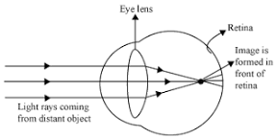  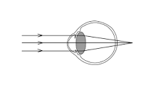
32 | i) Cornea: focuses light rays/ permits the light to enter the eye.  ii) Iris: controls the amount of light entering the eye & the size of the pupil.  iii) Crystalline lens: converges light rays at retina.  iv) Ciliary muscles: adjusts focal length of eye lens by contraction & relaxation so that sharp image can be obtained on the retina / helps in accommodation.
33 | The power of a lens is defined as the reciprocal of its focal length. Positive sign for convex lens & negative sign for concave lens. The SI unit of power is diopter (D). D= 1f
34 | A rainbow is a natural spectrum caused by dispersion of sunlight by tiny water droplets, present in the atmosphere.  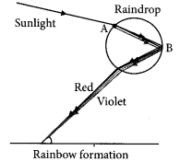  Point A denotes dispersion and point B denotes internal reflection.
35 | The emergent ray bends at an angle to the direction of the’incident, thus the angle between them is known as angle of deviation (D).  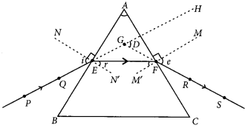
36 | a) This condition is called presbyopia.  (b) It happens due to gradual weakening of ciliary muscles and diminishing flexibility of eye lens due to agening.  (c) It can be corrected by using bifocal lenses
37 | hypermetropia , convex lens
38 | On earth ,the particles in the atmosphere scatters light ray making the sky blue but due to the absence of atmospheric particles, sky seems dark in space.
39 | When moon is observed through a thin layer of high clouds, reflection of light from fine icy crystals in the clouds result in formation of rings.
40 | a) i. bifocal lens  ii. A bifocal lens consists of both convex lens & concave lens. The convex lens used in bifocal lens is used to correct hypermetropia (farsightedness) & concave lens is used to correct myopia (shortsightedness) .  (b) P= 1/f  P₁ =+3D =1/f₁ F₁=1/3= +0.33 m(Convex lens)  P₂= -3D =1/f₂F₂ ₌ -1/3 =-0.33m(Concave lens)
41 | a) Visible spectrum is the band of coloured components of a white light beam.  b) Red light is scattered the least by air molecules & has longer wave length .It travels the longer distance.  c) The given set up will behave like a glass slab, resulting in combination of the seven colors to produce white light.
42 | Glass slab: It is rectangular in shape. In this, the direction of incident ray & emergent ray of light are parallel to each other.  Glass prism: It has two triangular sides, two inclined rectangular sides & one rectangular base. In this, the direction of incident ray & emergent ray of light are not parallel to each other.  When a narrow beam of monochromatic light passes through:  a) Glass slab: It has deviated from the actual path but the direction of the incident ray & the emergent ray are parallel to each other.  b) Glass prism: It has deviated from the actual path but the direction of the incident ray & the emergent ray are not parallel to each other.  When a narrow beam of light passes through:  a) Glass slab: it does not split into its constituent colour. The direction of incident ray & emergent ray of light are parallel to each other.  b) Glass prism: It splits into its constituent seven colour .The direction of incident ray & emergent ray of light are not parallel to each other.
43 | The ability of the eye lens to adjust its focal length is called power of accommodation. The ciliary muscles modifies the curvature to some extent. The change in the curvature of the eye lens can thus change its focal length. When the ciliary muscles contract, the lens becomes thick and its focal length decreases, thus enables us to see nearby objects clearly.
44 | 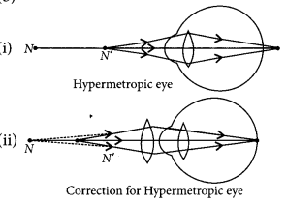  (a) Hypermetropia is caused due to following reasons:  (i) Shortening of the eyeball  (ii) Focal length of crystalline lens is too long.
45 | Splitting of white light into its seven constituent colours due to refraction is known as dispersion of white light.  Cause of dispersion : When a beam of white light enters a prism, it gets refracted and splits into seven constituent colours. The splitting of the light ray occurs due to the different bending angle for each colour. Thus, each colour ray when passing through the prism bends at different angles with respect to the incident beam, thus giving rise to a spectrum.  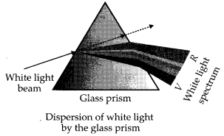
46 | Red light has longest wavelength and least deviation thus remains at the top of rainbow.
47 | Teacher should ask him to consult doctor as he might be suffering from myopia for which he can use concave lenses.
48 | His teacher was suffering from hypermetropia, so distant vision was clear but not near vision.
49 | i- b, ii-a ,iii- a, iv-c
50 | i- a ,ii-b ,iii-c, iv-c ,v- b
51 | When a bright light enters the eye then most of the refraction for the light rays entering the eye occurs at the outer surface of the cornea. Then, the crystalline lens merely provides the finer adjustment of focal length required to focus object at different distances on the retina. The pupil regulates and controls the amount of light entering the eye. At retina, the light-sensitive cells get activated upon illumination and generate electric signals. These signals are sent to the brain via the optic nerves. The brain interprets these signals and finally, processes the information so that we perceive objects as they are.
52 | Glass slab:  - It is a substance made of glass having three dimension and has cuboidal structure.  - It does not deviate the path of light falling on it but produces a lateral displacement of the light ray after refraction. The incident and emergent ray are parallel to each other.  Glass prism:  - A prism is a structure made of glass with two triangle bases and three rectangular lateral surfaces. These surfaces are inclined to each other.  - A prism deviates the path of light ray falling on it. Here the incident ray and emergent ray are not parallel to each other.  (i) When a narrow beam of monochromatic light falls on a  (a) glass slab, it gets refracted at its surface and the emergent ray is laterally displaced from the incident ray.  (b) prism, it gets refracted at the surface and the light gets deviated from its initial path. The angle between the incident ray and emergent ray is known as angle of deviation.  (ii) When a white light passes through a  (a) glass slab, the light does not undergo dispersion as its two refracting surfaces are parallel to each other. The white light is laterally displaced from its initial path.  (b) prism, the white light undergoes dispersion and splits into its constituent colours along with deviation from its initial path.
53 | 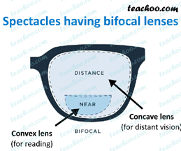  . a. hypermetropia and myopia  b. bifocal lens  c.
54 | a. Red light has longest wavelength thus least refraction through air particles and thus can be seen from long distances also.  b. Eye takes time to adjust photoreceptors as per the available light intensity and also lens takes time to readjust itself.
55 | 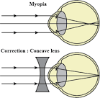  a) Power of accommodation: It is the ability of the eye lens to adjust its focal length.  Ciliary muscles of eyes are responsible for change in its focal length.  (b) Myopia  Causes: (i) Excessive curvature of the eye lens.  (ii)Elongation of eye ball.  This defect can be corrected by using a concave lens of suitable power.
56 | Myopia is also known as near-sightedness defect in which a person can see nearby objects clearly but cannot see distant objects distinctly. This defect may arise due to  (a) excessive curvature of the eye.  (b) elongation of the eye ball.  This defect can be corrected by using a concave lens of suitable power.

Chapter-11 Electricity
1 | The effective resistance when two identical resistors of resistances ‘R’ each connected in parallel is  (a) 2 R. (b) R / 2 (c) R (d) 4 R | 1
2 | A wire of resistance R is cut into two equal halves. The resistance of the half is  ( a) R (b) R / 2 (c) 2 R ( d) none of these. | 1
3 | Two conducting wires of the same material and of equal lengths and equal diameters are first connected in series and then in parallel in a circuit across the same potential difference. The ratio of heat produced in series and parallel combination would be…  (a) 1 : 2 (b) 2 : 1 (c) 1: 4 (d) 4 : 1 | 1
4 | When resistors are combined in series ____ through each resistor is same  (a) resistance (b) potential difference (c) current  (d) heat generated | 1
5 | When the temperature of a conductor increases ,its resistance ________.  (a) increases (b) decreases (c) No change  (d) initially increases then decreases. | 1
6 | Working principle of electrical fuse is based on_______  (a) heating effect of electric current  (b) chemical effect of electric current.  (c) magnetic effect of electric current  (d) All of these. | 1
7 | A cylindrical conductor of length ‘l’ and uniform cross section ‘A’ has resistance ‘R’. The area of cross section of another conductor of same material and same resistance but of length ‘2l’ is  ( a) A/2 (b) 3 A / 2 (c) 2 A (d) 3 A | 1
8 | An electric bulb is rated 220 V and 100 W. When it is operated on 110 V , the power consumed will be  (a) 100 W (b) 75 W (c) 50 W (d) 25 W | 1
9 | For the given question two statements are given, one labelled as Assertion (A) and the other labelled as Reason ( R). Select the correct answer to these questions from the codes (a), (b), (c) and (d) as given below.  (a) Both (A) and ( R ) are true and ( R ) is correct explanation of Assertion  (b) Both (A) and ( R ) are true but ( R ) is not correct explanation of Assertion  ( c) ( A) is true but (R ) is false  (d) (A) is false but (R ) is true  Assertion(A) : Tungsten metal is used for making filaments of incandescent lamps.  Reason (R): The melting point of tungsten is very low. | 1
10 | Assertion (A) : Longer wires have greater resistance and the smaller wires have lesser resistance.  Reason (R) : Resistance is inversely proportional to the length of the wire. | 1
11 | Let us consider that because of the flow of the current flowing through a metallic wire if the temperature of the entire system increases. What will happen from the following options ?  (a) Potential difference (V) increases  (b) Resistance (R) decreases  (b) Potential difference (V) decreases  (d) V and R remains the same | 1
12 | A cylindrical conductor of length ‘l’ and uniform area of cross section ‘A’ has resistance ‘R’. The area of cross-section of another conductor of same material and same resistance but of length ‘2l’ is :  (a) A/2  (b) 3A/2  (c) 2 A  (d) 3 | 1
13 | For which of the following substances, resistance decreases with increases in temperature?  (a) Mercury  (b) Silver  (b) Copper  (d) Carbon | 1
14 | Electrical resistivity of an alloy of copper and nickel is ________ when compared with the electrical resistivity of an alloy of copper, manganese and nickel.  (a) same  (b) double  (c) more  (d) les | 1
15 | A wire of resistance R is cut into ten equal parts which  are then joined in parallel. The new resistance is  (a) 0.01 R  (b) 0.1 R  (c) 10 R  (d) 100 R | 1
16 | A 24 V potential difference is applied across a parallel combination of four 6 ohm resistor. The current in each resistor is  (a) 1 A  (b) 4 A  (c) 16 A  (d) 36 A | 1
17 | 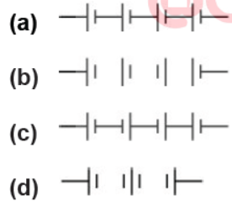  The proper representation of series combination of cells obtaining maximum potential is: | 1
18 | Which of the following terms does not represent electrical power in a circuit ?  (a) I2R  (b) IR2  (c) VI  (d) V2/R | 1
19 | Assertion : Voltmeter is always connected in parallel across the circuit while measuring the potential difference.  Reason : As the voltage in parallel circuits is measured to be the same.  (a) If both assertion and reason are true and reason is the correct explanation of assertion.  (b) If both assertion and reason are true, but reason is not the correct explanation of assertion.  (c) If assertion is true, but reason is false.  (d) If assertion is false, but reason is true | 1
20 | Assertion : Bulbs are filled with inactive nitrogen and argon gases.  Reason : As there is a requirement of thermal isolation of the filament.  (a) If both assertion and reason are true and reason is the correct explanation of assertion.  (b) If both assertion and reason are true, but reason is not the correct explanation of assertion.  (c) If assertion is true, but reason is false.  (d) If assertion is false, but reason is true | 1
21 | How is the current flowing in a conductor changed if the resistance of conductor is doubled keeping the potential difference across it the same? | 2
22 | What happens to the resistance and resistivity of a wire in the following cases  (i) wire is cut into two equal halves  (ii) wire is stretched to double its length, | 2
23 | State Ohm’s law. Draw a labelled circuit diagram to verify this law in the laboratory. | 2
24 | 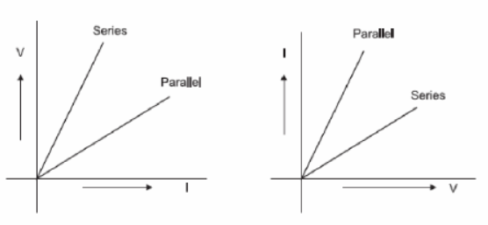  Two students perform the experiments on series and parallel combinations of two given resistors R1 and R2 and plot the following V-I graphs.  Which of the graphs is (are) correctly labelled in terms of the words ‘series’ and parallel’ Justify your answer. | 2
25 | 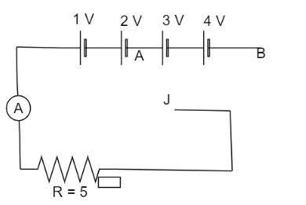  In the given figure what is ratio of ammeter reading when J is connected to A and then to B. | 2
26 | How many bulbs of 8Ώ should be joined in parallel to draw a current of 2A from a battery of 4 V? | 2
27 | Find the heat generating while transferring 96000 coulomb of charge in one hour through a potential difference of 50 V. | 3
28 | Write three advantages of connecting the electrical appliances in parallel with the mains than in series. | 3
29 | A battery of 9 V is connected in series with resistors 2 Ω , 3Ω, 5 Ω and 7 Ω, respectively. How much current would flow through the 7Ω resistor? | 3
30 | The current flowing through a resistor connected in a circuit and the potential difference developed across its ends are as shown in the diagram by milliammeter and voltmeter readings respectively  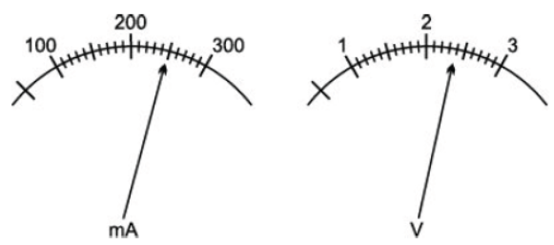  (a) What are the least counts of these meters?  (b) What is the resistance of the resistor | 3
31 | Two bulbs rated (60 W – 220 V) and (60 W – 110 V) respectively.  Calculate the ratio of their resistance | 3
32 | An electric kettle is rated at (100 W – 220 V).  (a) What is the resistance of its element when in use?  (b) What is the safe value of current that can pass through its element | 3
33 | The resistivity values of some substances are given below.  Answer the following questions in relation to them giving justification for each  (i) Which material is best for making connecting wires?  (ii) Which material do you suggest to be used in heating devices?  (iii) You have two wires of same length and same thickness. One is made of material A and another of material D. If the resistance of wire made of A is 2 Ω, what is the resistance of the other wire? | 4
  Materials | A | B | C | D | E
  Resistivity ( Ω m) | 1.6 x 10⁻⁸ | 6.4 x10⁻⁸ | 10 x 10⁻⁸ | 96 x10⁻⁸ | 100 x10⁻⁸
34 | Define 1 kWh. An electric refrigerator rated 400 W operates 8 hour per day . What is the cost of the energy to operate it for 30 days at Rs 3.00 per kWh? | 4
35 | Read the passage given below and answer the following questions from Two or more resistances are connected in series or in parallel or both, depending upon whether we want to increase or decrease the circuit resistance.  The two or more resistances are said to be connected in series if the current flowing through each resistor is same. The equivalent resistance in the series combination is given by RS = R₁ + R₂ + R₃  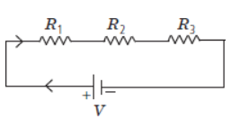  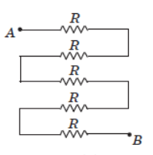  Question i) In the following circuit, find the equivalent resistance between A and B is (R = 2Ω)  (a) 10 Ω  (b) 5 Ω  (c) 2 Ω  (d) 4 Ω  Question ii) There is a wire of length 20 cm and having resistance 20 ohm cut into 4 equal pieces and then joined in series. The equivalent resistance is  (a) 20 ohm  (b) 4 ohm  (c) 5 ohm  d) 10 ohm  Question iii) When three resistors are connected in series with a battery of voltage V and voltage drop across resistors is V1, V2 and V3, which of the relation is correct?  (a) V = V1 = V2 = V3  (b) V = V1 + V2 + V3  (c) V1 + V2 + V3 = 3V  (d) V > V1 + V2 + V  Question iv) When the three resistors each of resistance R ohm, connected in series, the equivalent resistance is  (a) R/2  (b) > R  (c) < R/2  (d) <R | 4
36 | Read the passage carefully and answer the following questions from Ohm’s law is the relationship between potential difference and current in a circuit which was first established by George Simon Ohm. The law states that the current passing through a metallic conductor is directly proportional to the potential difference applied between its ends. V ∝ I i.e., V = kI where k is the resistance offered by the conductor and is constant for a given conductor. Although a large class of materials is known to follow Ohm’s law, there do exist materials used in circuits that do not follow the direct relationship between V & I  Question i) . The slope of the V-I graph shall give:  (a) resistance  (b) reciprocal of resistance  (c) power  (d) charge  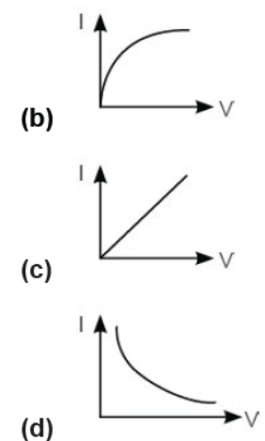  Question ii). Four students have plotted the graph between V-I for a conductor. Which one is correct?  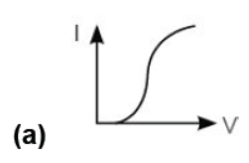  Question iii) By increasing voltage across a conductor:  (a) current will increase.  (b) current will decrease.  (c) resistance will decrease.  (d) resistance will increase  Question iv) If in a circuit both the potential difference and resistance are doubled, then  (a) current is doubled.  (b) current is halved.  (c) current remains same.  (d) current is four times | 4
37 | An electric geyser consumes 2.2 units of electrical energy per hour of its use. It is designed to work on the mains voltage of 220V.  a) What is the ‘power-rating’ of this device?  b) What is the current flowing through this device when it is connected across the ‘mains’?  c) What is the ‘resistance’ of this device?  d) Does the resistance of this device remain constant during its operation/working?  e) Find the cost of energy consumed if each unit cost Rs. 5/-. | 5
38 | An electric lamp of resistance 20 W and a conductor of resistance 4 W are connected to a 6 V battery as shown in the circuit. Calculate  (a) the total resistance of the circuit,  (b) the current through the circuit,  (c) the potential difference across the (i) electric lamp and (ii) conductor,  (d) power of the lamp. | 5

Answers
Chapter- 11 Electricity
Q | Answers
1 | For parallel combination, we know that equivalent resistance is given by  1/RP=1/R+1/R = R/2  Correct Option (b) R/2
2 | Let the length of the wire be 'l' and area of cross-section be 'A' and resistivity of the material be ρ  Therefore R = ρ L/A  When it is cut then take each of the piece:-  Its resistance = ρ L/2A= R/2  Correct option (b) R/2
3 | Let R be the value of each resistance.  For series combination, resistances are connected end by end and equivalent resistance is given by formula  R_{S}=R+R=2R  For parallel combination 1/R_{P}= 1/R+1/R= R/2  R_{P}/R_{S}=R/2×1/2R = ¼  According to Joule’s law of heating resistance is directly proportional to heat.  Hence the answer is option (d) 4:1
4 | In series combination of resistors the current is the same in every part of the circuit or the same current through each resistor.  Correct Option (c)
5 | Resistance is directly proportional to temperature which means whenever temperature increases, the resistance of the conductor will also tend to increase.  Correct Option (a)
6 | Electric fuse wire is working on the heating effect of electric current that the conductor will get heated up by passing an electric current through it for some time and this generated heat melts the fuse wire.  Correct option is (a)
7 | R= ρL/A  ρ is the resistivity of the cylindrical conductor.  According to question  R′ =ρ2L/ A′  A′ is the unknown cross section of the second conductor  Since R′=R (Given)  or, ρL/A​=ρ2L/ A′  A′=2A  Correct Option (c)
8 | P = V²/R  If V = 220 V we have  100 W = 220²/R  R = 220²/100 Ω = 484 Ω. This is the resistance of the bulb.  When V = 110 V, power consumed = V2/R = 110² /484 = 25 W.  Correct Option (d)
9 | Tungsten is used as the filament in incandescent light bulbs because it has the highest melting point of any metal (greater than 3400 deg. Celsius) and the higher the temperature, the greater the efficiency and whiter the light.  Correct Option (c)
10 | (C) Assertion is True but Reasoning is False.  Assertion: It is true that that R=ρ × L/A. Here, R, ρ, L and A are the resistance, resistivity, length of wire and cross-sectional area respectively.  Reason: Here, we can say that resistance is directly proportional to the length of a wire. That means if the length of a wire increases then resistance also increases.  Therefore, A is true but R is false.
11 | C
12 | C
13 | D
14 | C
15 | A
16 | B
17 | A
18 | B
19 | A
20 | C
21 | Using Ohm's law, for constant potential difference, we may write: I∝1/R.  Hence, if the resistance is doubled, current becomes half.
22 | - Resistance becomes half as it is directly proportional to length, resistivity remains constant.  Resistance is doubled as it is directly proportional to length, resistivity remains constant as it is a material specific property.
23 | It states that the potential difference V, across the ends of a given metallic wire in an electric circuit is directly proportional to the current flowing through it, provided its temperature remains the same. Mathematically,  V ∝ I  V = RI  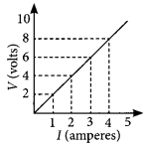
24 | Both are correct because ΔV/ΔI= resistance(R) and ΔI/ΔV=1/R Series means high resistance and parallel means low resistance.
25 | when J is connected to A  I=V/R=3/5A=O.6A  When J is connected to B  V=1+2+3+4=10V  I=10/5=2A
26 | R=V/I=4/2=2 Ώ, let ‘n’ be the no of bulbs.  1/R=1/R₁ + 1/R₂ +……..1/R_{n} =n/8  ½=n/8, n=4.
27 | Q=96000 C  t=1 hr=3600seconds  I=tQ​=360096000​=380​A  V=50 V  Amount of heat generated is  H=VIt  =50×380​×3600  =4800000 J
28 | (i)In parallel combination each appliance gets the full voltage.  (ii) If one appliance is switched on, others are not affected.  (iii) The parallel circuit divides the current through the appliances. Each appliance gets proper current depending on its resistance.
29 | Battery=9V  R1= 2ohm  R2= 3ohm  R3= 5ohm  R4= 7ohm  As all are connected in series effective resistance would be :  Reff = R1+R2+R3+R4  = 2+3+5+7  = 17 OHMS  By ohms law : V=IR  I=V/R  =9/17  =0.52 A  As resistors are connected in series current across 7 Ohms resistor is 0.52A
30 | (a) 10 mA and 0.1 V  (b) V = 2.4 volt, I = 250 mA = 0.25 A  From Ohm’s law. R = V/I = 2.4/0.25 = 9.6 ohm
31 | First bulb:  Power rating P1 = 60 W  Voltage rating V1 = 220 V  ∴ Resistance, R1 = V12/P1  = 220 X 220 /60 Ω  Second bulb:  Power rating P2 = 60 W  Voltage rating, V2 = 110 V  ∴ Resistance, R2 = V22/P2  = 110 x 110/60 Ω  220 x 220 / 60  R1/R2 = 110 x 110 /60  = 220 x 220 /60 x 60/110 x 110  = 4/1  R1 : R2 = 4 : 1
32 | Here, Power rating, P = 1000 W  Voltage rating, V = 220 V  (a) Using the relation P = V2/R  Resistance of element when in use,  R = V2/P = 220 x 220/1000  = 48.4 W  (b) Using the relation P = VI  Safe current, I = P/V = 1000/20  = 4.55 A
33 | - A is best conductor of electricity due to its least electrical resistivity.  - E because it has the highest electrical resistivity.  - Resistivity of material A, ρ1 ​= 1.6×10−8 Ohm m  Resistivity of material B, ρ2 = 96×10−8 Ohm m  The resistance of wire A, R1 = 2 Ohm  We need to find the resistance of wire B. It can be calculated using formula of resistance in terms of resistivity as : R = ρl/A  Since, two wires of same length and same thickness. So,  For two wires, ​R1/R2 ​= ρ1/ρ2​​  R2 = 2×96×10⁻⁸/1.6×10 ^{−8 ​}= 120 Ohm
34 | A kilowatt-hour is the amount of electrical energy used by a device of 1 kilowatt power when it is used for one hour.  1 kWh=3.6×106 J  Energy of one day = Power × Time = 400W × 8h = 3.2KWh  Energy of 30 days = 3.2KWh×30 = 96KWh  So, cost of the energy = 96×3 = Rs.288
35 | - a  - a  - b  - b
36 | - a  - c  - a  - c
37 | We know that  1 unit = 1KWH = 3.6×10^6 J  2.2 units = 7.92×10^6 J  V = 220 V  (a) Energy = 7.92×10^6 J  Time = 3600 s  Power = 7.92 × 10^3/3.6  = 2200W  (b) I = P/V = 2200/220 = 10 A  (c) R = V/I = 220/10 = 22 Ohms  (d) During working of electric geyser, temperature increases due to that, resistance may also increase  (e) Cost of 1 unit = Rs 5/-  Cost of 2.2 units = Rs 11/-
38 | (a) Given, R1 = 20 ohm, R2 = 4 ohm  Since, in Series R = R1 + R2  ∴ Total resistance of circuit : R = 20 + 4  = 24 ohm  (b) Current through circuit V = 6 V, R = 24 ohm  According to Ohm’s law V = IR  So, I = V/R  I = 6/24  = 1/4 = 0·25 ampere  (c) (i) Potential difference across electric lamp :  I = 1/4 A, R1 = 20 ohm  V1 = IR1  V1 = 1/4 × 20  = 5 V  (ii) Potential difference across conductor  V2 = IR2  = 1/4 × 4  V2 = 1 V  (d) Power of lamp : P = I2R  = (1/4)2 x 20  = 1/4 x 1/4 x 20  = 5/4 W  or P = 1.25 W.

Chapter-12 Magnetic effects of electric current
1 | 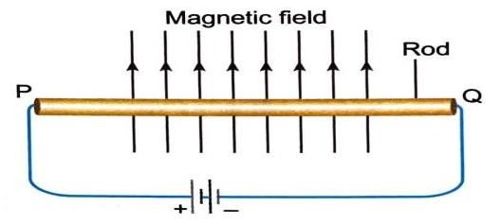  A metal rod PQ is placed in the magnetic field. The ends of the rod are connected with a battery using wires. Where will the rod move?  (a) Into the field.  (b) Upward  (c) Downwards  (d) Out of the field. | 1
2 | A student places some iron fillings around a magnet. The iron fillings arrange themselves as shown in image. The student labelled four different regions around the magnet. Where magnetic field would will be the strongest?  (a) S  (b) R  (c) Q  (d) P  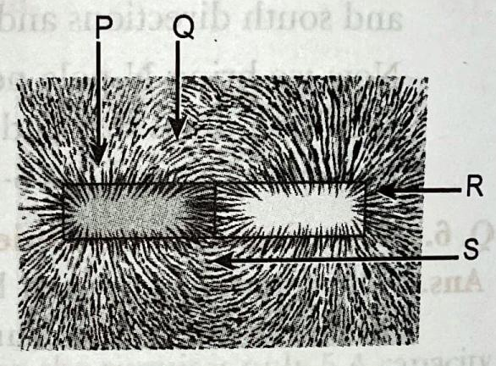 | 1
3 | An electron enters a magnetic field at right angles to it, as shown in figure. The direction of force acting on the electron will be  (a) to the right  (b) to the left  (c) out of the page  (d) into the page  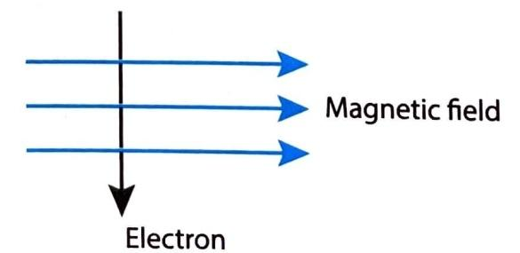 | 1
4 | A current through a horizontal power line flows in east to west direction. The direction of the close to magnetic field at a point directly below it is from  (a) North to South  (b) South to North  (c) West to East  (d) North to West | 1
5 | According to international convention of colour coding in a wire  (a) live is red, neutral is black and earth is green  (b) live is brown, neutral is blue and earth is green  (c) live is brown, neutral is green and earth is black  (d) live is red, neutral and earth is blue. | 1
6 | Appliances that have metal body are generally connected to the earthing wire. What is the reason to earth these wires?  (a) to prevent excess of current  (b) to prevent the leakage of current  (c) to provide extra current to appliance  (d) to provide high resistance to the appliance | 1
7 | Which diagram shows the magnetic field lines around a current carrying loop?  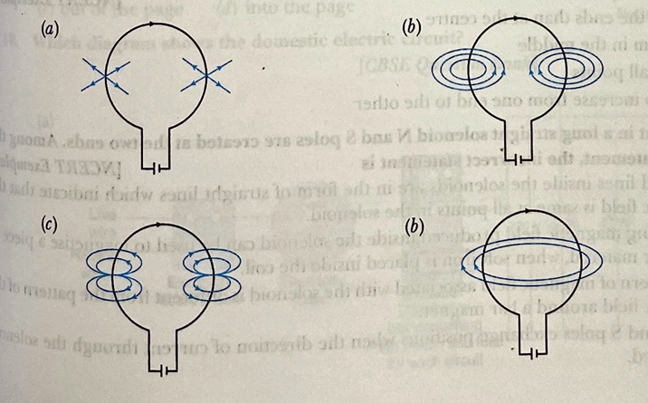 | 1
8 | The direction of the force on a current carrying wire placed in a magnetic field depends on  (a) the direction of the current but not on the direction of the field  (b) the direction of the field but not on the direction of the current  (c) the direction of the current as well as the direction of the field  (d) neither the direction of the current nor the direction of the field | 1
9 | What is the direction of magnetic field at a point A above the wire carrying current I as shown in figure?  (a) Out of the page  (b) Into the page  (c) Up the page  (d) Down the page   | 1
10 | The magnetic field inside a long straight solenoid-carrying current  (a) is zero  (b) decreases as we move towards its end  (c) increases as we move towards its end  (d) is the same at all points | 1
11 | The most suitable material for making the core of an electromagnetic is:  a)Steel b) iron c) soft iron d) Aluminium | 1
12 | When a straight conductor is carrying current:  a) There are circular magnetic field lines around it  b) There are magnetic field lines parallel to the conductor  c) There are no magnetic field lines  d) None of the above | 1
13 | A student inserts a bar magnet in the coil. The student observes deflection in the galvanometer connected to the coil. What will happen if the magnet is continuously getting in and out of the coil?  - The current induced in the coil will increase  - The current will change its direction continuously  (c) The magnetic field will create a motion in the coil  (d) The magnetic field of the bar magnet would keep decreasing | 1
14 | Which of the following correctly describes the magnetic field near a long straight wire?  (a) The field consists of straight lines perpendicular to the wire  (b) The field consists of straight lines parallel to the wire  (c) The field consists of radial lines originating from the wire  (d) The field consists of concentric circles centered on the wire | 1
15 | 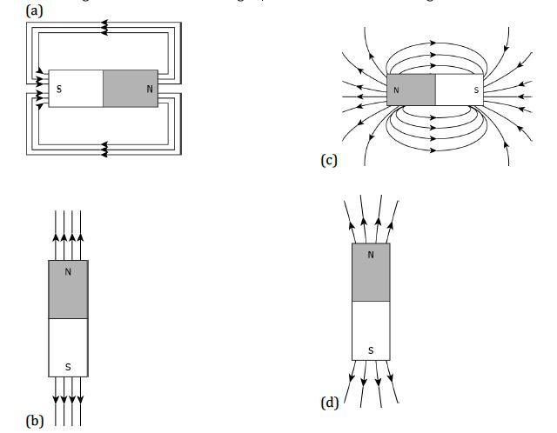  A student learns that magnetic field strength around a bar magnet is different at every point. Which diagram shows the correct magnetic field lines around a bar magnet? | 1
16 | 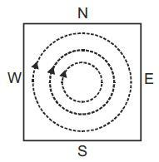  A metal sheet is placed in a variable magnetic field which is increasing from zero to maximum. Induced current flows in the directions as shown in figure. The direction of magnetic field will be –  (a) normal to the paper, inwards  (b) normal to the paper, outwards  (c) from east to west  (d) from north to south | 1
17 | The permanent magnets are kept with soft iron pieces at ends as keepers  (a) to magnetize the soft iron pieces  (b) to increase the strength of the magnets  (c) to avoid self demagnetization  (d) for physical safety of the magnets | 1
18 | The similar magnets of steel are …………….. than the magnets of soft iron  (a) stronger  (b) weaker  (c) of equal strength  (d) none of the above | 1
19 | 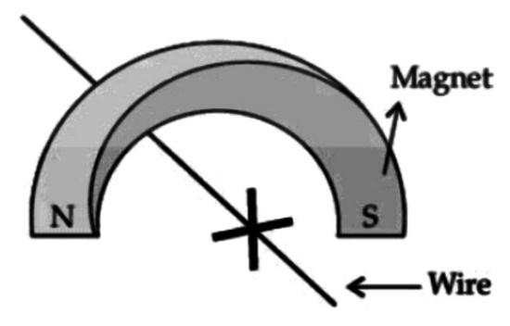  A copper wire is held between the poles of a magnet. The current in the wire can be reversed. The pole of the magnet can also be changed over. In how many of the four directions shown can the force act on the wire?  (a) 1  (b) 2  (c) 3  (d) 4 | 1
20 | Sneha connects a coil of wire with a sensitive galvanometer as shown in figure. Where should the bar magnet be placed to cause the deflection in the galvanometer  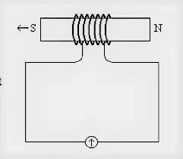  a. The bar magnet should be moved upward or downward of the coil and parallel to the axis of the coil.  b. The bar magnet should be moved towards or away from the coil and perpendicular to the axis of the coil.  c. The bar magnet should be moved towards or away from the coil and parallel to the axis of the coil.  d. The bar magnet should be moved uowards or downward of the coil and perpendicular to the axis of the coil | 1
21 | Magnetic lines of force inside current carrying solenoid are  (a) perpendicular to axis.  (b) along the axis and are parallel to each other.  (c) parallel inside the solenoid and circular at the ends.  (d) circular | 1
22 | Assertion: Strength of an electromagnet depends on the magnitude of current flowing through them.  Reason: Electromagnets are majorly used for lifting heavy weights.  (a) Both A and R are true and R is the correct explanation of A.  (b) Both A and R are true but R is not the correct explanation of A.  (c) A is true but R is false.  (d) A is false but R is true.  (e) Both A and R are false. | 1
23 | Assertion : Electric appliances with metallic body  have three connections, whereas an electric bulb has two pin connections.  Reason : Three pin connections reduce heating of connecting wires.  (a) Both A and R are true and R is the correct explanation of A.  (b) Both A and R are true but R is not the correct explanation of A.  (c) A is true but R is false.  (d) A is false but R is true.  (e) Both A and R are false | 1
24 | A magnet NS is placed along the axis of a circular coil. The magnet is moved away from the coil. The induced current in the coil is:  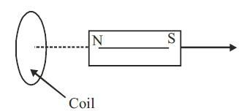  (a) Zero  (b) Clockwise  (c) Anti-clockwise  (d) None of these | 1
25 | When a bar magnet is broken into two pieces?  (a) we will have a single pole on each piece  (b) each piece will have two like poles  (c) each piece will have two unlike poles  (d) each piece will be loe magnetism | 1
26 | Which of the following statement is not correct about the magnetic field?  (a) Magnetic field lines form a continuous closed curve.  (b) Magnetic field line do not interest each other.  (c) Direction of tangent at any point on the magnetic field line curve gives the direction of magnetic field at that point.  (d) Outside the magnet, magnetic field lines go from South to North pole of the magnet. | 1
27 | 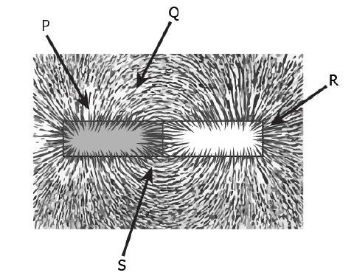  Rahul places some iron filings around a bar magnet. The iron fillings arrange themselves as the following  Where would the magnetic field be the strongest?  a. P  b. Q  c. R  d. S | 1
28 | (a) How is the direction of magnetic field at a point determined?  (b) What is the direction of magnetic field at the centre of a current-carrying circular loop? | 2
29 | An electron and a proton, moving parallel to each other, enter a uniform magnetic field with same velocity. The direction of magnetic field and their motion coincides (is same). How will the direction of their paths be affected when they are travelling in  (i) same direction  (it) opposite direction. | 2
30 | (i) How does the strength of the magnetic field at the centre of a circular coil of a wire depend on:  (a) radius of the coil  (b) number of turns in the coil. | 2
31 | State the factors on which strength of magnetic field at a point due to a current carrying conductor depends? | 2
32 | Draw magnetic field lines around a bar magnet? Give one point of difference between uniform and non- uniform magnetic field. | 2
33 | Explain two different ways to induce current in a coil. | 2
34 | Magnetic field lines of two magnets are shown in fig. A and fig. B. Select the figure that represents the correct pattern of field lines. Give reasons for your answer. Also name the poles of the magnets facing each other  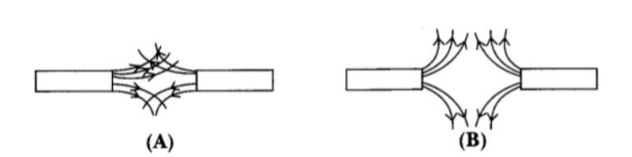 | 2
35 | Observe the following image and answer the following questions  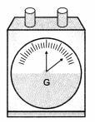  i. What is the name of the instrument  ii. What is the use of this instrument? | 2
36 | Identify the poles of the magnet in the given figure (1) and (2).  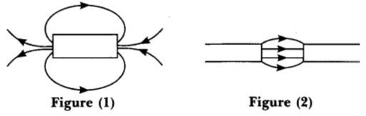 | 2
37 | What precautions should be taken to avoid overloading of domestic circuits? | 3
38 | (a)What is the purpose of the soft iron core used in making an electromagnet?  (b)How is it different from the permanent magnet? | 3
39 | What happens to the force acting on current carrying conductor placed in magnetic field when:  (a) Direction of magnetic field is reversed without changing the direction of current.  (b) Direction of the current is reversed without changing the direction of magnetic field.  (c) Direction of both the current and the magnetic field is reversed. | 3
40 | What is an electromagnet? Write two uses of an electromagnet? | 3
41 | List the properties of magnetic lines of force. | 3
42 | List three sources of magnetic fields. | 3
43 | Observe the following figure and answer  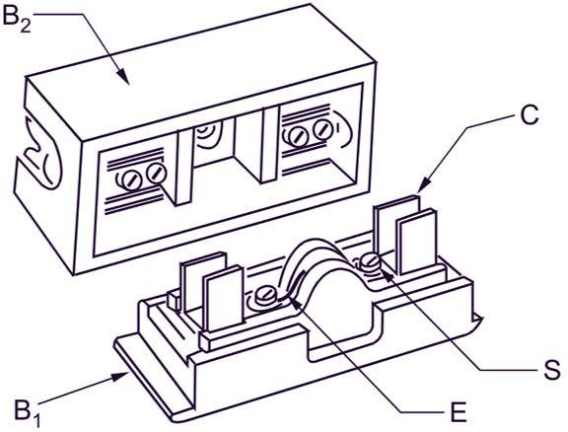  i. What is the name of this device?  ii. What is the use of this device?  ii. What about the resistance of this device? | 3
44 | A coil of insulated copper wire is connected to a galvanometer. What will happen if a bar magnet is:  (i) pushed into the coil  (ii) withdrawn from inside the coil  (iii) held stationary inside the coil | 3
45 | Distinguish between a solenoid and a bar magnet. Draw the magnetic lines for both | 3
46 | - Give one difference between the wires used in the element of an electric geyser and in a fuse.  (b) Mention the insulation colour of wires used in domestic circuits. | 4
47 | (a) Why is it necessary to earth metallic appliances?  (b) When current exceeds the fuse rating, fuse gets blown off. Why? | 4
48 | (a) State Right Hand Thumb rule to find the direction of the magnetic field around a current carrying straight conductor.  (b) How will the magnetic field be affected on:  (i) increasing the current through the conductor  (ii) reversing the direction of flow of current in the conductor | 4
49 | Distinguish between a bar magnet and an electromagnet. | 4
50 | 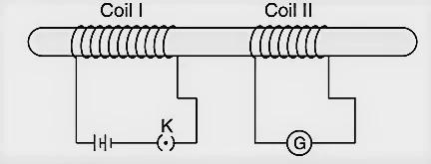  Two coils C1 and C2 are wrapped around a non-conducting cylinder. Coil C1 is connected to a battery and key and C2 with galvanometer G. On pressing the key (K), current starts flowing in the coil C1.  State your observation in the galvanometer.  (a) When key K is pressed on.  (b) When current in the coil C1 is switched off.  (c) When the current is passed continuously through coil C1 .  (d) Name and state the phenomenon responsible for the above observation | 4
51 | The domestic electric circuit consist of red insulated cover called as live wire, wire with black insulation called as neutral wire and the wire with green insulation is called as Earth wire. We know that fuse is connected in series with the circuit to prevent the damaging of electrical appliances and circuit from overloading. Overloading occurs when live wire and the neutral wire comes in direct contact with each other. Because of which current through the circuit increases suddenly. Also, overloading may occurs because of connecting many appliances to a single socket. The Earth wire which is green in colour is connected to a metal plate deep in the earth near the house. This type of safety measure is used in appliances like electric press, toaster, table fan, refrigerator etc. The Earth wire is gives low resistance conducting path for the electric current. In this way it protects us from severe electric shock.  All the appliances are connected in parallel circuit so that the potential difference across each appliance will be same.  1) What are the signs of live wire and neutral wire?  2) In our country what is the potential difference between live wire and neutral wire?  3) What is short circuiting?  4) What is the main purpose of using fuse in electric circuit? | 4
52 | When magnet is brought into the field of another magnet, the field interacts with each pole of the magnet and each of these poles experience magnetic force.  The space surrounding a magnet where a magnetic force is experienced is called magnetic field. A magnetic field line is a continuous curve in a magnetic field such that the tangent at any point on it gives the direction of magnetic field at that point.  (i) Magnetic field is produced by the flow of current in a straight wire. The phenomenon was discovered by  (a) Faraday  (b) Fleming  (c) Oerested  (d) Maxwell  (ii) At the centre of bar magnet, the magnetism is  (a) same as the pole  (b) zero  (c) maximum  (d) minimum  (iii) Magnetic field lines can be used to determine  (a) only the direction of magnetic field  (b) only the relative strength of the magnetic field  (c) both the direction and relative strength of the magnetic field  (d) the shape of the magnetic field  (iv) A bar magnet has strongest magnetism  (a) inside of the magnet  (b) at the centre of the magnet  (c) near the poles of the magnet  (d) at one quarter distance from the poles of the magnet  (v) Select the incorrect statements.  (a) magnetic field are closed curves  (b) no two field lines cross each other  (c) field lines can cross each other  (d) the relative strength of the magnetic field is shown by degree of closeness of the field lines | 5
53 | What are magnetic field lines? How is the direction of a magnetic field at a point determined? Mention three important properties of the magnetic field lines. | 5
54 | Observe the figure given below and answer the following questions:  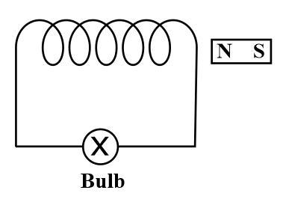  (a) Write the special name given to the coil AB which has many circular turns of insulated  copper wire.  (b) State the nature of magnetic field inside AB when a current is passed through it.  (c) Redraw the diagram and sketch the pattern of magnetic field lines through and around AB.  (d) List two factors on which the strength of the magnetic field produced by AB depends.  (e) What is the effect of placing an iron core in the coil AB? | 5

Answers Chapter-12 Magnetic Effects of Electric current
Q | Answers
1 | (D)
2 | (B)
3 | (D)
4 | (A)
5 | (B)
6 | (B)
7 | (B)
8 | (C)
9 | (C)
10 | Option (d)
11 | Option (c)
12 | Option (a)
13 | Option (b)
14 | Option (d)
15 | Option ( c )
16 | Option ( b )
17 | Option (c)
18 | Option (b)
19 | b. 2
20 | c. The bar magnet should be moved towards or away from the coil and parallel to the axis of the coil.
21 | (c) parallel inside the solenoid and circular at the ends
22 | (b) Both A and R are true but R is not the correct explanation of A
23 | (d) Fleming’s right hand rule
24 | (b) Clockwise
25 | (c) each piece will have two unlike poles
26 | (d) Outside the magnet, magnetic field lines go from South to North pole of the magnet.
27 | C. R
28 | (a) The direction of the magnetic field at a point can be found by placing a small magneticcompass at that point. The north end of the needle of a compass indicates the directionof magnetic field at a point where it is placed.  (b) The direction of magnetic field at the centre of a current-carrying circular loop isperpendicular to the plane of the loop.
29 | A magnetic field does not exert any force on a charge moving parallel or antiparallel to the field direction. Since they are travelling in the direction of the magnetic field, there will be no force acting on them. Hence their paths will remain the same after entering the magnetic field.
30 | (a) More the radius weaker the field.  (b) Field strength is directly proportional to the number of turns in the coil
31 | The factors on which strength of magnetic field at a point depends.  - Amount of current (I) following through the conductor.  Distance ( r ) from the current carrying conductor.
32 | The space or region where field is same everywhere is known as Uniform magnetic field. The magnetic field which is unequal in magnitude and direction at every point in the space is called non- uniform magnetic field.
33 | The different ways to induce current in a coil are as follows:  (a) If a coil is moved rapidly between the two poles of a horse-shoe magnet, then an electric  current is induced in the coil.  (b) If a magnet is moved relative to a coil, then an electric current is induced in the coil.
34 | Figure B represents the correct pattern of field lines. In figure A, field lines cross each other,which is not possible because if they cross each other, at the point of intersection, there would be twodirections of field lines.In figure B, field lines are emerging in nature, so poles of magnet facing each other are north poles while opposite faces will have south polarity.
35 | I.Galvanometer  II. To detect presence of current in a circuit
36 | Field lines emerge from north pole (N) and merge at the south pole (S) as shown in both the figures  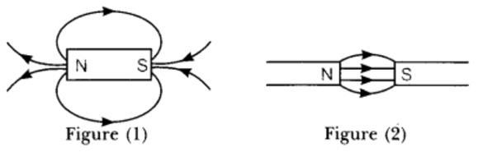
37 | The precautions that should be taken to avoid overloading of domestic circuits are:  (i) One should not use too many appliances in the domestic electric circuits. When we use too many appliances connected to the primary electric source, there are possibilities that the electric flow may increase rapidly, leading to an overload in the circuit.  (ii) One should not connect too many appliances in a single socket. It can also produce overload in the circuit.  (iii) One must always keep a routine check whether the connected appliances are in good condition or not. Damaged appliances can be hazardous for domestic uses.  (iv) One should always install a fuse or Mini Circuit Breaker to every switchboard to prevent this situation.  (v) Proper earthing should be installed in the domestic electric circuit. If the earthing is appropriately done in a circuit, then the excess current will flow through the earthing to prevent the circuit’s overload.  (any three of the above points)
38 | The purpose of soft iron core used in making an electromagnet that  • It loses all its magnetic property, i.e. magnetism immediately when current in the solenoid is switched off.  • It increases the magnetic field strength of an electromagnet.  (b) It is different from the permanent magnet in the following way:  (i) Electromagnet can be demagnetised by stopping the current flowing through the solenoid while permanent magnet cannot be demagnetised easily.  (ii) Strength of magnetic field produced by electromagnet can be changed by changing the magnitude of electric current through the solenoid while strength of magnetic field of a permanent magnet cannot be changed.  (iii) The polarities of the electromagnet can be interchanged by reversing the direction of current through the solenoid while the polarities of permanent magnet cannot be interchanged.  (iv) An electromagnet can easily be made more powerful than the permanent magnet.  (any three of the above points)
39 | Force acting on a current carrying conductor placed in a magnetic field will  (a) acts in opposite direction to that of previous direction.  (b) acts in opposite direction to that of previous direction.  (c) remains in the same direction.
40 | Ans. When current is passed through a solenoid it behaves as a magnet and is called as an  electromagnet.  The two uses of an electromagnet are-  (1) They are used to lift heavy iron pieces.  (2) They are used in many devices like micro phone, radio sets, electric bell etc.
41 | The magnetic field lines originate from the north pole of a magnet and end at its south pole  The magnetic field lines become closer to each other near the poles of a magnet but they are widely separated at other places.  Two magnetic field lines do not intersect one another.
42 | Three sources of magnetic fields are as follows:  (a) Current-carrying conductors  (b) Permanent magnets  (c) Electromagnets
43 | i. Fuse  ii. Fuse is used in the circuit to protect appliances from overloading  ii. Fuse has low resistance.
44 | (i) When the north pole (N) of the magnet is pushed into the coil, the galvanometer is deflected towards the right.  (ii) When the north pole (N) of the magnet is withdrawn from the coil, the galvanometer is deflected towards the left.  (iii) When the magnet is held stationary inside the coil, the deflection of the galvanometer is zero.
45 | Bar magnet  It is a permanent magnet.  The strength of a bar magnet cannot be changed.  The polarity (North – South) of a bar magnet cannot be changed.  Solenoid  It is a temporary magnet. It acts as a magnet only as long as the current passes through it.  The strength of a solenoid can be changed by changing the number of turns in its coil or by changing the current passing through it.  The polarity of a solenoid can be changed by changing the direction of current in its coil.  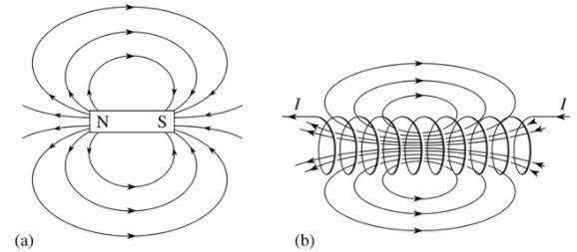
46 | (a) High melting point material is used in electric geyser whereas fuse wire has a low melting point.  (b) The insulation colour of wires used in domestic circuit:  (i) Red colour insulation wire - Live wire  (ii) Black colour insulation wire – Neutral wire  (iii) Green colour insulation wire - Earth wire
47 | - Earth wire offers low resistance path to the current and ensure that the body of the electrical appliance is at the same potential (electric) as that of earth (zero). Any leakage of current in an electrical appliances to their metallic body is immediately transferred to the earth through the earth wire and user gets protected from possible and dangerous electrical shock. Hence, it is necessary to ground the metallic appliances through the earth wire which acts as a safety measure.  Fuse element has high resistance and low melting point. It is connected in series with live wire. When current flows exceed the fuse rating, its temperature increases. This make it overheated (H =I2Rt). As a result, fuse element will melt and breaks the connection that was completing the entire circuit.
48 | (a) It states that you are holding a current carrying straight conductor in your right hand such that the thumb points towards the direction of current. Then your finger will wrap around the conductor in the direction of the field lines of the magnetic field.  (b) (i) If the current is increased, the magnetic field strength also increases.  (ii) If the direction of current is reversed, the direction of magnetic field also get reversed.
49 | Bar Magnets  The bar magnet is a permanent magnet.  It produces a comparatively weak force of attraction.  The strength of a bar magnet cannot be changed.  The polarity of a bar magnet is fixed and cannot be changed.  Electromagnets  An electromagnet is a temporary magnet.  It produces a very strong magnetic force.  The strength of an electromagnet can be changed by changing the number of turns in its coil or by changing the current passing through it.  The polarity of an electromagnet can be changed by changing the direction of current in its coil
50 | a) The galvanometer needle deflects momentarily in one direction.  b) The galvanometer needle deflects again momentarily but in opposite direction to  that in the previous case.  c) No deflection.  d) Electromagnetic induction.
51 | 1) The red insulated wire is the live wire or positive and the black insulated wire is the neutral wire or negative.  2) In our country the potential difference between live wire and neutral wire is 220 V.  3) When live wire and neutral wire comes in direct contact, in that situation the current through the circuit increases suddenly and it is called as short circuiting.  4) Because of Joule’s heating effect the heat produced causes the fuse to melt and to break the circuit. And thereby protect the circuit and electric appliances.
52 | (i) (c) Oerested  (ii) (b) zero  (iii) (c) both the direction and relative strength of the magnetic field  (iv) (c) near the poles of the magnet  (v) (c) field lines can cross each other
53 | The space surrounding a magnet in which magnetic force is exerted, is called a magnetic field. Magnetic field lines are the lines that are drawn at every point indicating the direction in which a north pole would move if placed at that point. They are determined by placing an imaginary hypothetical north pole at that point and finding the direction in which it would move due to the magnetic field at that point. A compass needle gets deflected when placed near a magnet due to the magnetic force exerted by the magnet on it.  Some important properties of magnetic field lines are;  (i) The tangent drawn at any point on the field line indicates the direction in which a north pole would move if placed at that point.  (ii) The relative strength of the field is proportional to the degree of closeness of the lines. The more clustered they are, the stronger the field in that region.  (iii) The magnetic field lines never intersect. This is because a pole can move only in zone direction and if the lines intersect they would have to move in two direction simultaneously which is impossible.
54 | (a) Solenoid.  (b) Uniform magnetic field.  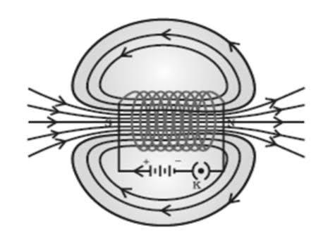  (c) Magnitude of current flowing through it.  (d) Number of turns of a circular coil.  (e) It becomes an electromagnet.

Chapter 13 Our Environment
1 | The percentage of solar radiation absorbed by all the green plants for the process of photosynthesis is about  A) 1% B) 5% C) 8% D)10% | 1
2 | Select the mismatch pair in the following and correct it.  - Bio-magnification –Accumulation of chemicals at the successive trophic levels of a food chain  - Ecosystem-Biotic components of environment.  - Aquarium-A man made ecosystem  - Parasites-Organisms which obtain food from other living organism. | 1
3 | Excessive exposure of humans to ultraviolet rays result in  - Damage to immune system and Skin cancer  - diabetes  - Damage to lungs  - Peptic ulcers | 1
4 | In the given food chain, suppose the amount of energy at fourth trophic level is 5KJ,what will be the energy available at the producer level?  5 KJ B) 50 KJ C) 500 KJ D) 5000KJ | 1
5 | Which statement shows interaction of an abiotic component with a biotic component in an ecosystem?  (a) A grasshopper feeding on a leaf.  (b) Rainwater running down into the lake.  (c) An earthworm making a burrow in the soil.  (d) A mouse fighting with another mouse for food. | 1
6 | In an ecosystem, the 10% of energy available for transfer from one trophic level to the next is in the form of :  (a) heat energy  (b) light energy  (c) chemical energy  (d) mechanical energy | 1
7 | The manufacturing of Chlorofluorocarbons free refrigerators is mandatory throughout  the world. How this help prevent ozone depletion?  (a) This will help convert oxygen molecules into ozone.  (b) This will help convert the CFCs into ozone molecules.  (c) This will reduce the production of CFC from oxygen molecules.  (d) This will reduce the release of CFCs that reacts with ozone molecules | 1
8 | 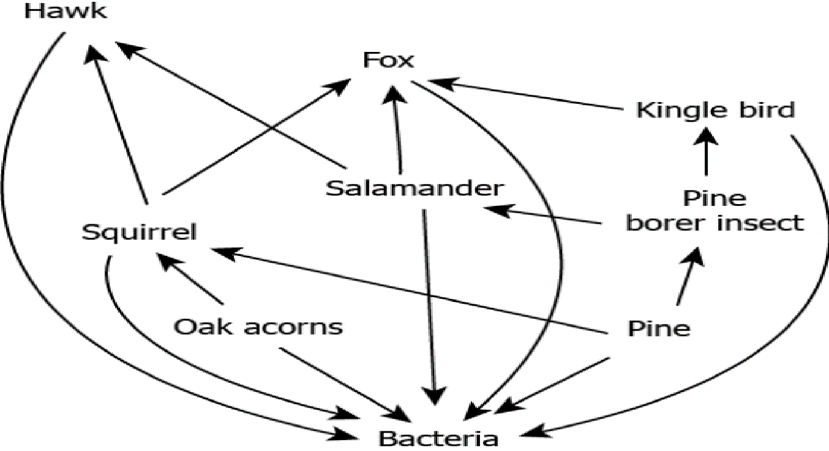  Which is correct as per above food web.  (a) Fox feeds on hawk obtain energy.  (b) Hawk feeds on oak acorn to obtain energy.  (c) Squirrel feeds on pine borer to obtain energy.  (d) Salamander feeds on pine borer to obtain energy. | 1
9 | Assertion(A) :Food chain is responsible for the entry of harmful chemicals in our bodies.  Reason(R) : The length and complexity of food chain vary greatly.  (a) If both Assertion and reason are true and Reason is the correct explanation of assertion  (b) If both Assertion and Reason are true but Reason is not a correct explanation of the Assertion  (c) If Assertion is true but the Reason is false  (d) If both Assertion and Reason are false | 1
10 | Which set of the organisms belong to the same trophic level?  a) Deer ,tiger  b) Rabbit, snake  c) Plants, Phytoplanktons  d) Phytoplanktons, zooplanktons | 1
11 | In an ecosystem, the ten percent of energy available for transfer from one trophic level to the next is in the form of  a) Heat energy b) Light energy  c) mechanical energy d) Chemical energy | 1
12 | Organisms of a higher trophic level which feed on several types of organisms belonging to a lower trophic level constitute the  a) Food web b) Ecological pyramid  c) Ecosystem d) Food chain | 1
13 | Select the mis matched pair | 1
  a) Ecosystem | Biotic components of environment
  b)Bio magnification | Accumulation of chemicals at the successive trophic levels
  c)Aquarium | A man made ecosystem
  d) Parasites | Organisms which obtain food from other living organisms
14 | Which of the statements given below about Omnivores is correct?  a) They are in the middle of the food chain.  b )They are either in the middle or at the top of the food chain.  c) They are at the top of the food chain.  d) They are capable of modifying the natural food chain. | 1
15 | Pesticide can disturb the balance within the ecosystem by  a) Biomagnification  b) Eutrophication  c) Bioaccumulation  d) Indiscriminately killing pests and the predators of these pests. | 1
16 | Assertion – Greater number of individuals are present in lower trophic levels.  Reason- The flow of energy is unidirectional. | 1
17 | Assertion- Decomposers act as cleaning agents of the environment.  Reason- The decomposers recycle waste materials in the hydrosphere. | 1
18 | In a food chain, if 10,000 joules of energy is available to the producer, how much energy will be available to the secondary consumer to transfer it to the tertiary consumer? | 2
19 | State with reason any two possible consequences of elimination of decomposers from the earth. | 2
20 | Indicate the flow of energy in an ecosystem. Why it is unidirectional? What will happen if decomposers are absent in an ecosystem ? | 3
21 | In a certain study conducted on the occurrence of DDT along food chains in an ecosystem, the concentration of DDT in grass was found to be 0-5 ppm. In sheep, it was 2 ppm and in man it was 10 ppm. Name the phenomenon and define? | 3
22 | Define an ecosystem. Draw a block diagram to show the flow of energy in an ecosystem. | 3
23 | (a) From the following group of organisms create a food chain which is most advantageous for human beings in terms of energy.  Hawk, Rat, Cereal plant, Goat, Snake, Human being  (b) State the possible disadvantage if the cereal plant is growing in soil rich in pesticides.  (c) Construct a food web using the organisms mentioned above. | 3
24 | Complete the following flow chart based on ecosystem and its components.  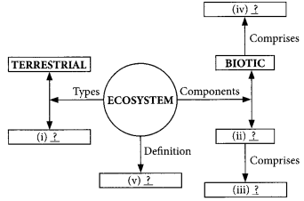 | 3
25 | Why are bacteria and fungi called decomposers? List any two advantages of decomposers to the environment. | 4
26 | We are an integral part of the environment. Changes in the environment affect us and our activities change the environment around us.Ozone (O3 ) is a molecule formed by three atoms of oxygen. While O2 , which we normally refer to as oxygen, is essential for all aerobic forms of life. Ozone, is a deadly poison. However, at the higher levels of the atmosphere, ozone performs an essential function. It shields the surface of the earth from ultraviolet (UV) radiation from the Sun.  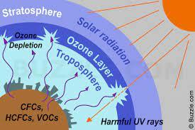  i) What are the effects of UV radiations?  ii) In which layer of atmosphere does ozone is present?  iii) What are the causes for ozone depletion?  iv) Write the chemical reaction for the formation of ozone? | 4
27 | Food chains are very important for the survival of most species.  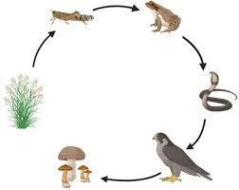  1) Which of the following limits the number of trophic levels in a food chain?  - a) Decrease in energy at higher trophic levels  - b) Less availability of food  - c) Polluted air  - d) Water  2) If Ravi is consuming curd/yogurt for lunch , which trophic level in a food chain he should be considered as occupying ?  - a) First trophic level  - b) Second trophic level  - c) Third trophic level  - d) Fourth trophic level  3) Matter and energy are two fundamental inputs of an ecosystem. Movement of  - a) Energy is bidirectional and matter is repeatedly circulating.  - b) Energy is repeatedly circulation and matter is unidirectional.  - c) Energy is unidirectional and matter is repeatedly circulating.  - d) Energy is multidirectional and matter is bidirectional.  4) If 10,000 J solar energy falls on green plants in a terrestrial ecosystem, what percentage of solar energy will be converted into food energy?  - a) 10,000 J  - b) 100 J  - c) 1000 J  d) It will depend on the type of the terrestrial plant. | 4
28 | Ganga river has been severely polluted. All the towns along its length contribute to the pollution load. It has been assessed that more than 80 per cent of the total pollution load (in terms of organic pollution expressed as biochemical oxygen demand (BOD)) arises from domestic sources, i.e., from the settlements along the river course. Due to over-abstraction of water for irrigation in the upper regions of the river, the dry weather flow has been reduced to a trickle. Rampant deforestation in the last few decades, resulting in topsoil erosion in the catchment area, has increased silt deposits which, in turn, raise the river bed and lead to devastating floods in the rainy season and stagnant flow in the dry season. Along the main river course there are 25 towns with a population of more than 100,000 and about another 23 towns with populations above 50,000. In addition, there are 50 smaller towns with populations above 20,000. There are also about 100 identified major industries located directly on the river, of which 68 are considered as grossly polluting. Fifty-five of these industrial units have complied with the regulations and installed effluent treatment plants (ETPs) and legal proceedings are in progress for the remaining units. The natural assimilative capacity of the river is severely stressed. The principal sources of pollution of the Ganga River can be characterized as follows:  - I)Which of the following activities may pollute the river water more?  (a) Bathing using detergent and soap  (b) Discharging animals excreta  (c) Deposit flowers and leaves as the part of puja  (d) Bathing without soap and detergent  - II)Which of the following organisms grow abundant in water when the water get mixed with nutrients like sulphates, phosphates etc.?  (a) Algae  (b) Zooplankton  (c) Small fishes  (d) Large fishes  III)When toxic chemicals and nutrients get deposited in the water bodies, which of the following gases get depleted in the water bodies?  (a) Oxygen  (b)Carbon dioxide  (c) Both oxygen and carbon dioxide  (d)Nitrogen  - IV) Accumulation of toxic substances at higher trophic levels of an ecosystem through the food chain in water bodies affects which of the following organisms more?  (a) Phytoplankton  (b) Zooplankton  (c) Small fishes  (d) Large fishes  - V) Green Algae and Diatoms are the major producers of Aquatic ecosystem. Which of the following will be more in the aquatic ecosystem:  (a) Small fishes  (b) Large fishes  (c) Algae and phytoplankton  (d) Tadpole | 5
29 | Create a food chain of the following organisms  Insect, Frog, Grass, Hawk, Snake  a) Name the organism at the second and fourth trophic level.  b) Which organism of this food chain will have the lowest and highest concentration of non-biodegradable chemicals?  c) Name the phenomenon associated with it.  d) If 1000 J of energy is available to snakes, how much energy will be available to insects and hawk | 5

Answers
Chapter-13 Our Environment
Q | Answers
1 | A
2 | B
3 | A
4 | D
5 | C
6 | C
7 | D
8 | D
9 | B
10 | C
11 | D
12 | A
13 | A
14 | B
15 | D
16 | B
17 | A
18 | According to ten percent law, 10% of the energy of producer will be available to primary consumer, and 10% of this energy will be available to secondary consumer and so on.  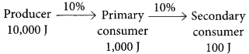  Hence, 100 J of energy will be available to the secondary consumer to transfer it to tertiary consumer.
19 | Consequences of elimination of decomposers are:  (i) There would be no recycling of nutrients and therefore, raw materials to produce food will not be available to producers. Hence, the food chains will get affected.  (ii) The dead bodies of plants and animals will go on accumulating in the absence of decomposition thereby polluting the environment.
20 | Because the energy moves progressively through the various trophic levels and is no longer available to the previous trophic level.  The energy captured by autotrophs does not revert to the solar input.  a. Pesticides, used for crop protection when washed down into the soil/ water body are absorbed by the plant along with water and minerals  b. Plants are consumed by animals and these chemicals get into animal body  c. Being non-biodegradable, these chemicals get accumulated progressively in the food chain and into our body  d. As we go into higher levels of food chain amount of harmful substances will  increase in the body of organisms as a result of bio magnification
21 | Bio-magnification  Bio-magnification is the increase in the level of a toxic substance with each successive rise in the trophic level of a food chain.
22 | An ecosyslcm is defined as a structural and functional unil of ihe biosphere. It comprises of living organisms and their non-living environment that interact by means of food chains and biogeo-chemical cycles resulting in energy-flow, biotic diversity and material cycling to form stable self-supporting system.  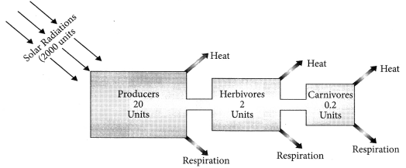
23 | (a) A food chain which is most advantageous for human beings in terms of energy is:  Cereal plant → Human being  (b) If the cereal plant is growing in soil rich in pesticides, these pesticides are absorbed by growing plants along with water and minerals, when animals eat these cereal plants, these poisonous chemical pesticides go into their bodies through food. This increase in concentration of harmful pesticides in the body of living organisms at each trophic level of a food chain is called biological magnification. Pesticides are lethal to non-target species also. The extensive use of pesticides in agriculture can change the community of microorganisms living in soil.  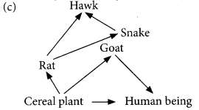
24 | - Aquatic  - Abiotic  - Inorganic substances  - Producers  Structural and functional unit of biosphere
25 | Decomposers degrade breakdown the complex organic substances into simple  inorganic substances that go into the soil and are used up once more by the plants.  Advantages: i- Clean environment by decomposing dead bodies of plants/ animals  ii- Replenish nutrients (Inorganic substance) into soil  iii- Helps in Nutrient recycling
26 | i. It causes different types of cancer in human beings.  ii. The ozone is present in the stratosphere layer of atmosphere just above troposphere.  iii. The synthetic chemicals like CFCs ( chlorofluorocarbons) which used as refrigerants amd in the fire extinguisher  iv. O2 → [O] + [O]  [O] + O2 → O3 (ozone)
27 | 1 a, 2c,3c,4c
28 | I ) A  II) A  III) A  IV) D  V) A
29 | a) Grass 🡪 insect 🡪 Frog🡪 snake🡪 Hawk  b) 2nd- insect, 4th – frog  c)lowest – grass, highest—Hawk  d)Biomagnification  e)insect -10 J, hawk- 10,000 J

